Jed W. Morison

Superintendent

**Franklin County Board of Developmental Disabilities**

2879 Johnstown Road • Columbus, Ohio 43219 • 614-475-6440 • www.fcbdd.org

***Helping people to live, learn and work in our community***

**Franklin County**

**Developmental**

**Disabilities**

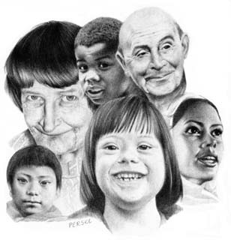

Perske

**Franklin County Provider Fair**

Wednesday, April 12th, 2017

12:00 – 5:00 pm

Ohio State Fairgrounds/Expo – Lausche Building

**COMMUNITY RESOURCES REGISTRATION**

*This information will appear on the Provider Fair roster distributed to families and individuals. Please be clear about services offered and preferred contact information.*

**Organization:**

**Contact Name:**

**Phone:**

**Address:**

**Summary of your organization:**

**Please return form by 1/10/17 to:**

**Lilian Beck**

**1481 W Town St, Columbus, OH 43223**

[**Lilian.Beck@fcbdd.org**](mailto:Lilian.Beck@fcbdd.org)

**Fax: 614-342-5260**