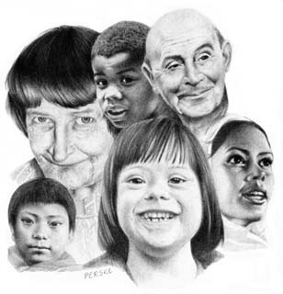

Jed W. Morison
Superintendent

Franklin County Board of Developmental Disabilities

2879 Johnstown Road • Columbus, Ohio 43219 • 614-475-6440 • www.fcbdd.org
Helping people to live, learn and work in our community
Franklin County
Developmental
Disabilities
Perske

Franklin County Provider Fair
Wednesday, April 12th, 2017
12:00 – 5:00 pm
Ohio State Fairgrounds/Expo – Lausche Building

COMMUNITY RESOURCES REGISTRATION

This information will appear on the Provider Fair roster distributed to families and individuals. Please be clear about services offered and preferred contact information.

Organization:

Contact Name:

Phone:

Address:

Summary of your organization:

Please return form by 1/10/17 to:
Lilian Beck
1481 W Town St, Columbus, OH 43223
Lilian.Beck@fcbdd.org
Fax: 614-342-5260

