Employer Resource Network®

Executive Overview
For business leaders, executives and senior management exploring joining an ERN

Tuesday, July 31, 2018, 8am-9am
Bethany Village Center Grand Room
6443 Bethany Village Drive
Centerville, OH 45459
(On the campus of Bethany Village. As you enter campus, follow the Event Parking signs leading you to Village Center parking.)

Presenters:
James Vander Hulst, President, ERN-USA
Stephen MacDonald, Impact Manager, Lucas County Family Council & ERN-OHIO

Executive Overview to include ERN structure, benefits and outcomes.

Sponsors:

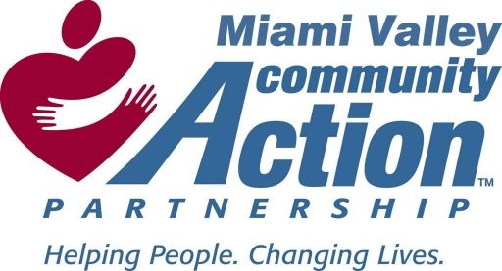

TO REGISTER: https://www.surveymonkey.com/r/ERNJuly31

FOR MORE INFORMATION:
Jennifer Wurzelbacher, (513) 612-6503; jwurzelbacher@graceworks.org

