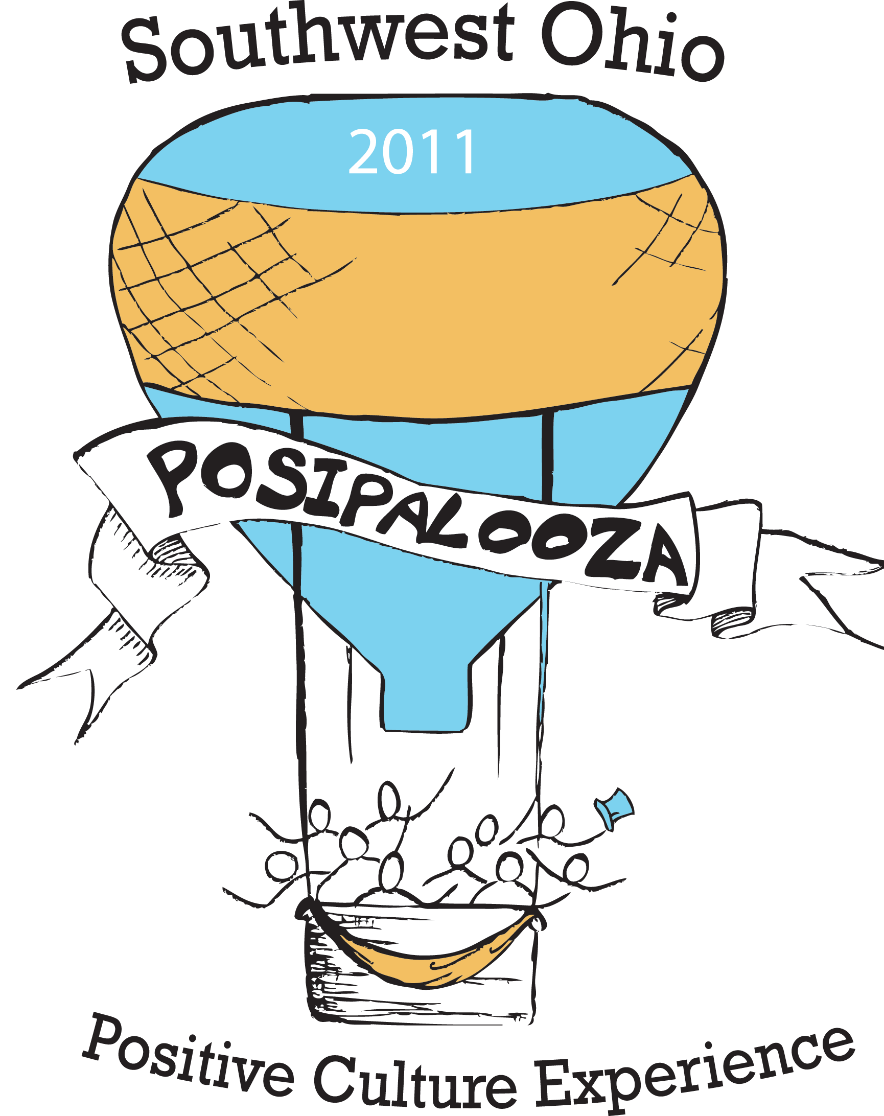
Southwest Ohio Posipalooza:
The Positive Culture Experience
Check it out on Facebook
http://www.facebook.com/#!/event.php?eid=185742564797306

REGISTER NOW!
http://www.surveymonkey.com/s/D58C9R3

April 14, 2011
9 a.m. – 4 p.m.
Vineyard Community Church
11340 Century Circle East, Cincinnati
Directions: https://vinenet.net/vincin/vcc.php?id=27

What is Posipalooza?
Posipalooza offers an opportunity to experience a positive culture AND learn how to create a positive culture in our communities and work places. Posipalooza is hosted by supporters of the Ohio Positive Culture Initiative in Butler, Clermont, Warren, Montgomery, and Hamilton County.

What Can I expect?
Participants will gather for an Opening Key Note and a Closing Session. Breakout sessions will be offered in the morning and afternoon. Each breakout will be hosted by a talented team of local people who will offer ideas and tools to create a positive culture. Sessions will include:
- What’s Your Story? Use a variety of tools to create, record, and preserve a life story.
- Conversation Starters: See a variety of videos and experience how videos can jump start good conversations about creating a positive culture.
- Positive Introductions: How we introduce ourselves and others matters! Join in the art and practice of positive introductions.
- Media and Disability: See how media reflects and influences our ideas of “disability”.
- Jeopardy! Play the game with a positive culture twist.
- Tools for Change: Experience the power of positive tools that help us get organized to create change together.
- Positive Psychology: Learn and practice the best of what the new field of positive psychology has to offer.
- See What We Mean! Use the Graffiti Wall and art area to show what Positive Culture means.
- Positive Culture Café: Join in an engaging conversation about taking the ideas and experiences of this event back to your community and place of work.

Who Should Attend?
This event is open to all. Everyone who cares about creating a positive culture is welcome!

Registration Information
Use the link above. Registration is $20 (includes lunch). Payment is required in advance. Scholarships are available. Contact Pam Berry at Pam.Berry@dodd.ohio.gov or 614-301-2992 See reverse for additional registration Information.
Please first register online at http://www.surveymonkey.com/s/D58C9R3
This step is necessary in order to place your lunch order and complete your registration!

Registration fee is $20. Registration includes lunch. If you are paying with check or money order, please also:

1. Complete the form below

2. Enclose a check made check payable to Hamilton County Developmental Disabilities Services by April 7th.

3. Mail form and payment to:
Hamilton County DD Services, Attn: Dawn Freudenberg
1520 Madison Road
Cincinnati, Ohio 45206

Name(s): __________________________________________________

Phone: ___________________________________________________

E-mail: ____________________________________________________

Please note: If you have made arrangements to pay by purchase order, you do not need to complete this form.

