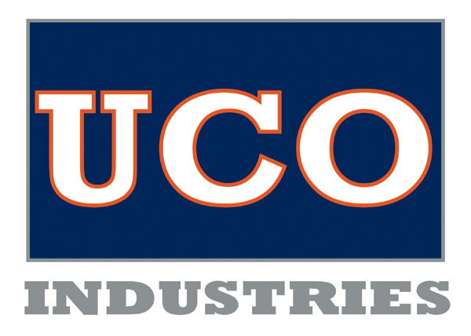

FOR IMMEDIATE RELEASE

February 26, 2014

The Board of Directors of UCO Industries, Inc., was informed at its Board Meeting on February 25th, that CEO Dan Ohler will be resigning his position with them to accept an unexpected offer to become Vice President, Government Solutions for Minneapolis-based Optum Health. The exact date of his departure is yet to be determined as his new employer is being flexible to the needs of UCO Industries in finding a new leader.

“While a huge loss to UCO Industries, this is a wonderful opportunity for Dan and his family,” states Board President Tom McCarthy. “We are pleased that he wants to stay involved with UCO Industries, and that he will remain in his role as CEO while the Board conducts its search for his successor.”

Mr. Ohler, a Marysville resident, will not be required to relocate for his new position which will allow for his continued service in an advisory role to the organization. “Dan’s expertise in the Developmental Disability world is a tremendous strength that we don’t want to lose,” provides McCarthy. “That Dan was sought out for such a prestigious national position only speaks to the strength of our board’s decision to hire him. Optum is getting a fine gentleman and a great businessman. We are committed to finding a new leader who can make as much of an impact in these exciting, albeit challenging times.”

“This opportunity is bittersweet,” reveals Ohler. “While I am excited about my role with Optum, I am deeply committed to the mission and the associates at UCO Industries. I am pleased the Board welcomes my continued involvement with the company.” Ohler believes that UCO Industries is the model company in Ohio for Governor John Kasich’s Employment First initiative. “Our associates are engaged in meaningful employment in an integrated work setting. This is not an adult activity center. Work happens here!”

**Media Release**

Page 2 of 2

UCO Industries, Inc., is a non-profit company that provides employment for people with developmental disabilities. Celebrating its 40th anniversary in 2014, the company is a Tier 1 supplier to Honda North America and also completes work for Alpha Container Company, Ikon Blue, M-TEK, Inc., and Tool Technologies. UCO Industries is located in Marysville and employs over 100 associates.

Recruited by Optum primarily for his work in the developmental disabilities field over the past 15 years, Ohler will be working with state & local government clients across the country in crafting programs that benefit the behavioral health and developmental disability populations. Many of the Medicaid-based systems across the nation have been identified as unsustainable. Optum partners with those governmental entities to develop solutions that are client focused, yet fiscally efficient. “It really is a unique opportunity to join a diverse Team of professionals in crafting solutions that will benefit so many of our nation’s most vulnerable citizens”, stated Ohler. “I consider it an honor to take the knowledge I have acquired here in Ohio and share it with our partners across the country.”

Media Contact: Tom McCarthy, Board President

[tom@mccarthyandcox.com](mailto:tom@mccarthyandcox.com)

937-645-0410