May 29, 2018

Ohio Provider Resource Association

1152 Goodale Blvd

Columbus, Ohio 43212

Ohio Alliance of Direct Support Professionals

PO Box 218145

Columbus, Ohio 43221

Dear Mark Davis and Bethany Toledo

Congratulations! We are pleased to announce The Community Career Partnership-Ohio Program has been selected as a winner of the **Moving Mountains Best Practice Award.**

We received numerous nominations this year and are excited about the workforce development efforts that are happening across the country. This thoughtfully planned and well implemented, system change effort is truly impressive. We are pleased to be recognizing this program of excellence with the 2017-18 Moving Mountains Award.

The University of Minnesota staff may be contacting you to learn more about your program. Moving Mountain Award winners from 2017-18 will be recognized at this year's Reinventing Quality Conference July 29-31 2018 at the Baltimore Renaissance Hotel.

Again, congratulations on this significant achievement in workforce development. We look forward to seeing you at this year's Reinventing Quality Conference.

Sincerely,

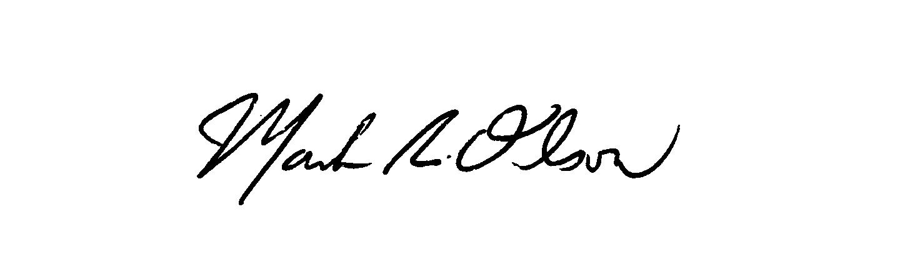

Mark Olson

Project Coordinator

Research and Training Center on Community Living Institute on Community Integration, UMN

150 Pillsbury Dr SE

Minneapolis, MN 55455

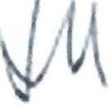 4( 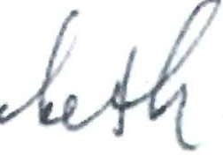

Joseph M. Macbeth Executive Director, NADSP

240 Washington Avenue Ext., Suite 501

Albany, NY 12203