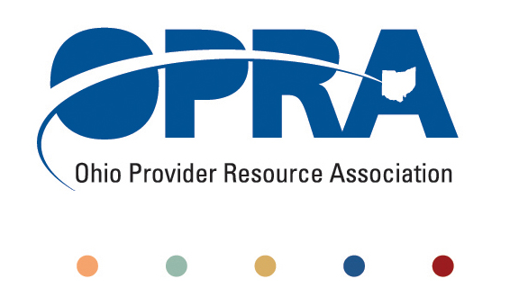

**OPRA BOARD AGENDA**

Wednesday, December 19, 2012

10:00AM – 2:00PM

1152 Goodale Blvd, Columbus OH, 43212

Convene Meeting Chair: Janice Hall

Please silence all phones and other electronic devices.

1. ICF 101 and Thoughts on 2013 – 2014 Ohio Budget (Pat McCormick 10:00 – 11:00AM)
2. Review Minutes
3. Finance Committee
   1. Financials (attachments A and B)
   2. Board Resolution – Checking Account (attachment C)
   3. Dues Update
   4. OPRA Budget (attachment D)
4. Efficiencies and Simplification
   1. Quality Assurance
   2. OHT streamlining: DODD licensure and ODH certification
   3. Provider Compliance/National Accreditation
   4. Money Management Guidelines
   5. MUI Rule
   6. Background Check Rule
   7. SSA and Program Management
5. Reimbursement Transformation for Workforce Sustainability
   1. Waiver Reimbursement Pilot
   2. Level of Care
   3. IAF language and process
6. Future Opportunities and Unmet Needs
   1. Employment First and Supported Employment
   2. ADS Conversions
   3. Health Home Project
7. Membership/Member Services
   1. Membership
   2. OPRA Conference Committee
8. Strategic Plan Review Process and Status
   1. Member Input
   2. Communication Plan Update
9. Budget Update
   1. November Revenue Report
   2. DODD Budget 2013 – 2014
   3. Federal Budget – fiscal cliff
10. Other Items
    1. Board Meeting – Survey Results (attachment E)

Schedule:

* Next OPRA Board Meeting – Wednesday, January 23rd
* Policy Committee Meeting – Monday, January 14th
* Program Directors Committee Meeting – Thursday, January 10th
* HR Committee Meeting – Tuesday January 8th