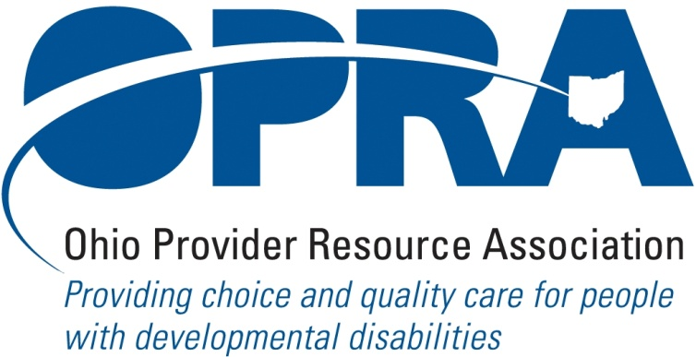

OPRA BOARD AGENDA

Wednesday, December 15, 2010
10:00AM – 2:00PM
1152 Goodale Blvd, Columbus, OH 43212

Convene Meeting Chair: Than Johnson
**Please turn off cell phones or place on vibrate.
- Minutes
- Finance Committee
- Reimbursement and Direct Support Professional Wages Strategic Focus Area
  - Direct Support Professional Wages, Benefits, Training And Supervision
  - Waiver Reimbursement Update
    - CPT training
    - Waiver reimbursement pilot
    - Franchise permit fee
  - IAF Modernization
- Simplification and Efficiencies Strategic Focus Area
  - Adult Day Services Training Requirements
  - SSA and Program Management Functions Grant
  - Licensure Process
  - Med Admin/DN issues
  - Member Services
- Waiting List Strategic Focus Area
- Unmet and Emerging Needs Strategic Focus Area
  - SELF Waiver
- State Budget and Legislative Update
  - November Revenue Report
- Rules Summary
- New Waiver Services
- Federal Issues
- Strategic Plan 2011 – 2012
- Policy issues for new administration
- Other Items
- Schedule:

Board Meeting – Wednesday, January 20th

Policy Committee Meeting – TUESDAY, January 19th
- HR Committee Meeting – Tuesday, January 12th
- IT Work Group Meeting at OPRA – Wednesday, January 13th
- Program Directors Committee Meeting – Thursday, January 14th

OPRA 2011 Spring Conference, Embassy Suites Hotel, March 29 – 30, 2011
- OPRA Committee Meetings (see OPRA Calendar under Events at www.opra.org)

