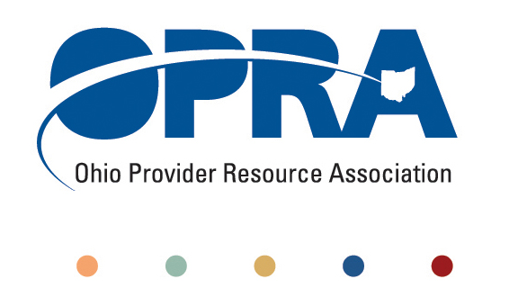

OPRA BOARD AGENDA

Wednesday, August 24, 2011
10:00AM – 2:00PM
1152 Goodale Blvd, Columbus, OH 43212

Convene Meeting Chair: Than Johnson

**Please turn off cell phones or place on vibrate.

- Finance Committee
- Review Minutes
- State budget and Legislative Update
  - July Revenue Report
  - HB 153 - Ohio Budget
- OPRA Strategic Plan
- Efficiencies and Simplification Strategic Focus Area
  - 3% Utilization Reduction
  - Adult Day Services Training Requirements
  - SSA and Program Management Functions Grant
  - Deeming
  - FPF in DD HCBS waivers
  - Quality Assurance and Nursing Quality Assurance Reviews
- Reimbursement and Direct Support Professional Wages Strategic Focus Area
  - Direct Support Professional Wages, Benefits, Training And Supervision
  - 2011 Compensation, Benefits and Turnover Survey Summary of Findings
  - Waiver Reimbursement Update
    - Waiver pilot and efficiency dividends
  - IAF Modernization, ICF Formulary and Outliers
- Waiting List and Unmet Needs Strategic Focus Area
- SELF Waiver
- Membership/Member Services Strategic Focus Area
  - DC Downsizing/District Meetings
- Rules Summary
- Federal Issues
- Board Retreat
- CMS/State/County/Provider Region V Summit
- DSP Week Resolution
- Other Items
- Schedule:

OPRA Board Meeting – September 28th

Next Policy Committee Meeting – Monday, September 19th
- Program Directors Committee Meeting – Thursday, September 8th
- New Waiver Services Trainings – 10AM-3PM
  - August 30 - St Joseph Home of Cincinnati
- OPRA/PAC Golf Outing – Madison Country Club – August 29th
- Positive Culture Initiative Trainings (August – September)
  - Tuesday, September 6
Rose-Mary Center - gymnasium
  - Friday, September 9
OPRA Training Center
  - Wednesday, September 14
St. Joseph Home - Seaton Hall
  - Wednesday, September 21
URS (United Rehabilitation Services)
  - Tuesday, September 27
Havar, Inc. - Wayne National Forest Welcome Center
  - Thursday, September 29
Filling Home of Mercy Chapel
- Coleman Institute and ANCOR Technology Summit – October 12 – 14th (www.colemaninstitute.org)

OPRA 2011 Fall Conference, Embassy Suites Hotel, October 25th - 26th
- Ethics Law Training, December 7th
- OPRA Committee Meetings (see OPRA Calendar under Events at www.opra.org)

