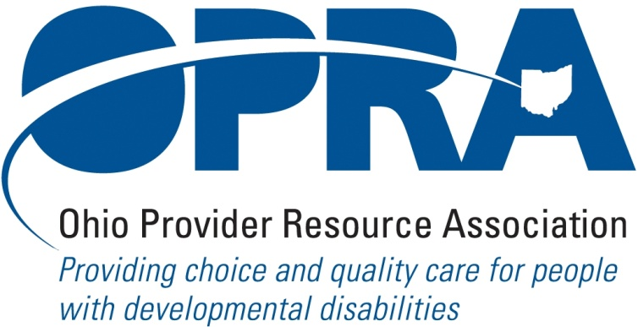

OPRA BOARD AGENDA

Wednesday, July 28, 2010
10:00AM – 2:00PM

There is construction along Route 315 that has closed some ramps. Go to: http://www.pavingtheway.org/sr-315/ for additional information.

- Convene Meeting Chair: Than Johnson
**Please turn off cell phones or place on vibrate.
- Finance Committee
- Review of Minutes
- Strategic Plan for 2010 – 2012
- IO Waiver Review Findings Response
- Reimbursement and Direct Support Professional Wages Strategic Focus Area
  - Direct Support Professional Wages, Benefits, Training and Supervision
  - Waiver Reimbursement Update
    - New Waiver Services
    - CPT Implementation
    - OSOC
  - IAF Modernization
- Waiting List Strategic Focus Area
- Unmet and Emerging Needs Strategic Focus Area
  - Flexible Supports Waiver
- State Budget and Legislative Update
  - June State Revenue Report
  - Legislative Recess – Contact with Local Legislators
  - State Budget Commission
- Rules Summary
  - ICF/MR FPF Rules
  - Rules On Access to Information by State Personnel
- Federal Issues
  - E-FMAP Extension
- District Meetings
- Simplification and Efficiencies Strategic Focus Area
  - Adult Day Services Training Requirements
  - SSA and program Management Grant
  - Member Services
    - Health Insurance
    - Provider Selection Web Site
    - Vacancy Registry
  - Licensure Process
  - Solana Updated Partner Agreement
  - CBIZ Partner Payroll Agreement
  - OPRA Tag Line
- Miscellaneous
- Schedule
- August 12, 2010 - Program Directors Comm Meeting – Columbus, Ohio – OPRA Office

August 16, 2010 - Policy Committee Meeting – Columbus, Ohio – OPRA Office

August 25, 2010 - Board Meeting – Columbus, Ohio – OPRA Office
- District Meetings
  - August 20, 2010 – District 4 Meeting – Maumee, Ohio - Sunshine Spiritual Life Center
  - August 24, 2010 – District 3 Meeting – Cambridge, Ohio - WorkPro
  - August 26, 2010 – District 1 Meeting – Sharronville - St. Joseph Home

Sept. 29, 2010 - NE OH OPRA PAC Golf Outing – Ravenna, OH -Windmill Lakes Golf Club

October 19–20, 2010 - OPRA 2010 Fall Conference – Dublin, Ohio - Embassy Suites Hotel

Behavior Support Trainings (Bob Bowen)

August 27, 2010 - Brecksville, Ohio - Brecksville Community Center

August 30, 2010 - Columbus, Ohio - OPRA Office

September 1, 2010 - Cincinnati, Ohio - St Josephs Home

September 8, 2010 - Toledo, Ohio - Anne Grady Center
- Positive Culture Initiative Training for Providers
  - August 19, 2010 - Cambridge, Ohio - WorkPro
  - September 16, 2010 - Columbus, Ohio - OPRA
  - September 17, 2010 - Maumee, Ohio – Sunshine Inc. of NW Ohio
  - September 24, 2010 - Cincinnati, Ohio - RHC
- OPRA Committee Meetings (see OPRA Calendar under Events at www.opra.org)

