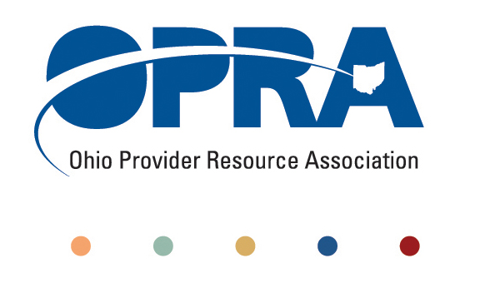
OPRA BOARD AGENDA

Wednesday, January 26, 2011
10:00AM – 2:00PM
1152 Goodale Blvd, Columbus, OH 43212

Convene Meeting Chair: Than Johnson
**Please turn off cell phones or place on vibrate.
- Minutes
- Finance Committee
- Simplification and Efficiencies Strategic Focus Area
  - Adult Day Services Training Requirements
  - SSA and Program Management Functions Grant
  - Med Admin/DN issues
  - Member Services
  - Deeming
- Reimbursement and Direct Support Professional Wages Strategic Focus Area
  - Direct Support Professional Wages, Benefits, Training And Supervision
    - 2011 Compensation, Benefits and Turnover Survey
  - Waiver Reimbursement Update
    - New waiver services
    - CPT training
  - IAF Modernization
- Waiting List Strategic Focus Area
- Unmet and Emerging Needs Strategic Focus Area
  - SELF Waiver
- State budget and Legislative Update
  - December Revenue Report
  - Budget Coalitions
  - Government transition
    - House committee appointments
    - New legislation
- Rules Summary
- Federal Issues
- OPRA Committees
- Federal Issues
- Strategic Plan 2011 – 2012
- OPRA Governance and Code of Regulations
- Other Items
- Schedule:

OPRA Board Meeting – Wednesday, February 23, 2011

Next Policy Committee Meeting – TUESDAY, February 15, 2011
- Program Directors Committee Meeting – Thursday, February 10, 2011

Ethics Law for the DD, Mental Health & Healthcare Professional - OPRA – February 16, 2011

OPRA 2011 Spring Conference, Embassy Suites Hotel, March 29 – 30, 2011
- OPRA Committee Meetings (see OPRA Calendar under Events at www.opra.org)

