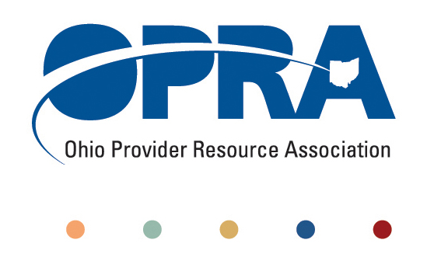
OPRA BOARD AGENDA

Wednesday, February 23, 2011
10:00AM – 2:00PM
1152 Goodale Blvd, Columbus, OH 43212

Convene Meeting Chair: Than Johnson
**Please turn off cell phones or place on vibrate.
- Minutes
- Finance Committee
- Simplification and Efficiencies Strategic Focus Area
  - Adult Day Services Training Requirements
  - SSA and Program Management Functions Grant
  - Member Services
  - Deeming
- Reimbursement and Direct Support Professional Wages Strategic Focus Area
  - Direct Support Professional Wages, Benefits, Training And Supervision
    - 2011 Compensation, Benefits and Turnover Survey
  - Waiver Reimbursement Update
    - New waiver services
  - IAF Modernization
- Waiting List Strategic Focus Area
- Unmet and Emerging Needs Strategic Focus Area
  - SELF Waiver
- State budget and Legislative Update
  - January Revenue Report
  - OPRA Proposed Budget Language
    - DODD
    - ODJFS
  - Legislation
- Rules Summary
- Federal Issues
- Strategic Plan 2011 – 2012
- OPRA Governance and Code of Regulations
- Affirmative Action Program
- Director John Martin to join meeting at 12:30pm
- Other Items
- Schedule:

OPRA Board Meeting – AT THE EMBASSY SUITES DUBLIN, TUESDAY Tuesday, March 29, 2011

Next Policy Committee Meeting – Monday, March 21, 2011
- Program Directors Committee Meeting – Thursday, March 10, 2011

OPRA 2011 Spring Conference, Embassy Suites Hotel, March 29 – 30, 2011
- OPRA Committee Meetings (see OPRA Calendar under Events at www.opra.org)

