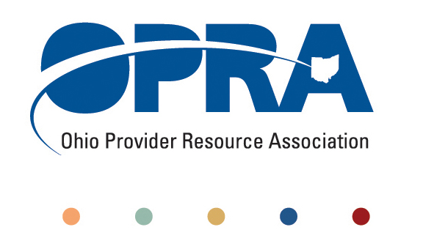

OPRA BOARD AGENDA

Wednesday, July 27, 2011
10:00AM – 2:00PM
1152 Goodale Blvd, Columbus, OH 43212

Convene Meeting Chair: Than Johnson

**Please turn off cell phones or place on vibrate.

- Finance Committee
- Review Minutes
- State budget and Legislative Update
  - June Revenue Report
  - HB 153 - Ohio Budget
- OPRA Strategic Plan
- Efficiencies and Simplification Strategic Focus Area
  - 3% Utilization Reduction
  - Adult Day Services Training Requirements
  - SSA and Program Management Functions Grant
  - Deeming
  - FPF in DD HCBS waivers
  - Quality Assurance and Nursing Quality Assurance Reviews
- Reimbursement and Direct Support Professional Wages Strategic Focus Area
  - Direct Support Professional Wages, Benefits, Training And Supervision
  - 2011 Compensation, Benefits and Turnover Survey Summary of Findings
  - Waiver Reimbursement Update
    - Waiver pilot and efficiency dividends
  - IAF Modernization, ICF Formulary and Outliers
- Waiting List and Unmet Needs Strategic Focus Area
- SELF Waiver
- Membership/Member Services Strategic Focus Area
  - DC Downsizing/District Meetings
- Rules Summary
- Federal Issues
  - Medicaid
- Board Web Page
- Other Items
- Schedule:

OPRA Board Meeting – August 24th

Next Policy Committee Meeting – Monday, September 19th
- Program Directors Committee Meeting – Thursday, August 11th
- New Waiver Services Trainings – 10AM-3PM
  - July 26 - United Cerebral Palsy of Greater Cleveland
  - August 11 – Ford Training Center Lima, OH
  - August 16 – Athens County Board of DD
  - August 30 - St Joseph Home of Cincinnati
- OPRA/PAC Golf Outing – Madison Country Club – August 29th
- Coleman Institute and ANCOR Technology Summit – October 12 – 14th (www.colemaninstitute.org)

OPRA 2011 Fall Conference, Embassy Suites Hotel, October 25th - 26th
- Ethics Law Training, December 7th
- OPRA Committee Meetings (see OPRA Calendar under Events at www.opra.org)

