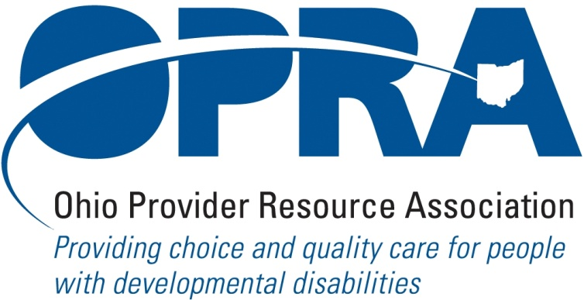

OPRA BOARD AGENDA

Wednesday, November 17, 2010
10:00AM – 2:00PM
1152 Goodale Blvd, Columbus, OH 43212

Convene Meeting Chair: Than Johnson
**Please turn off cell phones or place on vibrate.
- Finance Committee
  - OPRA Budget
- State Budget and Legislative Update
  - Election Results
  - October Revenue Report
  - Grass Roots – contact with local legislators
  - Agency budget submitted in November
  - Policy issues for new administration
- Reimbursement and Direct Support Professional Wages Strategic Focus Area
  - Direct Support Professional Wages, Benefits, Training And Supervision
  - Waiver Reimbursement Update
    - CPT training
  - IAF Modernization
- Simplification and Efficiencies Strategic Focus Area
  - Adult Day Services Training Requirements
  - SSA and Program Management Functions Grant
  - Licensure Process
  - Med Admin/DN issues
  - Member Services
  - Deeming
- Waiting List Strategic Focus Area
  - Waiting List Changes Resulting from SELF Waiver
- Unmet and Emerging Needs Strategic Focus Area
  - SELF Waiver
- Rules Summary
- Federal Issues
- Strategic Plan 2011 - 2012
- Other Items
- Schedule:

Next Board Meeting – Wednesday, December 15th

Next Policy Committee Meeting – Monday, December 13th
- Program Directors Committee Meeting – WEDNESDAY, December 9th

OPRA 2011 Spring Conference, Embassy Suites Hotel, March 29 – 30, 2011
- Ethics Law for the DD, Mental Health and Health Care Professional, November 22nd
- OPRA Committee Meetings (see OPRA Calendar under Events at www.opra.org

