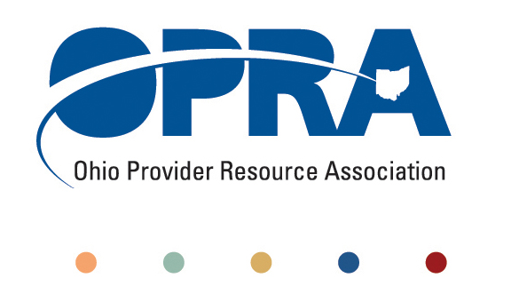

OPRA BOARD AGENDA

Wednesday, June 22, 2011
10:00AM – 2:00PM
1152 Goodale Blvd, Columbus, OH 43212

Convene Meeting Chair: Than Johnson

**Please turn off cell phones or place on vibrate.

- Finance Committee
- Review Minutes
- State budget and Legislative Update
  - May Revenue Report
  - HB 153 - Ohio Budget
- OPRA Strategic Plan Committees
- Efficiencies and Simplification Strategic Focus Area
  - 3% Utilization Reduction
  - Adult Day Services Training Requirements
  - SSA and Program Management Functions Grant
  - DODD money management recommendations
  - Deeming
  - FPF in DD HCBS waivers
  - Quality Assurance
  - Nursing Quality Assurance Reviews
- Reimbursement and Direct Support Professional Wages Strategic Focus Area
  - Direct Support Professional Wages, Benefits, Training And Supervision
    - 2011 Compensation, Benefits and Turnover Survey
  - Waiver Reimbursement Update
    - New waiver services and training
    - Waiver pilot and efficiency dividends
  - IAF Modernization, ICF Formulary and Outliers
- Waiting List and Unmet Needs Strategic Focus Area
  - SELF Waiver
- Membership/Member Services Strategic Focus Area
  - DC Downsizing/District Meetings
  - OPRA Connect
- Rules Summary
- Federal Issues
  - HCBS Waiver CMS NPRM comments – See June 15th news article on OPRA homepage
  - Medicaid
- Other Items
- Schedule:

OPRA Board Meeting – July 27th

Next Policy Committee Meeting – Monday, July 11th
- Program Directors Committee Meeting – Thursday, July 14th
- New Waiver Services Trainings – 10AM-3PM
  - July 21 – Rehabilitation Services Commission
  - July 26 - United Cerebral Palsy of Greater Cleveland
  - August 11 – Ford Training Center Lima, OH
  - August 16 – Athens County Board of DD (tentative)
  - August 30 - St Joseph Home of Cincinnati

- OPRA Committee Meetings (see OPRA Calendar under Events at www.opra.org)

