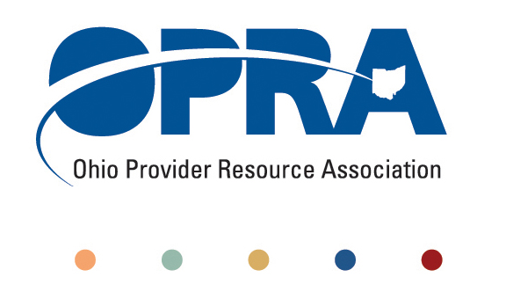
OPRA BOARD AGENDA

Wednesday, April 27, 2011
10:00AM – 2:00PM
1152 Goodale Blvd, Columbus, OH 43212

Convene Meeting Chair: Than Johnson
**Please turn off cell phones or place on vibrate.
- Minutes
- Finance Committee
- Review Minutes
- State budget and Legislative Update
  - March Revenue Report
  - HB 153 - Ohio Budget
    - Status of HB 153
    - OPRA Testimony
- OPRA Strategic Plan Committees
- Efficiencies and Simplification Strategic Focus Area
  - Adult Day Services Training Requirements
  - SSA and Program Management Functions Grant
  - Member Services
  - Deeming
  - FPF in DD HCBS waivers
  - Quality Assurance
  - Nursing Quality Assurance Reviews
- Reimbursement and Direct Support Professional Wages Strategic Focus Area
  - Direct Support Professional Wages, Benefits, Training And Supervision
    - 2011 Compensation, Benefits and Turnover Survey
  - Waiver Reimbursement Update
    - New waiver services
    - Waiver pilot and efficiency dividends
    - Remote Monitoring Assessment
  - IAF Modernization, ICF Formulary and Outliers
- Waiting List and Unmet Needs Strategic Focus Area
  - SELF Waiver
- Membership/Member Services Strategic Focus Area
  - Status of Membership Renewals and List Serve Purging
  - OPRA Connect
- Rules Summary
- Federal Issues
- Other Items
- Schedule:

OPRA Board Meeting – May 25th

Next Policy Committee Meeting – Monday, May 16th (Special Guest, REM Ohio)
- Program Directors Committee Meeting – Thursday, May 12th
- OPRA PAC Golf Outing, Urbana Country Club May 24th (day before May OPRA Board meeting)
- OPRA Committee Meetings (see OPRA Calendar under Events at www.opra.org)

