Community Connections Career Partnership - Ohio

Volume 2, Issue 3 June, 2017pril, 2017

C3P(O) Graduation Ceremonies

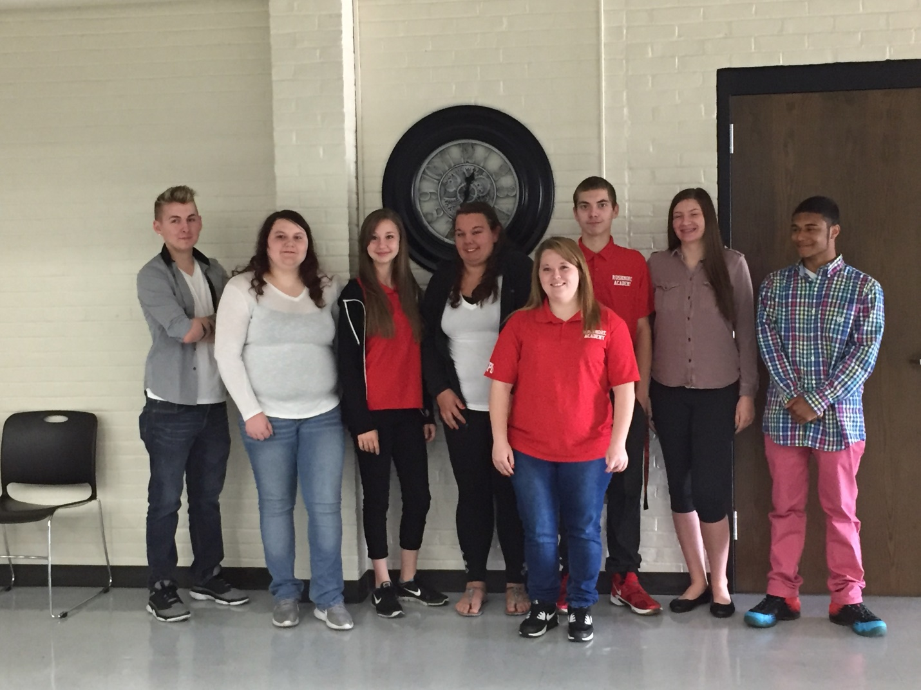

On May 9, these students from Rushmore Academy and Harding High School received their DSPaths certifications during a graduation ceremony at Rushmore Academy. Pictured, from left to right are: Brandon Meade (CIP), Kassidy Friley (CIP), Breanna Keeton (CIP), Brianna Millisor (Basic), Ciera Mullins (CIP), Clay Christian (CIP), Hannah Kennedy (CIP), and Brandon Ball (CIP).

**What these students had to say about their experience:**

Brandon Ball – *“Working here and being around everyone makes me feel like I can do anything I put my mind to as long as I try and I’m so proud to say I work at RHAM.”*

Clay Christian – *“My strengths and abilities are that I’m able to take time with the clients to get done what needs to be done and make sure they are in their best health. I’m also very good with my co-workers…”*

Kassidy Friley – *“I have chosen to work in human services because I enjoy helping other people, especially those in need. I enjoy teaching people new things and even learning new things from them.”*

Breanna Keeton – *“My strengths and abilities in human services are I am very caring and thoughtful of others. I am usually able to make individuals feel better when they are down or having a bad day.”*

Hannah Kennedy – *“My strengths are that I am a very positive person and it makes other people’s outlook on things positive as well…I never give up on people.”*

Brandon Meade – *“I have chosen to work in Human Services because I love to help people.”*

Ciera Mullins – *“My strengths and abilities in human services are that I’m caring and patient. I can help people if they have a problem…I can help them get out more and do more activities.”*

Brianna Millisor – *“My career goal in human services is to become a Direct Support Professional or a home health nurse.”*

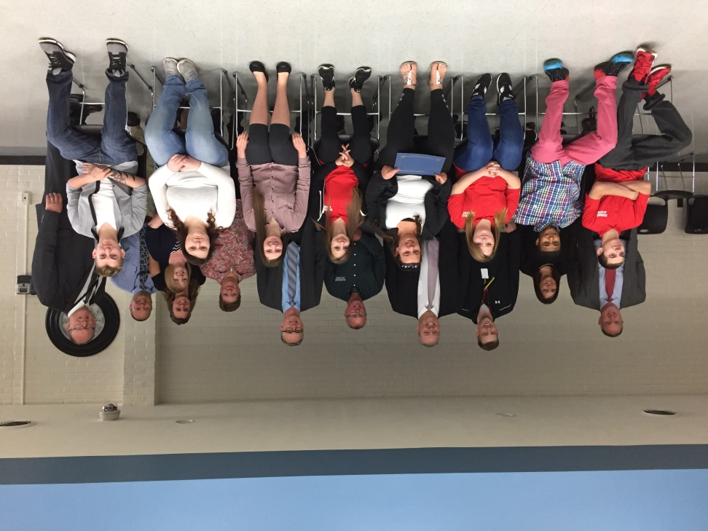

A special thank you to all of the people involved, including those at Rushmore Academy, Harding High School, and RHAM.

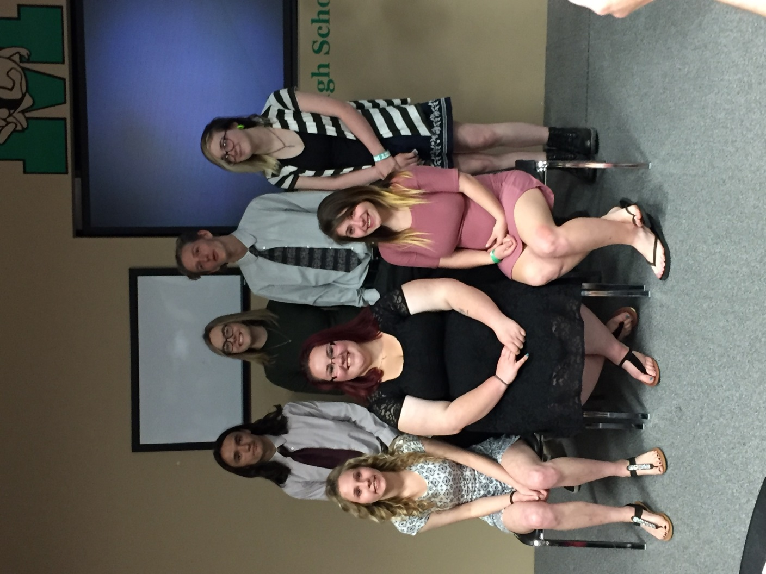

On May 11, these seven students received their Certificate of Initial Proficiency during a ceremony at Medina High School. Front row: Ellie Yuschak, Summer Miller and Tori Rogers. Back row: Joey Lyon, Ariell Kent, Charles Mains and Trisha Ritterbeck.

**What they had to say about their experience:**

Arielle Kent – *“Working in this program changed a lot of things for me including my attendance and even with proving to myself* *that I can do something if I set my mind to it…”*

Joey Lyon – *“In a half year to a year, I would love to see myself as a DSP who has the ability to become something more. Two to five years from now I would want to see the smiles of the clients I aid. At the end of five years, I want to be able to say I made an impact at TLC…”*

Charles Mains – *“One of my strengths in human services is that I am always willing to learn more about the disabilities or the field in general…I could go to the advanced level of C3P(O) and get my CAP and then stay dedicated to my work and just think about all of the positive things I’m getting out of this program and all the good it is doing for me…”*

Summer Miller – *“In a year from now, I could possibly see myself working somewhere in this field. Eventually, I would like to go to school to become a Social Worker…”*

Trisha Ritterbeck – *“I have many strengths that help me be a better DSP and employee: Punctual, compassionate, determined, enthusiastic, thoughtful. I want to go to college and further my education, either in art or medicine.”*

Tori Rogers – *“My career goal is to go to college for Child and Family Development, but still be working as a DSP throughout college and after I graduate college, I would like to be a QIDP because I like hearing about the goals the individual have and I would love to help them achieve those goals.*

Ellie Yuschak – *“I knew a really long time ago that I wanted to work with special needs people. And this program gave me such an amazing opportunity to do that and make me realize what I really want to do. I feel this program was meant for me.”*

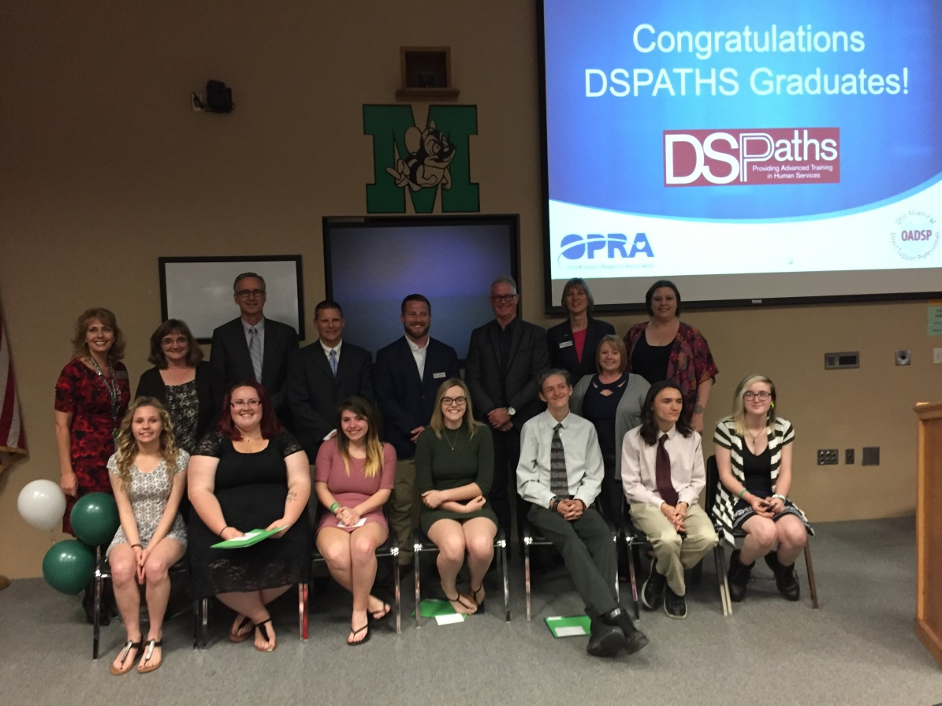

Special thanks to all those involved: Medina High School, Medina County Board of DD, SHC/The Arc of Medina County, Self-Determined Living and TLC.

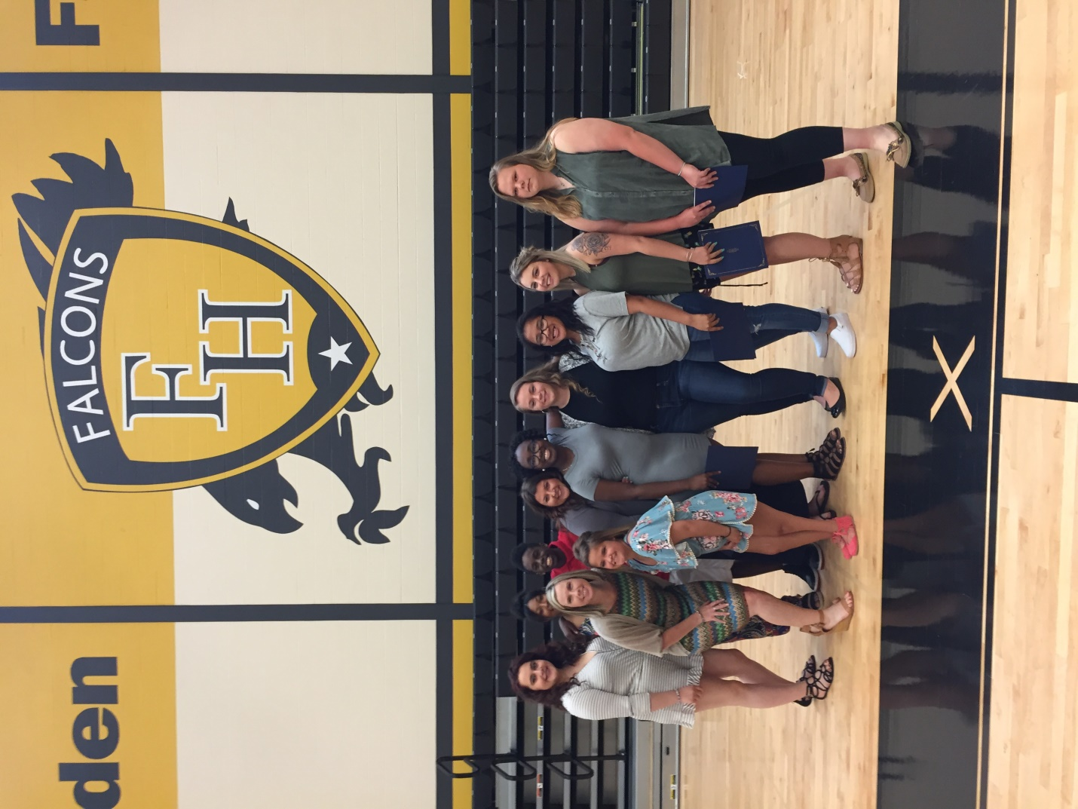

On May 18, this group of Juniors received their Certificate of Initial Proficiency at a ceremony at Franklin Heights High School. Shown, along with their instructor Katrina Sacay, are Kyla Blissett, Emily Foreman, Harley Gray, Morgan Halter, Nathena Po, Elizabeth Priddy, Aurora Smith, Santana Sowards, Taylor Speakman and Harvey Turner. Not shown are: Nate Henderson and Trent Wilkins.

**What these students had to say about their experience:**

Kyla Blissett – *“This whole experience was wonderful. I didn’t think I was going to like it or even get attached to the individuals at the site, but I did since the very first day because they were so outgoing.”*

Emily Foreman – *“The work sample that I am most proud of would have to be the Supporting Health and Wellness. Not only does this project help my resident with his hygiene, it teaches him independence, teaches him how to do things himself and to help himself with brushing his teeth.”*

Harley Gray - *“These people deserve everything and I will try to make them have the most exciting experience while I am here. I want to show them new things that they can keep doing even when I a gone, so that they will remember me forever, because I will remember them forever.”*

Morgan Halter – *“I learned that if you work with someone on a goal consistently, it will eventually be something that works. I also learned you should have a lot of patience and make sure everyone knows what goals you are working towards so they can help support them, too.”*

Nate Henderson – *“I feel like this program has challenged me this year and better prepared me for challenges I may face when I begin college. I enjoy having goals that I work towards to achieve and I feel this will be a good way to approach obstacles in the future.”*

Nathena Po – *“My strengths and abilities in human services are my drive to help others. I am good at solving problems and listening to others and their concerns. I’m outgoing and I like to experience new things that come into my life.”*

Elizabeth Priddy – *“I have chosen to work in human services because throughout the years I have been in and out of hospitals so, for me, I want to work in this field so that I’m able to give back the help that I’ve gotten and more.”*

Aurora Smith – *“When I first started this program I didn’t take it seriously but now I’ve learned to love it. I like the place that I’m at, the people are very helpful and informational. This program made me appreciate life and look at it from a different point of view.”*

Santana Sowards – ***“****My career goal in Human Services is to make an impact on someone’s life. I don’t want to just take care of someone to get money, I want to help them and change their life for the better.”*

Taylor Speakman – *“I enjoy going to CCHS to work with my individual. I learn something new every day. Every time I see G, she puts a smile on my face. We work on G painting, we take a walk, and I sit with her while she eats lunch. Working with people with DD has made an impact on me.”*

Harvey Turner – *“I have chosen to do this line of work because I feel that people with disabilities don’t get enough care and they were treated badly back when they were in asylums. I feel that it’s my job now to care and treat them like real and regular people because that’s who they are!”*

Trent Wilkins – *“My goals in human services is to learn anything and everything about people with disabilities. In two years, I see myself working in this field and in five years I plan to be completing college and looking for a teaching job. I am most proud of the communication goal because I learned that I like to teach people.*

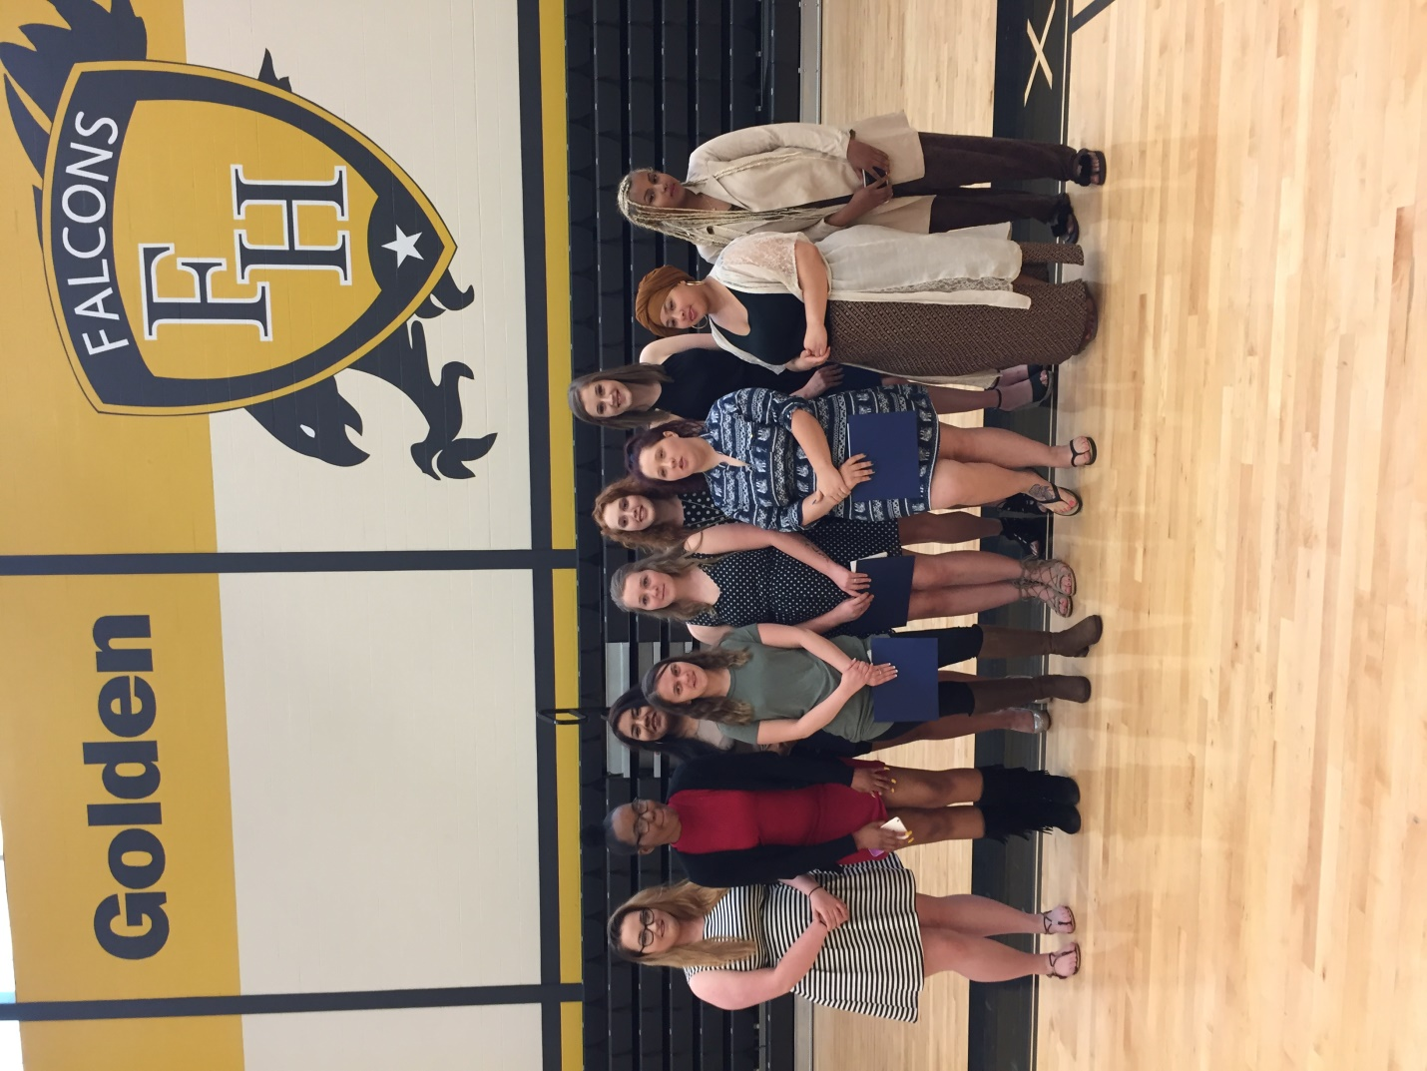

These ten Seniors made history again when they became the first class ever to receive both the CIP and CAP credentials when they were presented their Certificate of Advanced Proficiency at the award ceremony at Franklin Heights High School on May 18. Pictured from left to right are: Raine Gray, Diamond Frazier, Destiny Reyes, McKenzie Naguit, Anjewel Wood, Corinne Johnson, Kelsey Goodman, Victoria Weldin, Chabeley Arismendy, and Hyat Hussan.

**This is what they had to say about their experience in C3P(O):**

Chabeley Arismendy – *“These past two years I have grown so much, I am truly grateful that I have been given the opportunity to participate in this program. Not only did I learn how to properly give people with disabilities a full life, but I learned a different kind of respect for others.”*

Diamond Frazier – *“My work sample, Participant Empowerment, taught me that individuals with disabilities are capable of doing much more than people think. People underestimate people with DD and don’t think they’re capable of doing a lot, which isn’t true at all.”*

Kelsey Goodman – *“It was a long journey to get where I am now in the program but was all so worth it. We got to meet new people and some of the most amazing people. They said that once they get in your heart they will never leave and that is beyond the truth.”*

Raine Gray – *“during my time with TL, I would say everything went very well and I’m happy that he’s happy and proud of the work he has made. He taught me a lot about healing stones and how they are supposed to help you. It’s interesting to learn about all of the gens that go into his jewelry.”*

Hyat Hussan – “*I loved working with C. He taught me important lessons that I now take with me in my day to day life. If I ever feel like giving up, I remember how I prompted C to never give up. I am very proud of C and all we accomplished together.”*

Corinne Johnson – *“In my Building and Maintaining Friendships and Relationships work sample, I learned that anxiety and trust issues are a very real thing. Anxiety makes it harder for my individual to talk to people and build friendships or relationships. I helped this individual find ways to interact with other people for him to make friends.”*

McKenzie Naguit – *“I had an excellent experience with T. She had made such an improvement from the time I met her till right now in the present. To watch her grown and communicate through her communication box while we went for out walks was very amazing and a great experience.”*

Destiny Reyes – *“Working with A was a true joy, as he was always ready to go – waiting for me. He enjoyed the one on one time to work on his goals. I hope he continues to grow and participates in the job coaching program this fall as I know he will do great things.”*

Victoria Weldin – *“Working on this portfolio has taught me to be creative and how to organize things successfully and ensure all individuals have fun with what we are doing.”*

Anjewel Wood – *“Over the past two years, I have had a lot of fun in the DSPATHS program. I have had the opportunity to visit and have hands on experience at several different facilities. I feel that through this program I have grown as a person. I also think that going through this program has opened my eyes to a whole new career path and I plan to seek employment in the field of Developmental Disabilities.”*

**

Graduation Speech Given by Senior and CAP Recipient, Victoria Weldin – Franklin Heights High School

*“Let me start off by saying this was a great opportunity for all of us. We started off in a sticky situation and washed it away with success. We may have had tiring days and battled with motivation. But day in and day out we learned something valuable. We became generous, motivated, honest, cooperative, creative, energetic, empathetic, resourceful, learned to be a member of a team and most of all, we built a family. Through the ups and downs we were a helping hand to one another and we were making a difference and imprinting ourselves on each other, our coworkers and the individual’s lives. I can voice for everyone in this room – you have impacted us. We are so thankful for this amazing experience. Lastly, let’s give a shout out to all of our mentors, teachers and organizations. You’ve helped us better ourselves and helped us better others. Thank you!”*

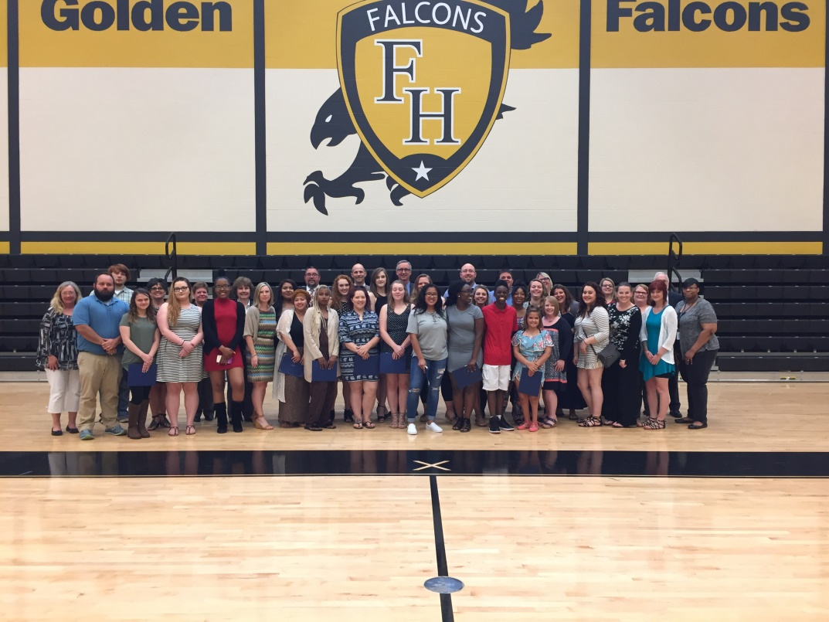

A special thank you to everyone involved: South-Western City School District, Franklin Heights High School, Heinzerling Foundation, ViaQuest, Columbus Center for Human Services (CCHS) and Boundless.

