**OPRA Policy Committee Meeting Notes**

**March 20th, 2017**

**10a-2pm**

**OPRA Offices-Goodale Blvd.**

Those in attendance: Refer to the signature sheet

1. **Introductions of all in attendance and those on-line or via phone**
2. **POWERPOINT-OUTLINE OF MEETING (REFER TO ATTACHED)**
3. **Task grid update from last meeting:**

|  |  |  |  |  |
| --- | --- | --- | --- | --- |
| # |  | Person(s)  responsible | Target Date |  |
| P1 | Provide information to members regarding Building Code changes and updates | OPRA | 2/15/17 | Discussions still going on- OPRA to send update |
| P2 | Resend MUI correspondence from Scott Phillips regarding strategies for returning staff to shift during investigation, etc. | OPRA | 2/1/17 | Completed |
| P3 | Invite Teresa back to discuss Autism work DODD | Jeff |  |  |
| P4 | Send email reminding Teresa K. to send to OPRA for distribution:  -list of Dual Diagnosis Treatment Team resources/contacts and info on second assessments  -Handouts from meeting via email  -Autism OCALI training information  -Trauma Informed Care trainers-training resources  -NCI Staff Stability survey results baseline survey  -Trauma Summit information | Becky  OPRA to distribute to members when received | 1/21/17 | Completed |
| P5 | MUI workgroup set up-Rules work group | OPRA and members who indicated they wanted to be involved | Met  2/13/17 | Committee met- follow up scheduled- see OACB and OPRA priorities |
| P6 | Send any certification issues/ information to Jeff so that it can be compiled for discussion with legislatures/DODD. | All members | ongoing | Completed |
| P7 | DSP WORKFORCE AWARENESS-send in responses to OPRA by Fri | All members | 1/25/17 | Completed |
| P8 | OPRA to distribute info to members regarding Project STIR | OPRA | 2/1/17 | Completed |

1. **EFFICIENCY AND SIMPLIFICATION-OPRA/OACB**

**REFER TO SLIDE ON NEXT PAGE (FOR LISTING OF THE PRIORITIES)**

* Joint Letter was sent to Director regarding the imperative need for efficiency and simplification of our complex system. OACB met with their members to identify priorities. In addition, the OPRA Rules group survey determined top three priorities for efficiency and simplification.
* Response received from Director asking for meeting and true priorities to identified.
* OPRA and OACB agree this is not lip service (waste time talking). We want to lead the discussion towards simplification and efficiency---true, honest discussions on realities/expectations and outcomes.

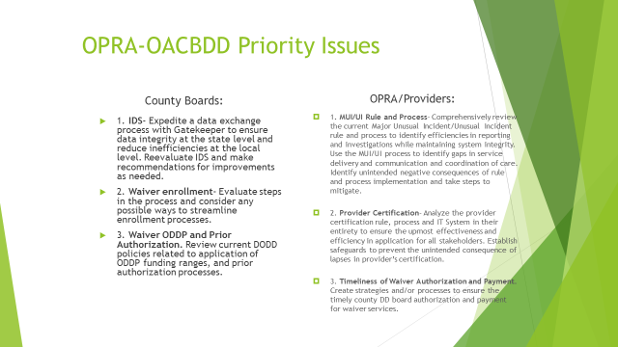

* Members recommended that we include “Accuracy” in #3 of OPRA priorities. (include that we are supposed to be agreeing to schedules prior to authorization, notify providers of any changes with new agreement, retrospectively adjusting CPT without provider knowledge resulting in rebilling and losing money after 365 days, incorrect authorizations, issues with prior authorizations, audit protocol, etc…)
* Discussion regarding no governing standard business rules regarding ISP and CPT.
* Meeting is scheduled with Director and DODD in first week of April.

1. **MUI/UI Recommendations regarding Rule and process**

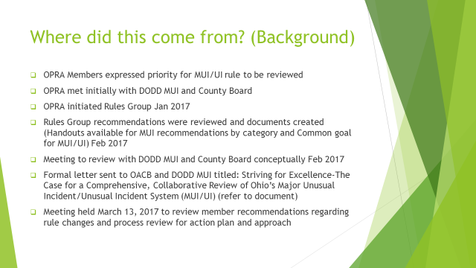

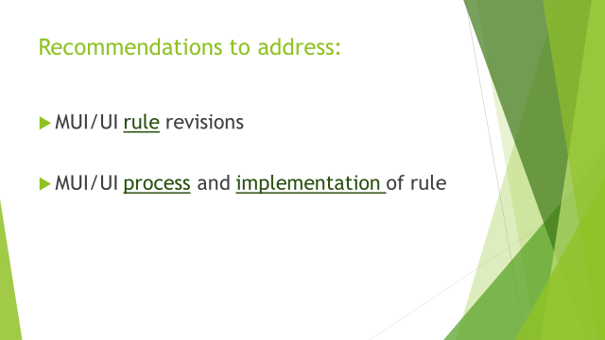

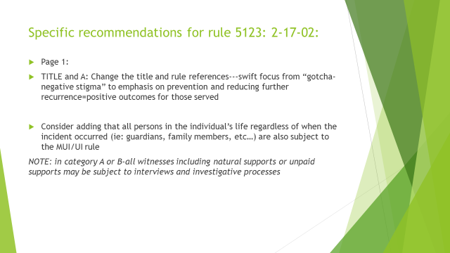

Committee feedback/discussion:

* Unanimous agreement that the title and rule references should be changed to place emphasis on prevention and recurrence (less on gotcha!); recommendation to change wording in purpose from requirements to process ; recommendation to replace words like investigation and investigator with something related to the purpose-recommendations for words: quality improvement, safety measures, opportunity for improvement and growth
* Mixed thoughts on the recommendation to include all family-guardian-NF-hospitals etc…in rule. Much discussion on if this is even possible; how will this be perceived by families and others?; does this hinder relationships with DSPs and families, etc… Also, some provider representatives felt this was very important as it seems to say that the DSPs are held to a different standard and promotes the gotcha culture. In addition, some providers said that the occurrences were at families home and then provider held responsible for return bruise, etc…
* All agreed that the hospital coordination must be addressed and was later discussed in subjects below.

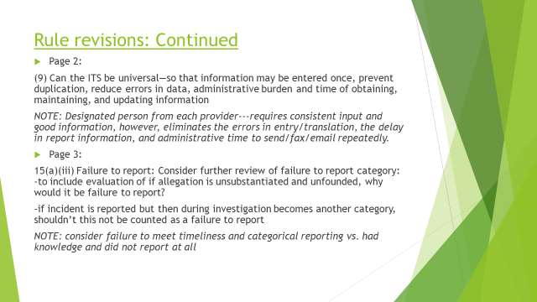

**Committee feedback/discussion:**

* Great discussion on the ITS entry system being universal with provider having ability to enter the initial report. It would be imperative that this be developed with stakeholder input to promore consistency, accuracy and simplification.; needs to have time stamp and log who is entering from County, provider, State; can it include Medicaid access?; could eliminate administrative time of communication issues, errors, delays with so many involved in duplicate information and semi-annual and annual reporting. Need to be mindful of those who have already set up electronic incident systems; Focus on the purpose of this is to reduce admin time/ costs to redirect towards DSPs initiatives and to promote efficient, accurate data.
* **Failure to report** (has also become a catch-all category-with it being said if I can’t prove this-I will get you for failure to report); agreement that this needs to be addressed and that we need to address timeliness and categorical issues separately from knowing and failing to report. NEED FURTHER CLARIFICATION ON VERBAL ACTS vs. VERBAL ABUSE PEER TO PEER as these seem to be interpreted differently and have resulted in failure to report pattern.

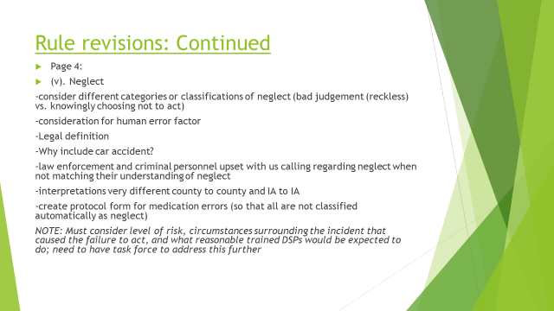

**Committee feedback/discussion:**

* The committee felt that this category is a priority to address and that taskforce is needed.
* The group overwhelmingly feel that there must be recognition of a true evaluation of risk for harm and actual injury; the human error factor of a reasonable, trained DSP; and bad judgement vs. knowingly choosing not to act. Rule too broad—wording ANY suggests that catch-all category-is there a way to clarify?
* Families have also expressed that when providers have neglect MUIs that the providers are giving notice based on these-causing more issues with the provider pool
* Can we have Med error protocol to prohibit every single med issue being neglect?
* Committee wanted to see if we could get data on number of neglects; number on abuser registry due to neglect; and how many are actually criminal neglect cases.

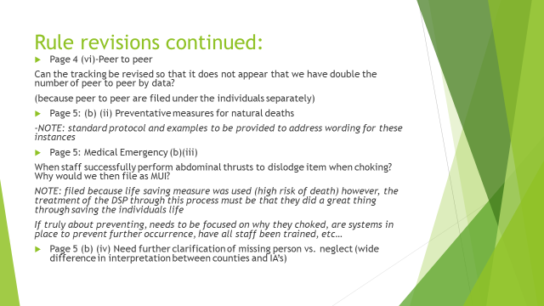

**Committee feedback/discussion:**

* Peer to peer verbal acts vs. verbal abuse needs further clarification-being interpreted very differently between all entities
* Can DODD provide visuals to train-role modeling etc…so that staff can be trained uniformally with visual examples vs. just reading on paper?
* All agreed that providing standard protocols and wording for natural deaths would be helpful
* All agreed that staff performing life saving measures should receive praise for their actions; explain the process and not focus on DSP being approached in negative manner-process/culture change required

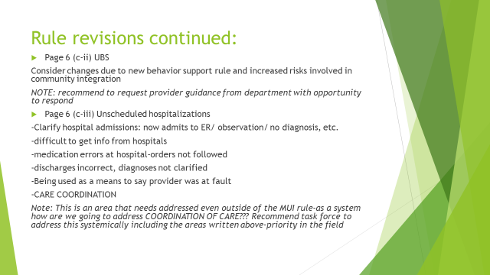

**Committee feedback/discussion:**

* All agreed that the rule for UBS is okay as written-it is how it is being interpreted and applied and the way DSPs are treated

(ie: individual running towards road with heavy traffic-DSP intervenes and provides life saving measure with escort-physical intervention and person receives bruise)-=-need supportive process

* Need to ensure that these are not always viewed as a bad provider thing; sometimes is the only way to avoid neglect or high risk of immediate harm
* Unscheduled hospitalization- very long discussion regarding need for care coordination (for all reasons listed above in slide) and all agreed that this a bigger discussion than just MUI and that a separate task force needs to focus and work on this; recommendations to review IV automatically being a MUI when at hospital ER-county interpretation very different.
* Need to have true discussion on what happens with continuity of care through hospitalizations, etc.

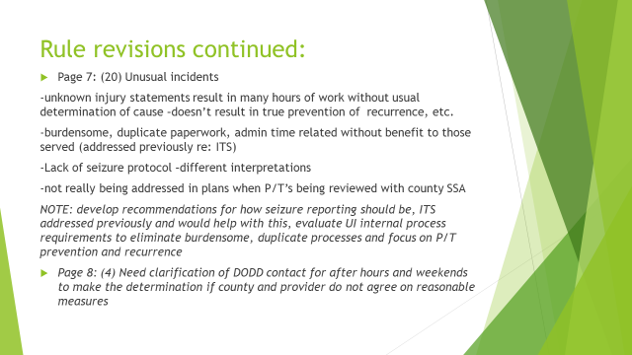

**Committee feedback/discussion:**

* Seizure protocol would be helpful so that they are being handled consistently the same
* Need P/T addressed in plan and how to make that happen?
* Where are we with the IT WORKGROUP that was set up for imagine IS etc. by DODD-no meetings for a very long time???
* Need collaboration on prevention plans
* Findings should be based on facts-not judgement or feeling of IA
* After hour and weekend DODD number would be very helpful

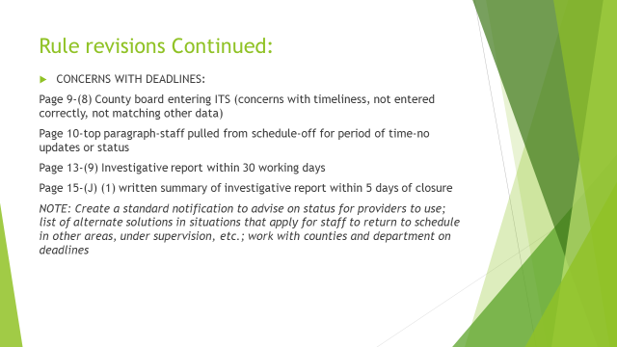

**Committee feedback/discussion:**

* Agreement on deadlines; discussion around ITS as above
* Request to send DODD guidance on alternative safety plans other than pulling staff from schedule-OPRA to resend that document to all
* Issue with not receiving reports, or status updates-therefore, prevention plans are not done because of lack of information on what is found during IA investigation

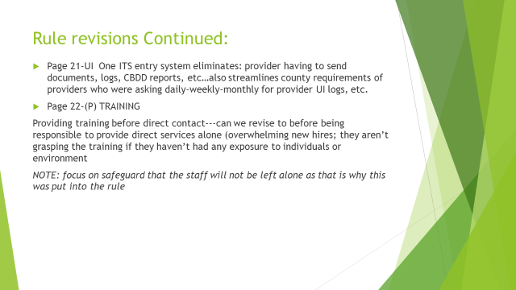

**Committee feedback/discussion:**

* ITS system addressed above
* Creates consistency, simplification, efficiency
* **TRAINING-**

Members were split on this topic. Some felt it must be done before direct contact. Others suggested DODD create a video for introduction of basics to work as a DSP (MUI/UI). (Basic rule) and then provider be responsible to have training after they worked at location to go over MUI/UI (because after being in environment and meeting individuals it seems to make sense more to those with no experience).

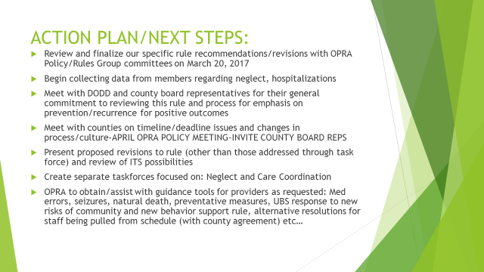

**Committee feedback/discussion:**

Agreement from all on next steps…however, some stated maybe county could initially meet with task force to introduce and then have joint policy meeting. Meeting to be scheduled with DODD by Jeff. Taskforces to be created for:  
1) MUI/UI rule-neglect 2)Unscheduled hospitalizations/Care Coordination

Those interested in taskforce topics should email Jeff, Becky, or Christine. From the meeting, those interested:

Mary Hall-Care Coordination

MUI/Neglect-Mark Hutchinson, Gary Mosier, Keith Poynter

Either: Martha DiLorenzo, Maura Mantell, Chris Rafeld, Mary Vail

1. **PROVIDER CERTIFICATION**

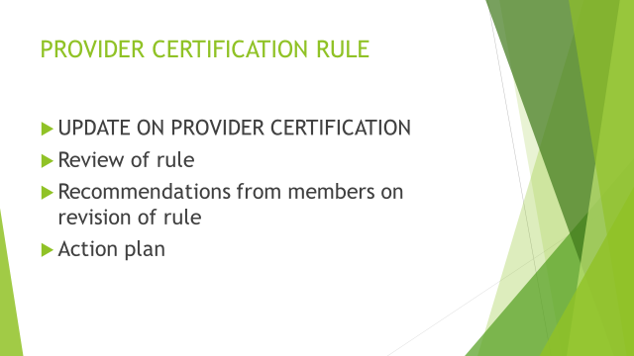

* **Draft Amendment presented to DODD regarding certification; no formal response received, but inclination that DODD does not agree with the amendment-further discussion to occur**
* **Provider Certification rule-OPRA to draft recommendations for revisions and present proactively**

1. **STATE BUDGET UPDATES:**

* Anita Allen/OPRA has been working with DODD and CPAs regarding amendment of language for ICF budget. More detailed information will be sent shortly to all ICF members. However, the freeze is out of the language replaced by a DSPP add on for direct-3% increase. This will impact ICF providers differently-some win, some lose and will cause squeeze on indirect side. The date of new reimbursement proposal changed from December 31 to Sept 30th, 2017. Continued discussions to occur with trade associations and accounting firms. Fair Rental Value removed from language replaced by capital calculation wording. Watch your email and join the weekly Friday OPRA calls to stay abreast on constant changes surrounding the budget. There is a huge credible threat for us to lose the money in the budget and they are asking for testimony in support. If you are interested, please email Jeff.

1. OPEN DISCUSSION:

* New issue at an ICF with admitting individuals on HMO-no back pay and must be prior authorized for ICF. (so now going without payment) Anita to check on this.

1. **ACTION STEPS/FOLLOW-UP:**

|  |  |  |  |  |
| --- | --- | --- | --- | --- |
| # |  | Person(s)  responsible | Target Date |  |
| P1 | Provide information to members regarding Building Code changes and updates | OPRA- Christine or Anita | 2/15/17 |  |
| P3 | Invite Teresa back to discuss Autism work DODD | Jeff | 6/1/17 |  |
| P9 | Create OPRA work group CFO/Policy addressing the Waiver initiatives/ evaluate rates send suggestions | OPRA | 4/1/17 |  |
| P12 | Set up training with AG office on their process for review for members | OPRA | 6/1/17 |  |
| P13 | Revise Priority wording to include Accurate and any other recommendations from member feedback | Jeff D. | 3/25/17 |  |
| P14 | Establish task forces to address:  MUI Rule/Neglect  Hospitalizations/Care Coordination | OPRA | TBD |  |
| P15 | Joint meeting with County Board on MUI/UI and taskforces | OPRA | TBD |  |
| P16 | Keep members abreast of budget updates and provider certification actions | OPRA |  |  |