**OPRA Strategic Plan**

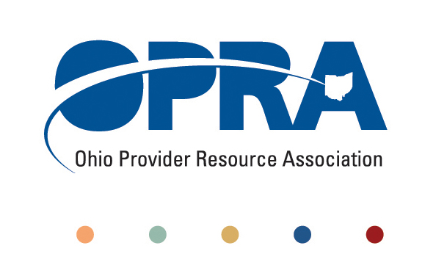

**2016 - 2017**

|  |  |  |
| --- | --- | --- |
| **Mission Statement** | | |
| To support and provide advocacy for community-based service providers to ensure the availability of programs, services, and funding adequate to support and assist individuals with developmental disabilities as they strive to achieve a life of increasing independence, productivity and integration. | | |
| **2016-17 Focus Areas & Goals** | | |
| **Workforce Sustainability** | **Efficiencies and Simplification** | **Quality, Accountable and Sustainable System Reform** |
| 1. Advocate for average DSP wage of 200% of the federal poverty level, DSP’s receiving average benefits package and funding to sustain. 2. Advocate for re-investment of County Boards of DD/DODD budget savings accrued from waiver budgets or efficiencies in County Boards and State systems in DSP wages, benefits, training and supervision, and waiting list. 3. Develop and implement strategies to attract, train and retain people to the direct support profession. | 1. Assist and advise our partners in the development and implementation of the CMS transition plan/HCBS rule and conflict-free case management. 2. Advocate for simple, quality-focused and innovative reimbursement models. 3. Advocate for a regulatory system that is rational, less cumbersome and results in meaningful outcomes for individuals with IDD. | 1. Advocate for adequate funding for all ICF’s, including responsible downsizing of ICF’s, setting size changes, individual needs and provider incentives. 2. Collaborate with stakeholders to build provider capacity and eliminate all barriers to community. Integrated community employment initiatives achieve the same employment rate as the general Ohio population while transforming day array services to community engagement. 3. Identify opportunities to improve people with IDD’s health and experience of care, while seeking to reduce the per capita cost of care. |