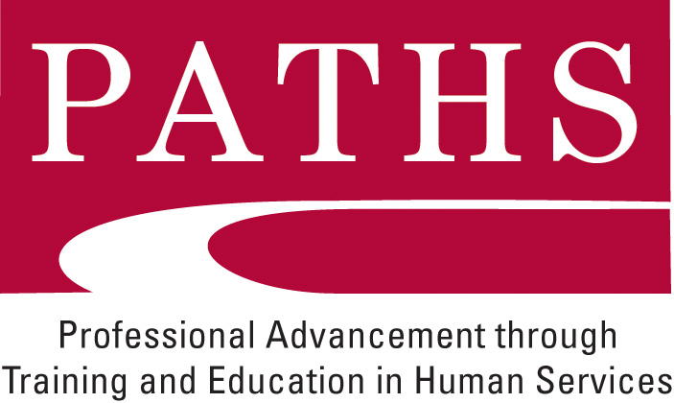
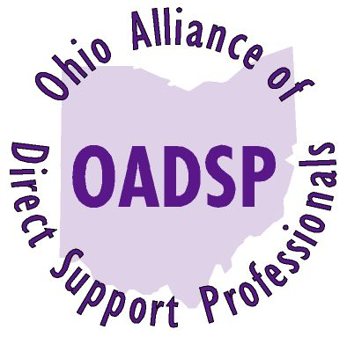

A Message to the OADSP/PATHS Community
From the OADSP Board of Directors and Amy Gerowitz – Executive Director
June 23, 2012

New Organizational Structure and Consultants:

As OADSP moves into its next phase we are announcing a change in our organizational structure. As many of you know by now, Scott Osterfeld, Chief Operating Officer resigned his position with OADSP to accept a position with the Butler County Board of DD. Scott will remain with OADSP as a consultant and supporter of the mission of assuring a well- trained and professional DSP workforce, adhering to best practice and a Code of Ethics. You will all get to see Scott at the annual DSP Recognition Event on September 12 where he will continue to serve as MC and Chief Cheerleader.

Our new organizational structure will draw on the talents and skills of wonderful people and allow us to continue to develop and grow in the years to come. We wanted to let you know about how the various functions and responsibilities of OADSP will be fulfilled. We are very excited to introduce you to the people who will be helping us all achieve our mission. As before OADSP remains a virtual organization and the positions described are all part time independent contractors. This is just a summary of their major responsibilities.

CEO: Amy Gerowitz will continue to serve in this capacity, working closely with the OADSP Board of Directors and other stakeholders to assure continuity, growth and sustainability.

Director of Statewide Operations: Kevin Metz will expand his long term involvement with OADSP and PATHS and coordinate the PATHS regions, provide training for instructors and new licensed entities, coordinate marketing and the sale of PATHS licenses. He is a fabulous trainer and an organized executive and we are thrilled that he is taking on these statewide responsibilities.

Coordinator of Marketing and Training: Katrina Sacay will continue her excellent work in these areas and increase her time commitment and responsibilities over the next few months. She is indeed the Go To Person for a myriad of operational issues related to training, scheduling, materials, OADSP’s social media activities, the data base and the evaluation to name a few.

Curriculum Development Specialist: Deb Easley has written PATHS curriculum for many years and will be developing our web based courses with Essential Learning and also serve as the key writer and editor of the PATHS curriculum in the future.

Outreach and Credentialing Coordinator: Bethany Toledo, currently the Mid-East Regional Coordinator will maintain those responsibilities and also be taking on statewide responsibilities. She will be coordinating the grading of portfolios, training graders in the new methodology of portfolio grading that OADSP is phasing in with its partner NADSP, representing us at conferences and coordinate training at these conferences.

Chief Financial Officer: Marc Seiffert will continue in this capacity assuring accurate and timely financial management for OADSP.

PATHS Regional Coordinators: The PATHS regional coordinators will continue to coordinate the delivery of PATHS classes in the various regions around the state.

The Community of PATHS Instructors and Skill Mentors will continue to assure that the CIP and CAP curriculum are delivered and implemented in the highest possible manner. The community of OADSP Specialized instructors will continue to deliver the high quality courses that are available throughout the state.

Look for more information on the OADSP web site. Change can be a challenge but we believe we have created a team that will do a wonderful job of enhancing this terrific program.

All contact information will be available on the web site very soon. Please contact Amy Gerowitz at agerowitz@me.com, or Tony Thomas at tthomas@welcomehouseinc.com with any questions.

