

Great Providers…

|  |  |  |  |  |  |  |  |  |  |
| --- | --- | --- | --- | --- | --- | --- | --- | --- | --- |
| Are Person-Centered | Have Great Leaders | Have Great Cultures | Have great Human Resources | Are Great Advocates | Can Navigate the System | Run Great Businesses | Have Great Policies | Connect with Their Communities | Understand Technology |
| * CQL * Personal goals and outcomes * The OISP * Teams Focused on the Person | * The Tree Leadership Experience * Advance Leadership Classes * The DD Executive Survival Guide * Ongoing CEUs Needs * DD 101 for Non-Profit Boards * On-Site Board Development Trainings (Customized) * Provider Leadership Team Building * Take Care of Yourself | * Good Life Culture Training * Gallup Culture Self-Assessment * DSP Professional Development * Supporting the Middle | * DD HR 101 * Recruitment and Retention Self-Assessment * Recruitment and Retention Basics * Are We Competitive: How Do You Compare to Other Businesses * Compliance Ready and Beyond * My HIPPA Guide | * OPRA Advocacy Army * Building and Maintaining Legislative Relationships * Partnering with the People You Support and Their Families | * Waiver 101 * Day 101 * Employment 101 * ICF 101 * An MUI Happen…Now What? * Understanding the MUI Machine * MUI Prevention: Understanding Trends and Patterns | * Maximize Your Return * Waiver Billing 101 * ICF Cost Reporting: Maximize your Return * Cost Projecting and Protecting Your Future * Where Does Our Money Go? | * Policies that Mold and Support Your Culture * The Policy Checklist for the DD System * “You Can’t Wear That!”…The Impact of Your Policies On People | * The E3 Model * How to Become a Community Leader and Why is it Important * The County Board as a Partner * Volunteering: Helping Ourselves While Helping Others * Do They Even Know What We Do? * The Schools Are Your Friend | * Technology and the People You Support * Technology and Your Staff * Death of the Paper Age * Start Small |

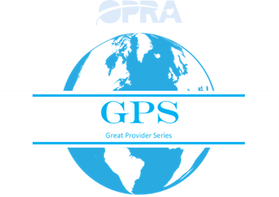

If we don’t drive quality, others will drive over us!

A menu of training opportunities with a common thread/goal

(improved Quality=improved Rates)

The Reality…

DODD (Bureacracy) is not capable of achieving what we can achieve

Who are our partners? How do we pick them?

Great Providers

* Provide great services
* Treat their employees well
* Understand the system and the services they provide
* Need less scrutiny

OPRA = the Association of Excellence

THE GO TO Spot for the entire system

Generate non dues revenue and new members

Are there opportunities outside of the agency provider? (IPs, CBs (SSAs), Self-advocates/families)

Can we use this platform to ensure quality?

Can this be the “go to” system for all providers in the system?

Is this the entry for OPRA Membership?

If you are GPS Certified are you treated differently by “the State’?

The GPS is Self-Assessment Focused

(people don’t like change and they don’t like being told what to do)