

Mission: To support and provide advocacy for providers to ensure the availability of high-quality programs, services, and funding adequate to support the individuals with intellectual and developmental disabilities they serve to achieve a life of increasing independence, productivity and integration.

Annual Board Retreat

August 22, 23, and 24

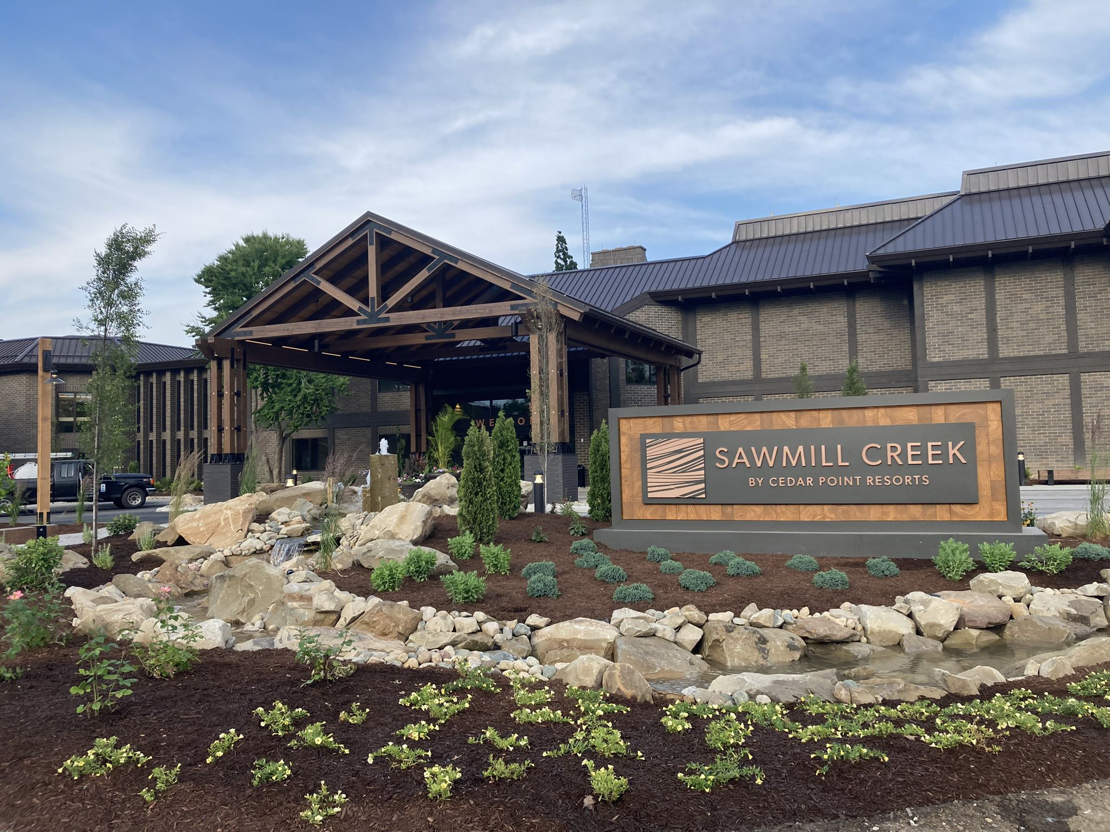

**2023 Board Retreat  
Dates:** August 23 – 25, 2023  
**Location:** Sawmill Creek Resort, Huron, OH  
**Website:** <https://www.sawmillcreekresort.com/>

**AGENDA  
  
Wednesday, August 23rd**

4:00 PM Hotel Check-in

**Sponsored Happy Hour by GT Independence @ Hideout Bar Sawmill Creek**

4:30 PM – 5:45 PM

**Sponsored Dinner by Gallagher @** [**Gideon Owen Winery**](https://www.gideonowenwine.com/)

5:45 PM Load shuttles

6:00 PM Transfers from Sawmill Creek Resort

6:30 PM Cocktails & HD’s

7:20 PM Welcome & Thank You Gallagher

7:30 PM Dinner served

9:30 PM Depart

10:00 PM Arrive Sawmill Creek

**Thursday, August 24th**

8:30 AM Hot Breakfast available until 9:30 AM

9:00 AM Strategic Planning

12:00 PM Boxed lunches

1:00 PM Transfers to Jet Express  
 Meet in Hotel Lobby

1:30 PM Arrive Jet Express

2:00 PM Arrive PIB

2:30 PM Scavenger Hunt on Golf Carts

4:00 PM Dinner at Keys or Boardwalk Upper Deck

7:45 PM Get in line at the Jet Express  
8:00 PM 1st return to Port Clinton  
8:30 PM Transfers to Hotel

10:45 PM Get in line at the Jet Express  
11:00 PM 2nd return to Port Clinton  
11:30 PM Transfers to Hotel

**Friday, August 25th**

8:30 AM Friday 5 Member Call

9:00 AM Hot Breakfast Available until 10:00 AM

9:30 AM Board Meeting

11:00 AM Check-out by

12:30 PM Strategic planning and the future of OPRA continued

1:30 PM Conclude

Table of Contents

Thursday’s Agenda 4

OPRA Strategic Planning 5

Icebreaker 6

OPRA is… 7

OPRA will be… 8

Guiding Principles 9

Internal Strategic Plan 11

Board Meeting Agenda 13

Coalition Reform Ideas 14

Rule Filter 25

**Safe Place Statement**

We would like to thank you for attending this meeting. This meeting, like all of the OPRA Committee meetings, are designed to offer a safe place for OPRA Members to share thoughts, opinions and ideas. The OPRA Team and the OPRA Board relies on these discussions to inform our efforts to provide Advocacy, Information and Resources. We are respectfully asking you, as a participant, to assist us to make this a safe place for professionals to openly share without fear. It is important that when personal experiences are shared, there is an assurance that what is shared stays within this group. We are looking forward to an open and honest conversation and we would like to thank you for being a part of this important meeting.

**Thursday Meeting Agenda**

Strategic Planning: The Future of OPRA

9AM Team Building Icebreaker

9:15 The “OPRA is” Activity

9:25 OPRA Today: We will review our current strategic plan goals and provide a progress report

10:00 The “OPRA will be” activity

10:15 External Strategic Planning: Facilitated discussion about OPRA’s goals and objectives heading into the next 5 Years

* Are the Guiding Principles still relevant?
* What do we need to build a sustainable system?
* Who should we align with and why?
* Providers and County Board…What do we want to the future to look like?
* How do we promote quality?

11:00 Internal Strategic Planning: OPRA and OPRA Community

* Guiding principles and internal planning
  + OPRA’s Relationships with members/partners
  + OPRA sustainability
  + OPRA is Trusted
  + OPRA’s Support of the Spectrum of Services
* Member Survey: what are the questions we should ask?
* Conferences
* Technical Assistance
* Training (the GPS Model)
* Should OPRA be the Association supporting excellence?

12:00PM Adjourn

OPRA Strategic Planning:

Team Building and Information Gathering

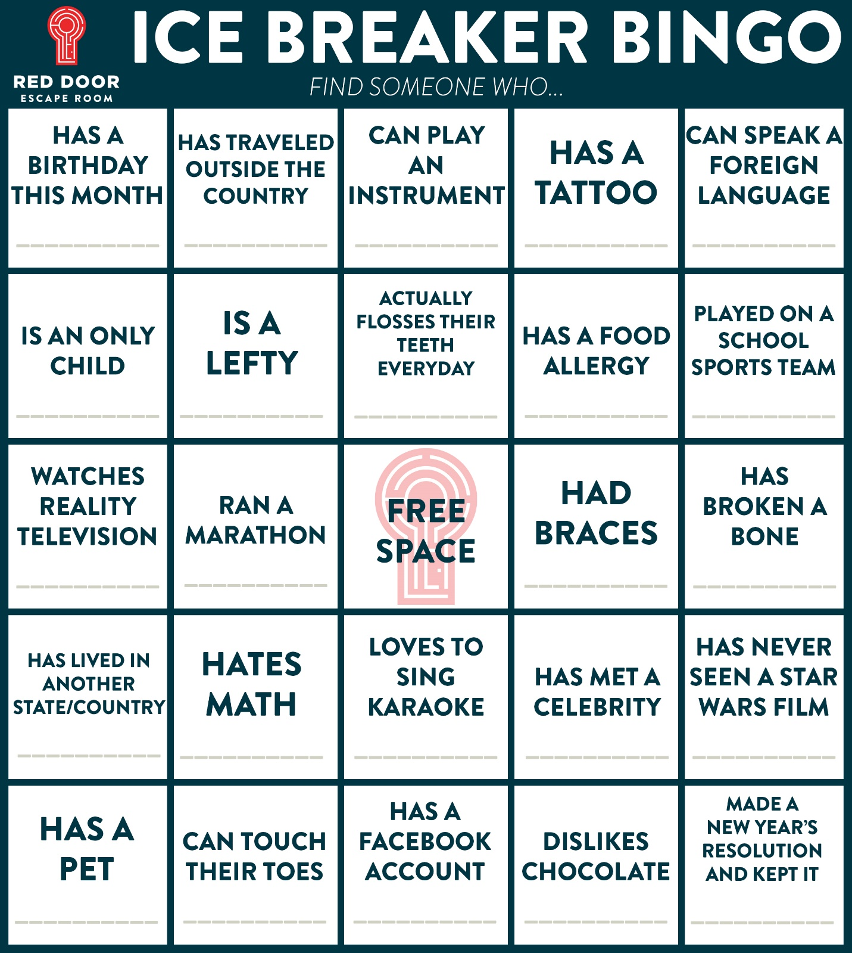

**OPRA is…**

In your group talk about where OPRA is today in Ohio’s DD system. Areas to think about:

* Leadership
* Partnerships
* Advocacy
* Membership
* Etc.

Please take notes and share your thoughts with the group when you are done.

**Strategic Plan Update**

**OPRA Will BE…**

In your group talk about where OPRA will be in Ohio’s DD system. Areas to think about:

* Leadership
* Partnerships
* Advocacy
* Membership
* Etc.

Please take notes and share your thoughts with the group when you are done.

**Are OPRA’s Guiding Principles Accurate and Relevant? (What you like and/or what you would change)**

**Anchor Statement:** Ohio’s providers are focused on supporting the success of the people we support.

**Principle #1:** We believe the primary focus of our work is the positive and supportive relationship between front-line professionals and the people they support.

**Principle #2:** We believe providers should be supported and trusted to support people with developmental disabilities and operate effective and successful organizations.

**Principle #3:** We believe providers must be sufficiently compensated to deliver essential services to meet the needs of the people they support in an ever evolving society and system.

**Principle #4:** We believe all services currently provided across the spectrum of services should be recognized as crucial to each and every person we serve.

**The Future of our System: OPRA’s Strategic Priorities**

1. What do we need to do to build a sustainable system?
   1. Waiver redesign
   2. ICF Modernization
   3. Ongoing cost of living increases
   4. System reform priorities
      1. MUI
      2. Certification
      3. Limit the number of providers
      4. Billing
   5. Funding priorities
2. Who should we partner with and why?
   1. What does the future Provider and County Board relationship look like?
   2. What does the future Provider and DODD relationship look like?
   3. What does the future Provider and Person Served/Family relationship look like?
3. How do we lead the Quality Discussion?
   1. What is a “Provider in Excellent Standing” (PIES)?
      1. How do we measure quality services?
      2. How do we measure sound business practices?
      3. How do we measure compliance with rules and regulations?
   2. What should PIES providers get in return?

**Internal Strategic Planning**

Internal strategic actions related to:

**Anchor Statement:** Ohio’s providers are focused on supporting the success of the people we support.

**Principle #1:** We believe the primary focus of our work is the positive and supportive relationship between front-line professionals and the people they support.

**Principle #2:** We believe providers should be supported and trusted to support people with developmental disabilities and operate effective and successful organizations.

**Principle #3:** We believe providers must be sufficiently compensated to deliver essential services to meet the needs of the people they support in an ever evolving society and system.

**Principle #4:** We believe all services currently provided across the spectrum of services should be recognized as crucial to each and every person we serve.



Questions:

Do the 4 areas represent what we do? Are we missing anything?

What are your priorities for each area?

Are the 4 areas balanced?

What does the OPRA Team need to provide these supports better?

We are going to conduct a member survey this year, what questions would you like us to ask?

**Friday Meeting Agenda (Board Meeting)**

* Intro and Safe Place Statement
* Approval of July minutes
* Governance Committee
  + Executive Committee election
  + Update on upcoming elections
  + Information regarding election impact on Executive Committee
  + Upcoming Board member survey
  + Conflict of interest form signing
* Board Report
  + Coalition system reform items (review and comment)
  + MUI Rule revisions
  + DODD Accreditation and Certification modifications
  + Quality and Provider in Excellent Standing
  + Rule review process
* CEO Report
  + Fall Conference
  + Spring 2024 update
* Open comment
* Adjourn

Strategic Planning and Future of OPRA continued

Topic: County Board, Person Receiving Services/ family relationships

**Coalition System Reform: Introduction**

Over the past several years, Ohio’s system supporting people with Developmental Disabilities has made incredible progress in promoting self-determination, person-centered planning and services that allow people to live and thrive in their homes and communities. But the COVID-19 pandemic and ensuing staffing crisis threaten that progress. Our system struggles to recruit and retain the workforce and other resources needed to ensure the high quality supports that Ohioans with disabilities need, and so many have worked so hard to attain. The workforce shortage continues to intensify, severely challenging our ability to fulfill the plans and promises made, and threatening the safety and welfare of the people we collectively support.

Stabilizing our system requires a significant investment in funding, resources and regulatory advances, enabling us to turn the corner away from the crisis pose of the last few years and pivot towards a sustainable and successful future. The ideas presented below are intended to confront the workforce crisis and continue the progress Ohio has made towards a person-centered system that meets the needs and accommodates the choices of Ohioans with Developmental Disabilities. To meaningfully address the challenges posed by the workforce crisis, we need flexibility and creativity, and the ability to reimagine aspects of service delivery directly impacted by the shortages.

The COVID-19 pandemic taught us that the system can change, and we are capable of adapting to crisis and working together to ensure that Ohioans with Disabilities have **services** to remain healthy and safe. We present the policy proposals here in the spirit of that partnership and future collaboration on ideas and initiatives that address the current crisis and preserve the progress Ohio has made towards person-centered, high-quality disability services.

System Reform Topic #1: Reimbursement and Service Design Reform

**Summary**

As part of the Waiver Reimbursement System Modernization Project, we will be presenting a separate proposal that will include actions and items that must be included in the effort and some things that we believe should not continue in order to simplify and prepare our DD system for long-term sustainability. Part of the proposal will include a variety of issues that complicate the current financial structure of DD waivers including reimbursement structures, acuity factors, prior authorizations, etc. Additionally, the proposal will include some recommendations for redefining services in a way that recognizes the broad range of service needs and thus skill sets required for direct support professionals. We strongly believe that a well-rounded workgroup will be essential to the success of this important redesign.

**Coalition Team Leader(s):** Debbie Jenkins, OHCA and Scott Marks, OPRA, Monica Juenger, OACB

|  |  |  |  |
| --- | --- | --- | --- |
| **Core Team** | **Key Advisors** | **DODD Representative(s)** | **Action Steps /Timelines** |
| *Group of 3-4 “experts” who will drive the work (these are people who will join the Team Leader(s).*  *Becky Sharp*  *Scott DeLong*  Neil Townsend  Amber Gibbs  Joe Harmon  *Jason Abodeely* | *Key stakeholders who the core group can rely on to React and Enhance/offer value added input and support.*  *Josh Anderson* | *DODD will assign an internal expert who can React and Enhance/offer value added input and support*  *.* | *Action steps with due dates.* |

System Reform Topic #2: Individual Choice and Autonomy

**Summary**

This proposal seeks to promote individual choice, self-direction and autonomy to the greatest extent possible. To that end we propose:

1. To decrease the over reliance of traditional paid DSPs, the system should fully embrace self-directed services, including expanding participant directed HPC options in our 3 waivers.  PD-HPC expansion would allow more non-traditional providers to be selected by people and their families decreasing the demand on agencies. However, to do so, this service needs to be less complex and simplified. We have an opportunity now to redesign this service with the new FMS which would require the providers to have an agreement with GT Independence and not be required to also be certified in the state system.
2. Implementation of the new self-directed transportation will provide new options for people with disabilities to get transportation without DSPs which will provide much needed relief to the system. In addition, Participant Directed Goods and Services (DGS) now available to both Level One and SELF waiver enrollees, provides increased access to equipment, goods and services that are available to all citizens and can reduce the reliance on paid staff. Enhanced training on self-direction will be necessary to achieve these objectives.

Consider expanding Participant Directed Goods and Services to the IO Waiver after reviewing its use within the Level 1 Waiver.

1. Promote additional self-advocacy at the local level to ensure people with disabilities speak up for themselves, are trained on exercising their rights and understand their responsibilities. Utilize, among others, People First & OSDA to provide additional support to county boards to strengthen their local processes and regional groups as needed. OSDA, People First and other advocacy organizations will work with OACB to identify specific steps that can be taken by county boards that will strengthen the ability of people to speak up for themselves.
2. DODD will take a leadership role in strengthening and developing Supported Decision-Making as a tool available to consumers across Ohio. This would create a new alternative to guardianship in Ohio that will strengthen our DD system. Ohio Revised Code Section 5126.043 currently provides for the designation of authorized person to assist with decisions but the statute is not widely understood and/or utilized by consumers.  This statute is also not viewed by Probate Courts as an alternative to guardianship.  The proposal would be to rescind Ohio Revised Code Section 5126.043 and replace it with a more robust statute which directly recognizes and empowers Supported Decision-Making as an alternative to guardianship.

There are presently twelve states that have supported decision-making laws in place and Ohio should join those states by empowering its individuals with developmental disabilities with this great tool.

**Coalition Team Leader(s):** Lisa Comes, OACB

|  |  |  |  |
| --- | --- | --- | --- |
| **Core Team** | **Key Advisors** | **DODD Representative(s)** | **Action Steps /Timelines** |
| *Group of 3-4 “experts” who will drive the work. (these are people who will join the Team Leader(s).*  Nancy Richards  Leia Snyder  Gary Tonks | *Key stakeholders who the core group can rely on to React and Enhance/offer value added input and support.* | *DODD will assign an internal expert who can React and Enhance/offer value added input and support.* | *Action steps with due dates.* |

System Reform Topic #3: Remote Supports Rule

**Summary**

Ohio has shown its dedication to being a Technology First state and we believe this service in the waivers can be modified to promote the use of various technology driven supports. Increased flexibility could lead to increased usage and benefit to those who utilize remote supports.

* 1. Redefine the relationship between the residential provider and the technology supports provider. Need to address “free choice of provider” in connection with expectations of both the residential provider and the technology provider.
  2. Reconsider rates for active vs. passive remote supports.
  3. Create rate structure that covers small units of service such as virtual health related supports, verification, or assistance with self-administration of medications or well checks.

**Coalition Team Leader(s):** Monica Juenger, OACB; Scott Marks OPRA

|  |  |  |  |
| --- | --- | --- | --- |
| **Core Team** | **Key Advisors** | **DODD Representative(s)** | **Action Steps /Timelines** |
| *Group of 3-4 “experts” who will drive the work (these are people who will join the Team Leader(s).*  *Scott DeLong*  Michelle Madden  Jamie Steele  Scott Marks  Lisa Comes  Jimmy Finley  Jarrod Hunt  Kyle Corbin  SSA directors as needed | *Key stakeholders who the core group can rely on to React and Enhance/offer value added input and support.*  *Debbie Jenkins* | *DODD will assign an internal expert who can React and Enhance/offer value added input and support.* | *Action steps with due dates.* |

System Reform Topic #4: Waiver Nursing & Medication Administration

**Summary**

Waiver Nursing & Medication Administration: One of the lessons learned during the pandemic is that there is a desperate need to increase nursing capacity within our DD system. Although waiver nursing was added as a service years ago, utilization is extremely low due to the complex nature of accessing the service. This proposal seeks to make changes in the following areas:

* 1. Short-term: work with DODD to develop a streamlined process to permit county boards to authorize waiver nursing to provide much needed reimbursement with severe nursing shortage in Ohio.
  2. Build on current work with DODD, enhance structure and processes to allow for expanded use for medication dispensers and other technology solutions for health-related needs.
  3. OAC 5123-9-37 needs to be revised to voluntarily permit county boards and councils of governments who choose and are able to provide nursing services now due to lack of willing and able providers.
  4. Consider various models of “tiered DSPs” to review a number of nursing functions with a matching rate to align with the services.
  5. Long-term: work with DODD to find a way to allow expanded access to waiver nursing, including adding the service to Level 1 and SELF, and increase flexibility for these services. We believe this is being done in other states and would like to reduce the barriers for DD providers to provide waiver nursing services. In addition, we believe that technology related health care services, such as Station MD, should be covered by Medicaid.

**Coalition Team Leader(s):**  Lisa Comes, OACB, Debbie Jenkins, OHCA and Rachel Hayes, OPRA

|  |  |  |  |
| --- | --- | --- | --- |
| **Core Team** | **Key Advisors** | **DODD Representative(s)** | **Action Steps /Timelines** |
| *Group of 3-4 “experts” who will drive the work (these are people who will join the Team Leader(s)*  Jen Meadows, Hamilton county  Matt Costello Guernsey  Karin Crabbe, Franklin  Kristi Black  Gina Kerman  Christine Touvelle | *Key stakeholders who the core group can rely on to React and Enhance/offer value added input and support.* | *DODD will assign an internal expert who can React and Enhance/offer value added input and support.* | *Action steps with due dates.* |

System Reform Topic #5: Residential Setting Capacity and Innovation

**Summary**

Develop a workgroup to facilitate discussions with stakeholders to discuss increased flexibility in development of residential settings that includes parameters in unlicensed and licensed settings. In particular, specialized services for multisystem youth and adults with significant behavioral challenges are sorely lacking and need bold solutions. Conversations about setting size, while difficult, are necessary to address the sustainability of the system due to the sever workforce shortage.

In addition, flexibility in our current rules may allow for the creation of “intentional integrated communities” or multi-unit living situations which are desired by many people receiving services and their families.

Provide an opportunity for Shared Living to permanently permit HPC services in the Shared Living (OSL) setting on the same day with some limitations. Ongoing promotion of OSL and expansion statewide would have a positive impact on services for people, as well as assist with the workforce crisis long term.

As future assessments are considered to replace the Ohio Developmental Disabilities Profile, consider the elimination of scoring which provides a lower funding level for individuals choosing to live within the family unit.

**Coalition Team Leader(s):** Gary Tonks, The Arc, Pete Moore, OPRA, and Debbie Jenkins, OHCA

|  |  |  |  |
| --- | --- | --- | --- |
| **Core Team** | **Key Advisors** | **DODD Representative(s)** | **Action Steps /Timelines** |
| *Group of 3-4 “experts” who will drive the work (these are people who will join the Team Leader(s).*  *Scott DeLong*  Sarah Zimmerman  Kara Brown  *Jason Abodeely* | *Key stakeholders who the core group can rely on to React and Enhance/offer value added input and support.*  *Pete Van Runkle* | *DODD will assign an internal expert who can React and Enhance/offer value added input and support.* | *Action steps with due dates.* |

System Reform Topic #6: Provider Compliance and County Board Accreditation

**Summary**

We believe that provider compliance and county board accreditation need revamped to allow for increased partnership when providers or county boards are in good standing. This to include agency and independent providers.

* 1. Compliance should be focused on providers/county boards who are struggling and not those who have demonstrated consistency in their ability to be in significant compliance with rules and regulations. Providers/county boards in good standing should have access to technical assistance and support rather than being subject to ongoing compliance reviews.
  2. County board accreditation: Given the nature of county board services, we recommend a compliance structure that is different than that of providers and more focused on the actions required from the county board.
  3. Create a very limited self-review compliance tool to be utilized for providers who are in good standing and also otherwise accredited.

**Coalition Team Leader(s):** Pete Moore, OPRA & Monica Juenger, OACB

|  |  |  |  |
| --- | --- | --- | --- |
| **Core Team** | **Key Advisors** | **DODD Representative(s)** | **Action Steps /Timelines** |
| *Group of 3-4 “experts” who will drive the work (these are people who will join the Team Leader(s).*  *Becky Sharp*  Julie Monroe  Theresa Schnipke  Carl Brass  Michele Byrne | *Key stakeholders who the core group can rely on to React and Enhance/offer value added input and support.*  *Debbie Jenkins* | *DODD will assign an internal expert who can React and Enhance/offer value added input and support.* | *Action steps with due dates.* |

System Reform Topic #7: Provider Certification

**Summary**

Provider Certification Requirement: Limited revisions to the Provider Certification rule would assist with addressing the staffing crisis. This to include agency and independent providers.

* 1. Permanently remove the 18 year old requirement for DSPs. Agency providers only.
  2. Permanently remove the high school diploma/GED requirement for DSPs, including Independent Providers.
  3. Discuss appropriate staff orientation, including which Appendix K flexibilities should be made permanent.
  4. Discuss training requirements focusing on adult learners, addressing various ways of comprehension.  Explore ways to reduce duplication in training such as permitting substitution of previous experience and education for specific training requirements (ex. requiring Medication Administration Training for a nurse), creating a database to capture employee specific training that would be portable to new employers, etc.
  5. Include a provision that permits both Independents and Agencies to substitute previous experience and education for mandated training in the certification rule. (Registered Nurses that must currently receive Medicaid Administration Training or Master’s Level Special Education Teachers who must also go through the same training as an 18 year old with no experience, as just two examples.)

**Coalition Team Leader(s):** Scott Marks, OPRA

|  |  |  |  |
| --- | --- | --- | --- |
| **Core Team** | **Key Advisors** | **DODD Representative(s)** | **Action Steps /Timelines** |
| *Group of 3-4 “experts” who will drive the work (these are people who will join the Team Leader(s).*  *Becky Sharp*  Jason Umstot  *David Lewis*  *Gina Kerman* | *Key stakeholders who the core group can rely on to React and Enhance/offer value added input and support.*  *Debbie Jenkins* | *DODD will assign an internal expert who can React and Enhance/offer value added input and support.* | *Action steps with due dates.* |

System Reform Topic #8: Multi-System Youth/Intensive Behavioral Support ICF Add-On

**Summary**

Unfortunately, the design of this program has not led to the intended outcome of creating additional residential options for children with intensive behavioral support needs. We would like to work with DODD to redesign the program in a way that can meet the variety of needs across the state. A specific proposal will be submitted on the rule with recommendations for changes.

**Coalition Team Leader(s):** Lori Stanfa, OACB

|  |  |  |  |
| --- | --- | --- | --- |
| **Core Team** | **Key Advisors** | **DODD Representative(s)** | **Action Steps /Timelines** |
| *Group of 3-4 “experts” who will drive the work (these are people who will join the Team Leader(s).*  Brent Baer  Jason Umstot  Ed Stark  Steve Williams  Emily Martinez  Larry MacIntosh  Michele Giess  Rich Johnson | *Key stakeholders who the core group can rely on to React and Enhance/offer value added input and support.*  *Debbie Jenkins*  *Josh Anderson* | *DODD will assign an internal expert who can React and Enhance/offer value added input and support.* | *Action steps with due dates.* |

System Reform Topic #9: ICF Modernization

**Summary**

There are several modifications needed for the ICF program to ensure long term sustainability.

1. While the department and stakeholders spent a lot of effort on creating the current reimbursement structure, there were several concerns that all agreed needed to be addressed in the future.
   1. The acuity scoring for people with high behavioral needs does not accurately reflect the resources needed to serve these individuals, especially if they do not have other medical or adaptive needs in addition to their behavioral needs.
   2. The group agreed to capture additional information on active treatment costs and then revise the reimbursement to address active treatment. Additionally, since then, DODD is getting ready to implement service and reimbursement changes to day and vocational services funded through the waiver. ICF reimbursement should be in-line with waiver reimbursement to allow ICF residents choice in where they receive their day services.
2. The cost reporting for ICFs needs reviewed and streamlined to ensure that only necessary data is being requested. A comprehensive review of the ICF cost report hasn’t been completed in over a decade and it is time to complete this and hopefully reduce some of the administrative expense in completing this function.

**Coalition Team Leader(s):** Debbie Jenkins, OHCA, Rachel Hayes, OPRA, and Dan Connors, St. Joseph Home

|  |  |  |  |
| --- | --- | --- | --- |
| **Core Team** | **Key Advisors** | **DODD Representative(s)** | **Action Steps /Timelines** |
| *Group of 3-4 “experts” who will drive the work (these are people who will join the Team Leader(s).*  *Scott DeLong*  *Josh Anderson*  Michelle Giess  *Jason Abodeely* | *Key stakeholders who the core group can rely on to React and Enhance/offer value added input and support.*  *Accounting Firms as needed*  *Pete Van Runkle* | *DODD will assign an internal expert who can React and Enhance/offer value added input and support.* | *Action steps with due dates.* |

**Rule Review Filter**