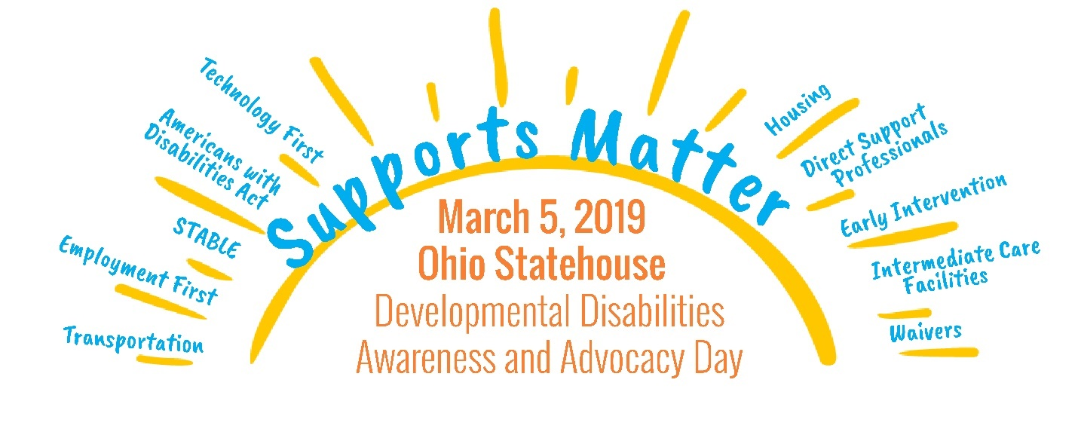

2019 DD Awareness and Advocacy Day
Post Event Report & Evaluation
Paul Jarvis
May 3, 2019

Each year the Ohio DD Council, in collaboration with the Ohio Department of Developmental Disabilities, the Ohio Association of County Boards of Developmental Disabilities, and the Ohio Provider Resource Association, plans and prepares an annual event at the Ohio Statehouse to kickoff DD Awareness Month and to allow individuals with developmental disabilities, their families and other stakeholders in the system to meet with their state legislators and other policymakers.

The Council provides funding to support the work needed to coordinate the event registration, marketing, program and legislative meetings. Funding from the grant can be used to provide participants at the event with food, transportation, translation services, and other assistance as requested. The Ohio Provider Resource Association has been the grantee for this project since 2016. Prior to that, a number of entities have held a grant from Council to conduct this event or previous iterations of this event:

2018 – Ohio Provider Resource Association – Celebrate CommUNITY!
2017 – Ohio Provider Resource Association – Side by Side
2016 – Ohio Provider Resource Association – What’s Your Story?
2015 – Ohio Special Initiative for Brothers and Sisters (SIBS) – Can Do, Like You!
2014 – Ohio Special Initiative for Brothers and Sisters (SIBS) – What are We Waiting For?
2013 – Ohio Special Initiative for Brothers and Sisters (SIBS) – Look Beyond
2012 – The Axis Center for People with Disabilities – Legislative Advocacy Day
2011 – Carmen Shelton and The Nisonger Center – Legislative Advocacy Day
2010 – Carmen Shelton and The Nisonger Center – Legislative Advocacy Day
2009 – Carmen Shelton and the Nisonger Center – Legislative Advocacy Day
2008 – No Event
2007 – The Arc of Ohio – Legislative Event
2006 – The Arc of Ohio – Legislative Event

In 2013, the event was merged with the annual DD Awareness Month Kickoff event at the Ohio Statehouse in an effort to consolidate the number of events that received government funding or resources. The focus of Council’s project was getting individuals to engage in active advocacy with their legislators, while the focus of the kickoff event was to celebrate and encourage awareness of developmental disability issues. As a result of the merger, the event was renamed DD Awareness and Advocacy Day to accommodate both purposes.

Since 2013, the Ohio DD Council grant for an annual legislative event has provided the bulk of resources and support for planning this joint event. Council grant funds for the event was awarded at $50,000 per year, beginning in 2009 and ending in 2016. Following a review of actual expenditures, the grant amount was reduced to $38,000 per year in 2017 and remains at the amount for the current 5 Year Plan on Developmental Disabilities.

Planning for each event generally starts with a planning committee meeting in late summer of each previous year. The planning committee for the event is coordinated by the grantee, OPRA. For the 2019 event, the planning committee included representation from the Ohio Department of Developmental Disabilities, Ohio Association of County Boards of Developmental Disabilities, Ohio Self Determination Association, AT Ohio, Ohio Provider Resource Association and DD Council, along with several invited self-advocates.

Profile of Participants:

Registration 540
No Shows 117
On Site Registration 33
Attendance 456
Live Stream Views (4/29/19): 236

Total Attendance Breakout:

Type | Total | Percentage
Self-Advocate / PWD | 207 | 45%
Parent/Guardian/Family | 43 | 9%
County Board | 78 | 17%
Other Professional | 68 | 15%
DSP | 20 | 4%
N/A | 40 | 9%

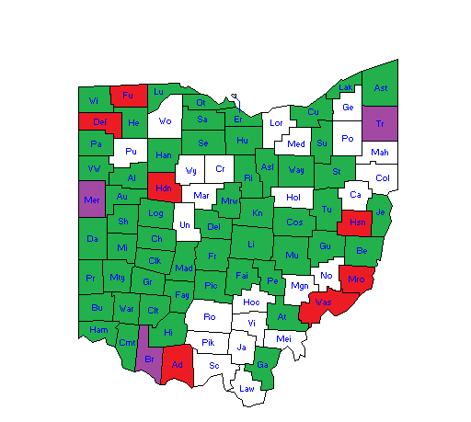

Green = Attendance Purple = Targeted County - Attendance
White = No Attendance Red = Targeted County – No Attendance

No Show Breakout:

Type | Total | Percentage
Self-Advocate / PWD | 48 | 41%
Parent/Guardian/Family | 19 | 16%
County Board | 14 | 12%
Other Professional | 26 | 22%
DSP | 5 | 4%
N/A | 5 | 4%

Total Attendees Data:

Race | Total | Percentage
American Indian/Asian/Hispanic | 16 | 4%
Black/African American | 40 | 9%
Refusal to Answer | 54 | 12%
White | 313 | 69%
N/A | 33 | 7%

Advocacy Participation | Total | Percentage
Met with Legislator/Staff | 370 | 81%
No Meeting Scheduled | 53 | 12%
N/A (Day of Registration) | 33 | 7%

Income | Total | Percentage
Less than $10,000 | 89 | 20%
$10,000 - $20,000 | 7 | 2%
$20,000 - $30,000 | 22 | 5%
$30,000 - $40,000 | 33 | 7%
$40,000 - $50,000 | 29 | 6%
More than $50,000 | 48 | 11%
Refuse to Answer | 195 | 43%
N/A (Day of Registration) | 33 | 7%

Sex | Total | Percentage
Female | 265 | 58%
Male | 128 | 28%
N/A | 63 | 14%

Age | Total | Percentage
Less than 18 | 1 | <1%
19-29 Years Old | 103 | 23%
30-39 Years Old | 102 | 22%
40-49 Years Old | 66 | 14%
50-59 Years Old | 51 | 11%
60 Years or Older | 33 | 7%
Refuse/NA | 100 | 22%

Evaluation Responses – FULL ATTENDANCE

Participants at the event were provided with a paper evaluation and were sent an electronic evaluation via e-mail to the e-mail address used to register each person. A total of 34 Self Advocates provided responses to all 5 rating questions. Additionally, responses have been sorted to provided generalized understanding of who provided specific feedback (below).

Paper Evaluations Received = 31
Electronic Evaluations Completed = 51

Response Rate = 18%

Question 1: On a scale of 1 to 10, with 10 being the best, how would you rate the DD Awareness and Advocacy Day Event: Celebrate Community?

Total Score = 709
Average Rating = 9.0

Question 2: On a scale of 1 to 10, with 10 being the best, how would you rate the speakers at the event?

Total Score = 695
Average Rating = 8.8

Question 3: On a scale of 1 to 10, with 10 being the best, how would you rate the registration and check in at the event?

Total Score = 738
Average Rating = 9.3

Profile of Self Advocates – People With Disabilities

County Participation:
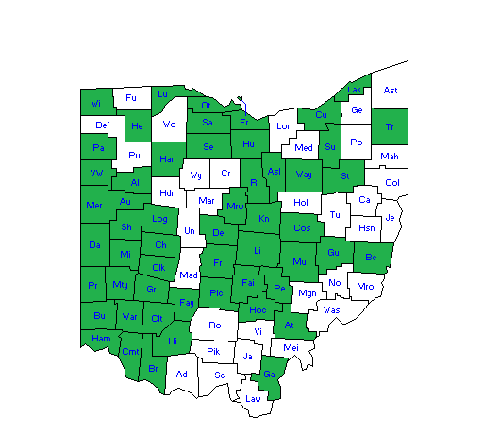

Evaluation Responses From Self Advocates / PWD

Participants at the event were provided with a paper evaluation and were sent an electronic evaluation via e-mail to the e-mail address used to register each person. A total of 34 Self Advocates provided responses to all 5 rating questions. Additionally, responses have been sorted to provided generalized understanding of who provided specific feedback (below).

Paper Evaluations Received = 20
Electronic Evaluations Completed = 12
Response Rate = 15%

Question 1: On a scale of 1 to 10, with 10 being the best, how would you rate the DD Awareness and Advocacy Day Event: Celebrate Community?

Total Score = 305
Average Rating = 9.5

Question 2: On a scale of 1 to 10, with 10 being the best, how would you rate the speakers at the event?

Total Score = 285
Average Rating = 8.9

Question 3: On a scale of 1 to 10, with 10 being the best, how would you rate the registration and check in at the event?

Total Score = 302
Average Rating = 9.4

Question 4: In your opinion, what was the best part about the day?

STABLE Account – Great Speakers

Meeting Mike DeWine and Rob McColley and Jim Hoops

Meeting Others

I liked everything

Hearing the speakers and what their jobs were in Ohio

Listening to the guest speaker

Mike DeWine

The speakers and meeting new people

Snacks and drinks and seeing Mike DeWine was cool too

The speakers

Listening to what the speakers have to say

Everything

Talking to Senator

I think Shari did a great job

Seeing all kind of stuff – handing out all the shirts

Staying in a motel, seeing the scenery, and eating at motel and pizza place

Speakers and networking

Meeting the Senator

The advocates

Meeting the representatives

Meeting with my senator or representative

The speakers. Shari Cooper was great.

Speakers

Getting to talk to the Representatives

Going and meeting some of the people from the state

Speaking with state officials

Hearing the newly elected Governor and Director of DD speak

Meeting with the legislators

Governor took time to come, speak, and stay a while on same day as State of State Address + most other speakers very good as well.

Question 5: In your opinion, what could we do better?

Larger ladies room

Nothing

Have better instructions for registration

It was a very nice event – was happy to attend this year

Nothing, because the more jobs we have the more we make. God Bless you all and Go Bucks!

Visit with legislators

Get people more jobs

As someone with a visual and hearing disability, I had a hard time hearing some speakers

Also have a speech given by Sherrod Brown I would have voted for him, I’m a nice person

Have speakers be louder

Nothing for me to complain about here. You all are doing great!! Keep it up!!

Vital to show himself (legislator?)

Parking

Parking

Parking

Always trying your best – do stuff we can do

Speak louder so we can hear Senator

Nothing

Serve a hot breakfast

Try to schedule when representatives are available because it’s better

Have someone help lead the way to the Senators/Representatives offices. Have bigger signs at the registration tables.

Nothing

I can’t think of anything now

Talk louder it was hard to understand what the guest speakers where saying due to sitting far back

Give parking vouchers so people can park for free. Have more parking areas available

Have adult small t shirts

Gets a bit better every year; Having fact sheets available online in advance was great

Profile of Parents/Family Members/Guardians
County Participation:
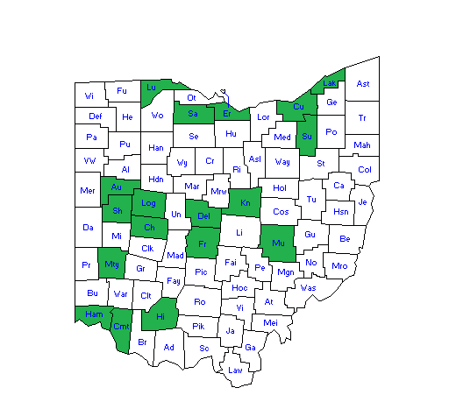

Evaluation Responses From Parents/Family Members/Guardians

Participants at the event were provided with a paper evaluation and were sent an electronic evaluation via e-mail to the e-mail address used to register each person. A total of 18 Parents, Family Members or Guardians provided responses to all 5 rating questions. Additionally, responses have been sorted to provided generalized understanding of who provided specific feedback (below).

Paper Evaluations Received = 5
Electronic Evaluations Completed = 8
Response Rate = 30%

Question 1: On a scale of 1 to 10, with 10 being the best, how would you rate the DD Awareness and Advocacy Day Event: Celebrate Community?

Total Score = 98
Average Rating = 7.5

Question 2: On a scale of 1 to 10, with 10 being the best, how would you rate the speakers at the event?

Total Score = 102
Average Rating = 7.8

Question 3: On a scale of 1 to 10, with 10 being the best, how would you rate the registration and check in at the event?

Total Score = 111
Average Rating = 8.5

Question 4: In your opinion, what was the best part about the day?

Lieutenant Governor and Governor appearances – very inspiring

Love hearing the speakers and hearing what is going on

All the speakers

Speakers and networking

Meeting others

The Governor being there

Meeting with legislators to talk about our issues

Getting to network and the speakers

Advocate speakers

Emcee Shari Cooper was entertaining and kept the program rolling

Governor stopping by!

Question 5: In your opinion, what could we do better?

Some of the speakers could have talked more slowly – although I think there was time pressure on them today due to State of the State.

It was a very nice event. Was happy to attend again this year

More stories

Have the event where there are more wheelchair van parking. We had to park 2 blocks away in the bitter cold and push my son in his wheelchair.

I’m not sure

Set up labeled areas for wheelchair seating in atrium

Parking was horrible. When having an event for people with needs, most of them use adaptive vehicles. There were not enough wheelchair van parking. We had to park 2 blocks away and walk in the bitter cold.

As a parent of a child with down syndrome, we would like some of the focus to be on children. Our struggles with school districts, IEPs and abuse. We are advocates of cameras in the classroom.

Serve a hot breakfast

Don’t schedule something at the same time (Governor’s State of the State. Advise your Representatives and State Senators to not try and duck out on their scheduled meetings. Look into the bottleneck security checkpoints that probably work for the normal visitor but not for the handicapped. Figure out a system to bypass the time consuming checkpoints. The Highway Patrol does it right, but the other security are arrogant and militaristic like TSA agents. One elevator of an entire section is inadequate. The signage in the Old building is inadequate, confusing and no posted diagrams (Again try to put yourself in the shoes of your visitors on “DD Day.” One of the visitors with Muscular Dystrophy tried to use the escalator and started to fall, fortunately someone caught her before real damage was done. The food service is inadequate. There were not enough seats in the speakers area even though everyone RSVP’s. There is an air of patronization by some of the elected officials and a few employees…more so than I have ever seen before….do better next year….really engage your guests….not same old tired state officials trying to indicate that they “feel your pain!” Don’t feel it do something tangible about it. One state senator tried to duck out her appointment, having staff say she was unavailable. One of the more aggressive members of the visiting team walked into her office and found her hiding out… when the visitor exclaimed that this was unacceptable…all of the sudden the senator became available…shame on her, but that attitude carried over to others, as well, not all but enough to make us reconsider coming back. These elected officials need to know that while not everyone is created equal (physically) that we are all equal to vote one person at a time!
Profile of County Board Participation
County Participation:
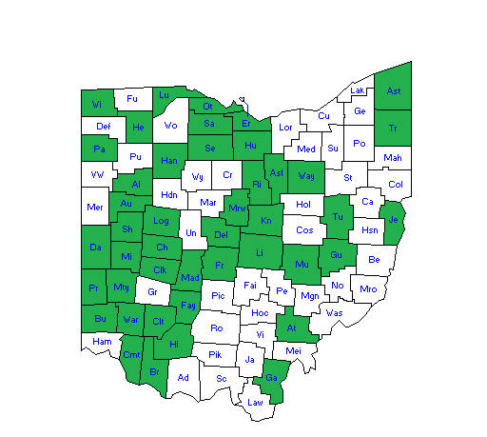

Evaluation Responses From County Board Personnel
Participants at the event were provided with a paper evaluation and were sent an electronic evaluation via e-mail to the e-mail address used to register each person. A total of 25 County Board Personnel provided responses to all 5 rating questions. Additionally, responses have been sorted to provided generalized understanding of who provided specific feedback (below).

Paper Evaluations Received = 4
Electronic Evaluations Completed = 14
Response Rate = 23%

Question 1: On a scale of 1 to 10, with 10 being the best, how would you rate the DD Awareness and Advocacy Day Event: Celebrate Community?

Total Score = 139
Average Rating = 7.7

Question 2: On a scale of 1 to 10, with 10 being the best, how would you rate the speakers at the event?

Total Score = 142
Average Rating = 7.9

Question 3: On a scale of 1 to 10, with 10 being the best, how would you rate the registration and check in at the event?

Total Score = 159
Average Rating = 8.8

Question 4: In your opinion, what was the best part about the day?

Shari Cooper, the emcee, because she was a visual reflection why choices and support can increase the quality of someone’s life

Speakers

Hearing Mike DeWine speak

I enjoyed Director Miller

Great job!

Snacks

Getting to hear the speakers at the beginning of the day

Speakers

Shari Cooper does an amazing job!

Speakers

Mike DeWine coming to speak briefly to the audience.

Being around the many advocates. Shari

Meeting and hearing from those who receive services and the success they are having in their world

Hearing advocates speak about issues that are important to them.

Question 5: In your opinion, what could we do better?

In my opinion every was excellent

Have representatives show up for meeting, not their aides. Make meetings schedule better. It is hard to meet 2 different people in 2 places at the same time.

Making more public places accessible for people with disabilities.

Although I appreciate her passion for the field, Shari is very difficult to understand.

Representative to show his ass

Meetings in the morning and afternoon and have the speakers in the middle of the day so people are not waiting for hours after the 10 a.m. speakers for a 4:30 meeting.

The tele-prompter that types what is being said

Better communication with the offices of the legislators. So they know that we are coming.

Had a great time.

It took us longer to travel than the program. It did not have enough Advocates participation. The meeting with our legislators should be removed since they are not available to meet. Just have a longer celebration.

Meetings with legislators – understandable with the State of the State address, it was difficult, but this is an ongoing issue each year.

Have more seating

Not sure if possible, but check-in might be easier if we could check by county instead of by individual. It is very difficult to hear our representative/senator or their aide when sitting in the open area.

Someone at the security check-in directing participants where to go. Wasn’t sure where to go, even with the map. Speakers weren’t even present for the breakout sessions.

While having it on the same day as the “state of the state” was insightful, it was challenging to coordinate and maneuver through the day with so much other state house activity going on.

Profile of Direct Support Professionals
County Participation:
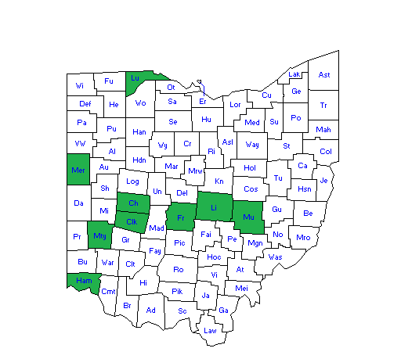

Evaluation Responses From Direct Support Professionals
Participants at the event were provided with a paper evaluation and were sent an electronic evaluation via e-mail to the e-mail address used to register each person. A total of 7 Direct Support Professionals provided responses to all 5 rating questions. Additionally, responses have been sorted to provide generalized understanding of who provided specific feedback (below).

Paper Evaluations Received = 1
Electronic Evaluations Completed = 7
Response Rate = 40%

Question 1: On a scale of 1 to 10, with 10 being the best, how would you rate the DD Awareness and Advocacy Day Event: Celebrate Community?

Total Score = 73
Average Rating = 9.1

Question 2: On a scale of 1 to 10, with 10 being the best, how would you rate the speakers at the event?

Total Score = 73
Average Rating = 9.1

Question 3: On a scale of 1 to 10, with 10 being the best, how would you rate the registration and check in at the event?

Total Score = 77
Average Rating = 9.6

Question 4: In your opinion, what was the best part about the day?

The hostess with the mostess. She did an awesome job.

I can’t just brad about one part of it. This was my first year and this will not be my last. I loved seeing every person work together to make this such a special day. I feel ever day should be fulfilled with that much laughter and happiness for everyone.

Overall everything, the speakers were inspirational, seeing friends from all over the state, and meeting with our representative.

Listening to speakers

I don’t have one specific thing; it was all good.

That the event exists and developmental disabilities are being given a day at the Statehouse.

Question 5: In your opinion, what could we do better?

Have representatives actually seem interested in hearing from constituents.

I honestly have no complaints to post on here.

We did not get a chance to ask our questions to our state representative because of time and others who took a long term expressing their concerns/asking their questions.

Profile of Other Professionals
County Participation:
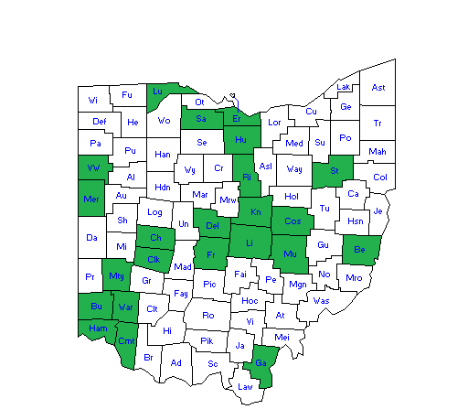

Evaluation Responses From Other Professionals
Participants at the event were provided with a paper evaluation and were sent an electronic evaluation via e-mail to the e-mail address used to register each person. A total of 19 Direct Support Professionals provided responses to all 5 rating questions (1 evaluation left a rating blank on question 2). Additionally, responses have been sorted to provide generalized understanding of who provided specific feedback (below).

Paper Evaluations Received = 0
Electronic Evaluations Completed = 10
Response Rate = 15%

Question 1: On a scale of 1 to 10, with 10 being the best, how would you rate the DD Awareness and Advocacy Day Event: Celebrate Community?

Total Score = 86
Average Rating = 8.6

Question 2: On a scale of 1 to 10, with 10 being the best, how would you rate the speakers at the event?

Total Score = 84
Average Rating = 8.4

*The zero reflects a blank answer – average adjusted for this blank answer.

Question 3: On a scale of 1 to 10, with 10 being the best, how would you rate the registration and check in at the event?

Total Score = 80
Average Rating = 8.0

Question 4: In your opinion, what was the best part about the day?

Hearing from speakers about current events and future plans for the state.

Seeing all and meeting with people around the county

Speeches

Meeting legislators

Meeting with Representatives

I loved seeing the outflowing of support from legislators!

Hearing individuals advocating for themselves and being confident and proud to do so.

Hearing self-advocates talk

Hearing from leadership that are prioritizing the needs of the developmental disability community

Question 5: In your opinion, what could we do better?

Registration was a bit confusing; it was hard that the day was scheduled with the state of the state. I think this is why our reps did not meet with us.

I don’t know right now.

Have enough chairs for everyone who registers. Although the Statehouse is beautiful, a larger place would help. Maybe have the legislators more accessible, there was a lot of walking back and forth.

Make sure the speakers read their speech before the event. It seemed like a lot of the state cabinet was just there for the photo op and their speeches didn’t make sense. DeWine did surprisingly well but it was evident that Jon Husted didn’t even proof read his.

Bigger area with more seats.

Make sure that the designated speakers are available.

This is probably a pie in the sky wish, but giving people the options of which legislators to meet with when coming from a professional perspective which serves multiple counties. One of my assigned legislative groups was huge and the other much smaller. I’d rather have spent my time in smaller groups. However, I realize this is a lot to coordinate!!

Evaluation Responses From N/A – Non-Identified Category

Participants at the event were provided with a paper evaluation and were sent an electronic evaluation via e-mail to the e-mail address used to register each person. A total of 7 responses were provided from individuals who did not provide a category identification. These evaluations are provided to show general feedback received that does not fit into one of the categories identified above.

Paper Evaluations Received = 1
Electronic Evaluations Completed = 0

Question 1: On a scale of 1 to 10, with 10 being the best, how would you rate the DD Awareness and Advocacy Day Event: Celebrate Community?

Total Score = 8
Average Rating = 8.0

Question 2: On a scale of 1 to 10, with 10 being the best, how would you rate the speakers at the event?

Total Score = 9
Average Rating = 9.0

Question 3: On a scale of 1 to 10, with 10 being the best, how would you rate the registration and check in at the event?

Total Score = 9
Average Rating = 9.0

Question 4: In your opinion, what was the best part about the day?

We love to hear from everyone, especially the advocates!

Question 5: In your opinion, what could we do better?

The construction noise made it hard to concentrate and hear the speakers. Also need to have 3X shirts for larger people. I heard more than 1 person ask for bigger shirts. (Thanks for getting the noise stopped)

