the

We

Light Refreshments to follow the ceremony

**Please join us in**

**awarding the**

**Community Connections**

**Career Partnership – Ohio**

**Students**

**The Certificate of Initial Proficiency**

**and**

**The Certificate of Advanced Proficiency**

**Tuesday, May 21, 2019**

**2:00 PM**

**Franklin Heights High School**

**Auditorium**

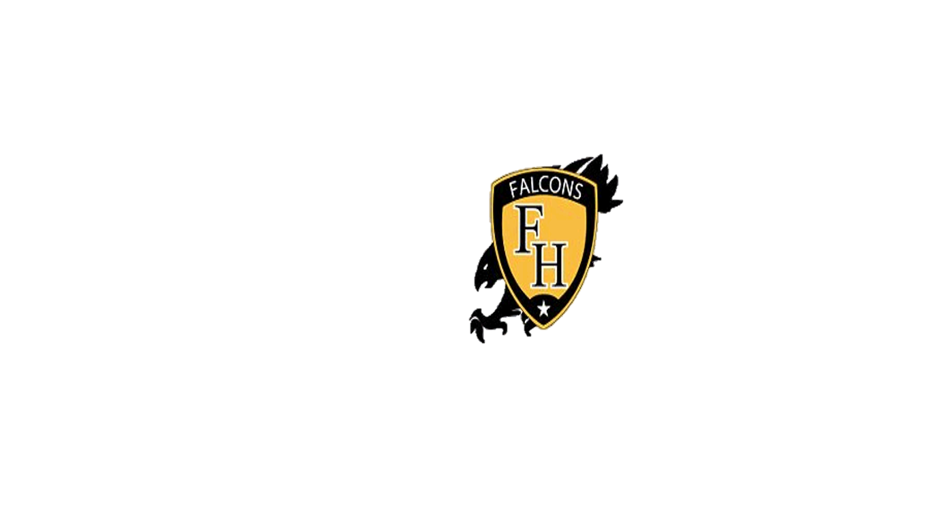

DSPaths

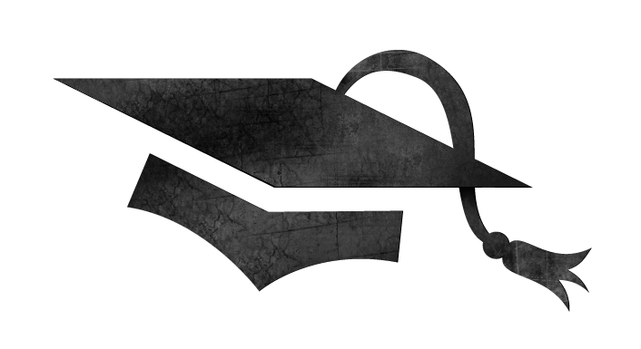

DSPaths

