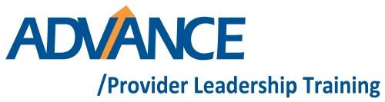

**All Trainings will be held at the OPRA offices**

**List of Training Dates & Outline Curriculum**

**May 22, 2014 10A-2PM**

*Complete Strength Finders 2.0 Assessment (Prior to the Meeting, sending to Jamie by 5/15)*

Introductions and Outline of the program

Meet the leadership facilitation team and assign coaches

Overview of Strength Finders and Strengths Based Leadership

Get into the “weeds”, What does your strengths say about you as a leader and how you can look for people with different strengths to round out a productive team?

**July 24, 2014 10AM-2PM**

*READ PRIOR TO MEETING: Primal Leadership & The Truth about Leadership*

Developing a definition of leadership & management

Servant Leadership

The truth about leadership

Leading with Emotional Intelligence

**September 18, 2014 10A-2PM**

*READ PRIOR TO MEETING: Good to Great*

Good to Great and the social sector overview, 4 Stages

Process to achieve organizational greatness

The “Tool Box” for leaders

**November 20, 2014 10A-2P**

*READ PRIOR TO MEETING: The Five Temptations of a CEO*

Discussion on the Five Temptations of a CEO

**January 15, 2015 10A-2P**

*READ PRIOR TO MEETING: Start with Why*

Discussion of Start with Why

**February 25, 2015 10A-2P**

Attend OPRA Board Meeting as guests

**March 19, 2015 10A-2P**

*READ PRIOR TO MEETING: The Five Dysfunctions of a Team*

**Guest Speaker:** OPRA Staff

**Guest Speaker:** Board Members

Discussion of The Five Dysfunctions of a Team

Leader Assessments

**April 2015**

Graduation recognition at the OPRA spring conference

**Guest Speakers:**

- History of service providers in Ohio

- Human Resources

- Marketing

- CEO’s The highs and lows

- Strategic Planning & Board Development

- Coaches Table

- Development and Fundraising

- Finance

- Aging and our DD System