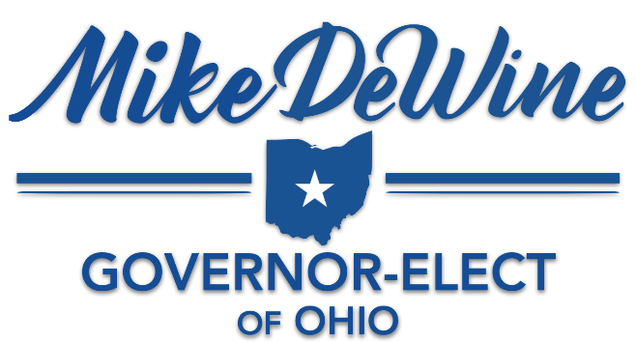

FOR IMMEDIATE RELEASE  Thursday, January 10, 2019 |  | MEDIA CONTACT  Joshua Eck | (614) 549-2846
DeWine nominates additional cabinet heads

COLUMBUS— Ohio Governor-elect Mike DeWine today announced additional nominees for Members of the Governor’s Cabinet as well as appointed a Senior Advisor for Criminal Justice Policy.

URSEL MCELROY
Nominee for Director of the Department of Aging

Ursel McElroy has a wealth of experience in both local and state government with specific focuses on eldercare and programs aiding those in poverty. Her career began at the Franklin County Department of Jobs and Family Services and was a Case Management Supervisor for the Franklin County Office on Aging. She served as the Chair of the Ohio Coalition for Adult Protective services through 2008 and worked in the Office of the Ohio Attorney General for 10 years as the Deputy Director of Education and Policy where she managed the establishment of the Ohio Elder Justice Initiative. She has also held key roles at the Ohio Department of Youth Services and the Ohio Department of Job and Family Services.

McElroy earned a Bachelor’s Degree in Psychology and a Master’s Degree in Public Administration, both from The Ohio State University. She resides in Columbus.

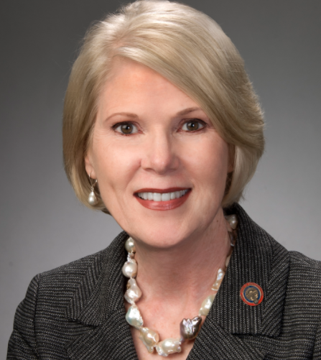 | DOROTHY PELANDA  Nominee for Director of the Department of Agriculture  Dorothy Pelanda’s career in public service began in 2011 when she was appointed to the Ohio House of Representatives. In 2015, Pelanda was elected by her colleagues to serve as House Majority Whip. In 2017, she was elevated to the position of Majority Floor Leader, the number three position in the House of Representatives.  A graduate of Marysville High School, Miami University, and the University of Akron School of Law, Pelanda recognizes the value of education in pursuing ones’ dreams and has fought to provide opportunities to young Buckeyes to achieve their own.  Pelanda practiced law in her own private practice for nearly 30 years, where she represented hundreds of clients from Union County and the surrounding area.  She has called Ohio home all her life and still lives on the farmland in Marysville, where she was raised. Pelanda is married to Sam Gerhardstein and they have three adult children.
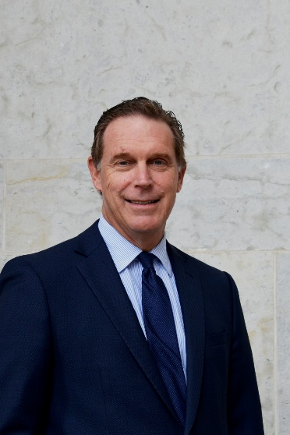 | JEFFREY DAVIS  Nominee for the Director of the Department of Developmental Disabilities  Jeffrey Davis is a longtime public servant, having began his career with former Ohio Senate President Richard Finan. He also served for over ten years at the Ohio Department of Developmental Disabilities, most recently as the Deputy Director for Constituent Services.  Davis currently serves as the Director of Government Relations and Interim Executive Director for the Ohio Provider Resource Association (OPRA), which represents 150 organizations across Ohio that provide services to over 15,000 Ohioans with developmental disabilities.  Mr. Davis is a member of the Ohio Board of Professional Conduct and a Member of the City Council for Grove City, Ohio.
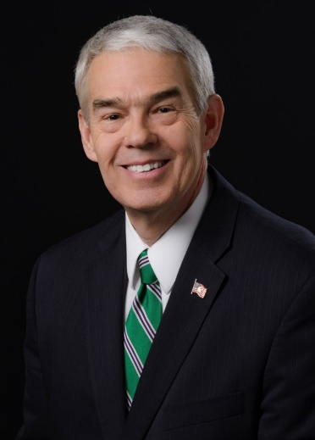 | RANDY GARDNER  Nominee for Chancellor of the Department of Higher Education  Randy Gardner is a longtime legislative leader in Ohio, having served in either the Ohio House or Ohio Senate since 1985. He currently serves as Majority Floor Leader of the Senate.  Prior to his service in state government, Senator Gardner taught high school history and government. He most recently served as Chairman of the Senate Finance Subcommittee on Higher Education and on the Senate Standing Committee on Workforce and Economic Development.  Senator Gardner resides in Bowling Green with his wife, Sandy, and their three children, Brooks, Christina, and Austin.
JILLIAN FROMENT
Nominee for Director of the Department of Insurance

Jillian Froment has been the Director of the Ohio Department of Insurance since 2017. She has been a member of the department’s senior staff since 2011 when she joined as Chief Administrative Officer before being named Deputy Director.

Froment has over 15 years of public sector and executive experience with a reputation for streamlining organizations and realizing operational efficiencies. Prior to her state service, she was the City Administrator for the City of Marysville. She was also the inaugural Executive Director for eTech Ohio, an agency created to consolidate the state’s investment in the telecommunications networks used by Ohio’s public broadcasters and the K-12 education community.

Director Froment earned a Bachelor’s Degree in Engineering from The Ohio State University and a Juris Doctorate from Capital University.

KIMBERLY HALL
Nominee for Director of the Department of Jobs and Family Services

Kimberly Hall presently serves as senior vice president of administration and general counsel at Columbus State Community College. Kim joined Columbus State in 2012, and she provides executive guidance on College policy, administration and strategic initiatives. Kim’s leadership portfolio includes supervision of the Legal Office, Human Resources Department, Equity and Compliance Office, Police Department, Facilities Management Division and the Shared Governance Office. She also serves as liaison to the Board of Trustees for the development and implementation of Board policy.

Prior to joining Columbus State, Kim served as deputy chief counsel for Attorney General Mike DeWine. Kim has served as deputy chief counsel for the Ohio Department of Education and, early in her career, she practiced as a labor and employment attorney with the Vorys, Sater, Seymour and Pease firm and the Littler Mendelson firm. She serves on the Board of Directors for the Columbus School for Girls and the YWCA of Columbus.

Kim is the founder and president of the Olive Tree Foundation for Girls, a non-profit organization that provides mentoring, enrichment programs and scholarships for young women. She received her Bachelor’s degree from Columbia University in the City of New York and her Juris Doctorate from Fordham University School of Law.

LORI CRISS
Nominee for Director of the Department of Mental Health & Addiction Services

Lori Criss has over 20 years of operations and leadership experience with addiction and trauma treatment. She has extensive experience in policy related to recovery housing, opiate addiction, and integrated physical and behavioral healthcare.

She is an active member of of recovery community, including sitting on the National Alliance of Recovery Residences (NARR), an organization dedicated to supporting individuals in recovery from substance use disorders.

Chriss holds a Master’s Degree from The Ohio State University College of Social Work. She resides in suburban Columbus with her husband, Scott, and their two daughters.

MAUREEN CORCORAN
Nominee for Director of the Department of Medicaid

Maureen Corcoran is the President and founder of Vorys Health Care Advisors where she has worked on a variety of health care policy issues and with a number of provider groups. Prior to this, she gained extensive experience in public service as the Assistant Deputy and Acting Deputy for Medicaid at the Ohio Department of Jobs and Family Services. She also served as a Human Services Policy Advisor to Ohio Governor Richard Celeste and as the Chief of the Office of Healthcare Cost Containment policy for the Ohio Department of Health.

Before beginning in public service, Corcoran was the Assistant Director of Nursing for University Hospitals in Cleveland and a Clinical Instructor for Case Western Reserve University. She earned a Master’s Degree in Nursing and a Masters of Business Administration in Finance, both from Case Western Reserve University.

Prior to her work in state government, Corcoran

JACK MARCHBANKS
Nominee for Director of the Department of Transportation

Jack Marchbanks is currently the assistant director for business and human resources at the Department of Transportation where he is responsible for the management of the department’s 5,000 employees and the development of ODOT’s $3.3 billion dollar budget. Jack is responsible for the strategic direction of the agency’s finance, human resources, IT, legal and communications divisions and the opportunity, diversity and inclusion programs. In addition, he has served as the department’s district six deputy director twice.

Previously, Marchbanks worked in the private sector as a Marketing Director for PRIME AS Group, a minority-owned architectural and engineering firm.

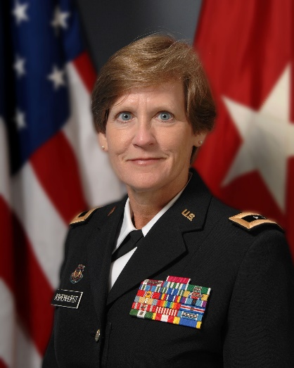 | MAJOR GENERAL (RETIRED) DEBORAH ASHENHURST  Nominee for Director of the Department of Veterans Services  Major General (Retired) Deborah Ashenhurst retired from the U.S. Army and the National Guard in October 2015 after over 37 years of service. She served at all levels of command and in 2011 was appointed to the gubernatorial-level cabinet position of adjutant general of the State of Ohio, commanding the 17,000 service members of the Ohio National Guard, the Ohio Naval Militia and the Ohio Military Reserve. She served as adjutant general until January of 2015. Her career culminated in service as a special assistant to the vice chief, National Guard Bureau in Washington DC.  Prior to her appointment as the adjutant general, she was a 25-year federal employee in various positions of increasing responsibility with the United States Property and Fiscal Office with the Ohio National Guard.  Upon retirement from the military, General Ashenhurst served as the senior vice president, military strategy with R2 Associates.  She served as a commissioner on the Ohio Military Facilities Commission and served as a member of the Synod Council of the Southern Ohio Synod of the Evangelical Lutheran Church of America. General Ashenhurst resides with her husband, Colonel (Retired) Jim Ashenhurst in Hilliard, Ohio.
RYAN GIES
Nominee for Director of the Department of Youth Services

Ryan Gies is currently the deputy director of the Division of Parole, Courts and Community for the Ohio Department of Youth Services. The division includes three bureaus—Parole, Community Facilities, and Courts and Community Services—as well as a number of initiatives involving community facets of Ohio’s juvenile justice system. Among these are RECLAIM Ohio, Targeted RECLAIM, Competitive RECLAIM, Behavioral Health / Juvenile Justice and other subsidies; state-funded community corrections facilities; private residential treatment facilities for male and female youth in DYS custody; inspection of county juvenile detention centers; coordination of the Juvenile Detention Alternatives Initiative (JDAI); competitive grant funding; alternative revenue streams; and compliance with and grants received per the Juvenile Justice and Delinquency Prevention Act. Parole supervision of youth released from DYS facilities is coordinated through two parole regions, with five district offices located in Akron, Columbus, Cleveland, Dayton and Toledo.

Gies has worked for the Department since 1993, including the positions of bureau chief of subsidies and grants, subsidies manager, and community corrections monitor. Throughout his career he has worked with community programs for youth and subsidy funding to the county juvenile courts, including RECLAIM Ohio and the Youth Services Grant. His education includes a Master of Public Administration degree from The Ohio State University and a Bachelor of Arts degree from Syracuse University in policy studies and magazine journalism.

Hall holds a Bachelor of Arts from Cedarville University and a Juris Doctorate from Washington University School of Law in St. Louis, Missouri.

STEPHANIE MCCLOUD
Nominee for Administrator of the Bureau of Workers’ Compensation

Stephanie McCloud has significant workers’ compensation experience in both the public and private sectors. She has extensive leadership experience in the private sector as a practicing attorney, McCloud previously had a lengthy career in public service as a Staff Attorney and a fiscal officer at the Ohio Bureau of Workers’ Compensation, an Assistant Deputy Legal Counsel to Governor George Voinovich, and a number of different senior positions in the Attorney General’s Office, including Chief Counsel and Senior Deputy Attorney General.

McCloud earned a Bachelor’s Degree in Journalism from Ohio University and a Juris Doctorate from Capital University Law School.

LAURIE STEVENSON
Nominee Director of the Environmental Protection Agency

Currently Laurie Stevenson is the deputy director for business relations at the Environmental Protection Agency (EPA). She acts as a primary contact for regulated entities to help coordinate permitting activities within the agency, particularly for complex projects requiring multiple permits. In addition, she serves as an agency contact to help coordinate compliance assistance-related education and outreach activities. She also acts as the agency’s ombudsman in assisting regulated entities with problem-solving related to permitting and regulatory issues.

Stevenson has worked at Ohio EPA for 20 years. She most recently served as the director's industrial liaison and chief of the Office of Compliance Assistance and Pollution Prevention (OCAPP). OCAPP is an independent office within Ohio EPA that helps small businesses achieve compliance with environmental regulations and helps all businesses reduce waste. She continues to provide oversight of this office. Previously, Stevenson managed Ohio EPA's Small Business Assistance Office for six years. She also held positions in Ohio EPA's Division of Hazardous Waste Management, starting in the Southeast District Office as a hazardous waste field inspector.

Stevenson earned a bachelor's degree in environmental health from Bowling Green State University and a master's degree in public health from The Ohio State University.

ANDY WILSON
Senior Advisor for Criminal Justice Policy

Andrew Wilson has served as the Prosecuting Attorney for Clark County, Ohio since 2011. He also served in the Ohio National Guard and achieved the rank of Lieutenant.

Prior to his election as Clark County Prosecutor, Wilson worked in the civil section representing the townships and agencies within Clark County. He was later assigned to the criminal division where he specialized in prosecuting cases involving violence against women.

Wilson currently resides in Northridge, Ohio with his wife, Libby, and their two daughters.

# # #

Mike DeWine and Jon Husted are the Governor-elect and Lt. Governor-elect of Ohio having been elected in the General Election on November 6, 2018. They take office on January 14, 2019.

