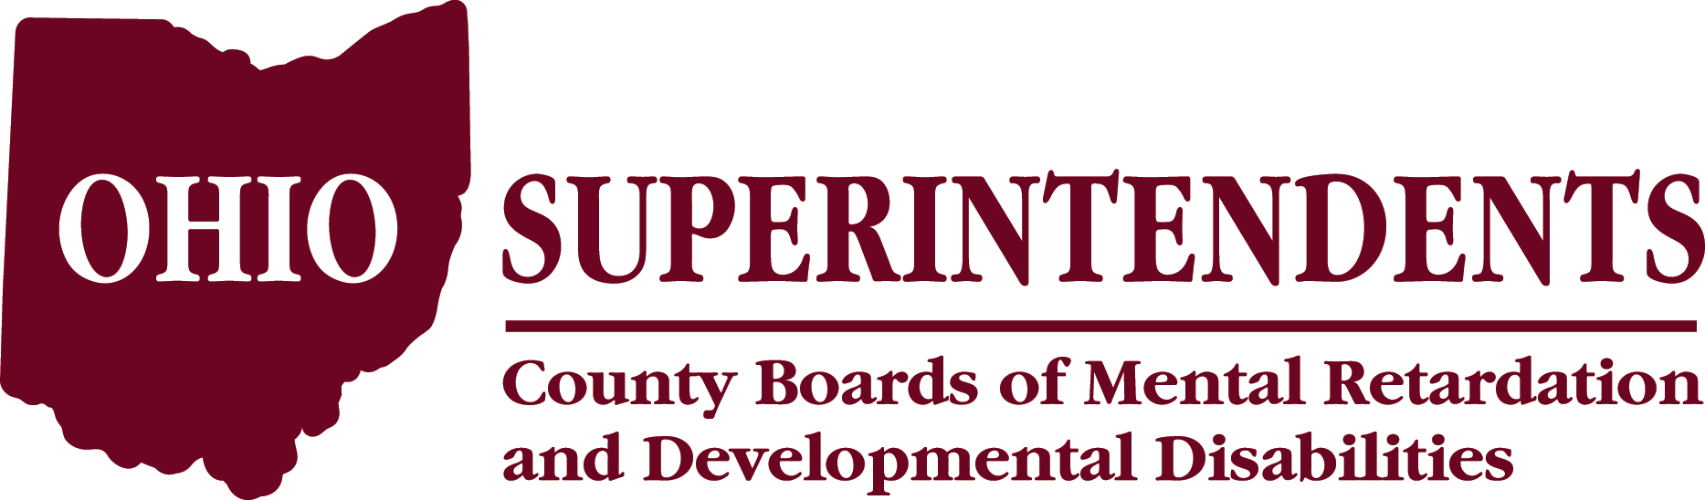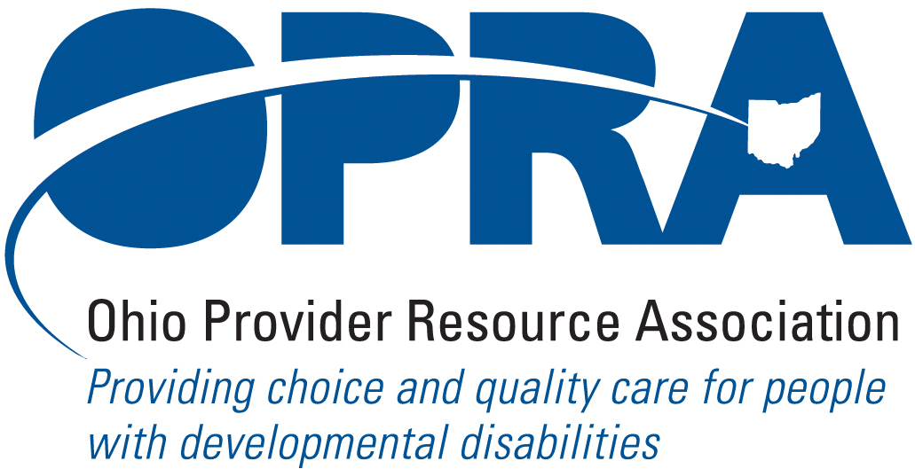

Call for Presentations

In the Spring of 2008 and at the request of leadership of the Ohio Superintendents’ Association and the Ohio Provider Resource Association, a workgroup was convened to re-establish and discuss the need for continued collaboration between County Boards of DD & private providers. Through the leadership of Cheryl Phipps, Superintendent,
(Hamilton County Board of MRDD) and Mark Davis, President (OPRA) numerous projects have been undertaken to strengthen these relationships at the local level.

One outcome was the decision to co-sponsor a one-day Symposium to allow for presentations on successful collaborations and hear about preparation for the biennial budget process. The 2008 Collaboration Symposium was a HUGE success!

We are now soliciting proposals related to successful collaborations between County Boards of DD and private providers of services for the 2009 Annual Collaborative Symposium to be held on November 17th 2009 at the The Westin – Columbus located @ 310 S. High Street. Columbus, OH 43215. Sessions will be held from 9-4 on that day.

Last year’s symposium included presentations from agencies from throughout Ohio and included successful collaborative strategies in serving individuals with developmental disabilities. A listing of presenters from last year’s conference is attached for your review. To submit a proposal each applicant must complete a session description form. Representatives from each collaborative partner must be willing to co-present at the symposium. The audience will include Superintendents, Executive Directors, Program Managers, Service and Support Administrators and other mid-level management employees of County Boards of DD and private providers. Presentations should include details on why the collaborative effort was initiated; the benefit to the individuals supported and served; and the reason why the partnerships made the initiative successful. Each presentation will be ½ hour. Three to four concurrent collaborative sessions will take place at one time. We hope new initiatives that have been developed in the past year will apply.

Each room will have microphones for presenters and projectors for visual presentations. Participants will need to bring jump drives with POWERPOINT presentation materials loaded on the drive. Written materials will be duplicated for participants if received one-week prior to the training. Please click here to submit a proposal..

Submission deadline is October 15, 2009 EXTENDED TO OCTOBER 21, 2009
2008 Presentations
Working with Offenders with Mental Retardation
- Cuyahoga County Board of MRDD
- Grand Manner, Inc. , Madison, OH
Dual Diagnosis Intervention Team Collaboration
- MHRS of Allen, Auglaize Hardin Counties
- Warren and Clinton County Board of

- MRDD

Southeast Ohio Autism Center
- Washington County Board of MRDD
- HAVAR, Inc., Athens, OH
Autism Respite Program
- Hamilton County Board of MRDD
- Ohio Valley Residential Services
Community Intervention Services
- Sunshine Inc. of Northwest Ohio
- Lucas County Board of MRDD

Northstar Advantage – Eliminating Aversive Interventions
- Hamilton County of MRDD
- Ohio Valley Residential Services
Respite: An Answer to Coshocton County Families
- Echoing Hills Village, Inc.
- Coshocton County Board of MRDD

