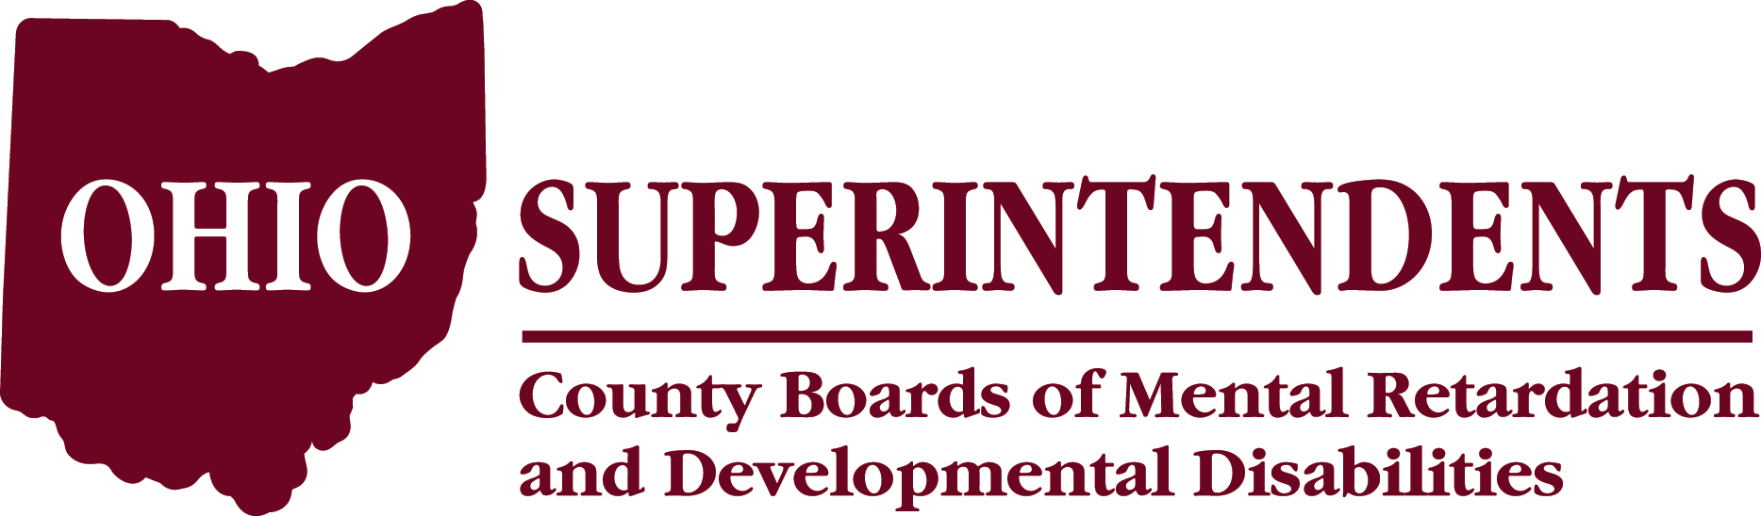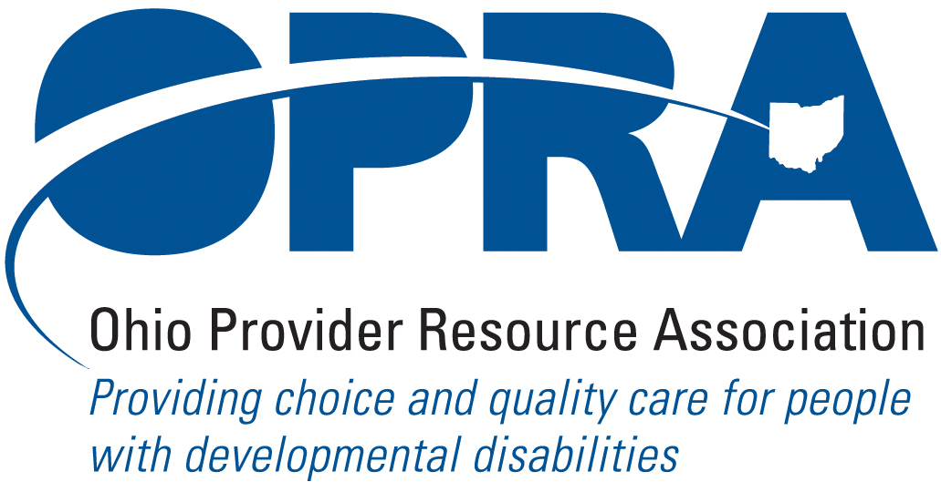

2009 Collaborative Symposium
In the Spring of 2008 and at the request of leadership of the Ohio Superintendents’ Association and the Ohio Provider Resource Association, a workgroup was convened to re-establish and discuss the need for continued collaboration between County Boards of DD & private providers. Through the leadership of Cheryl Phipps, Superintendent, (Hamilton County Board of MRDD) and Mark Davis, President (OPRA) numerous projects have been undertaken to strengthen these relationships at the local level.
One outcome was the decision to co-sponsor a one-day Symposium to allow for presentations on successful collaborations and hear about preparation for the biennial budget process. Registration is now open for the 2009 Collaboration Symposium which will be held on November 17th 2009 at the The Westin – Columbus located @ 310 S. High Street. Columbus, OH 43215. Sessions will be held from 9-4.
The agenda includes updates from the collaborative workgroup, poster sessions showcasing collaborative projects, concurrent breakout sessions about collaborative partnerships and updates from state and local agency personnel. Registration is $75 and includes lunch.
Please click here to go to the registration website. Invoicing for this event will be administered by OPRA.

