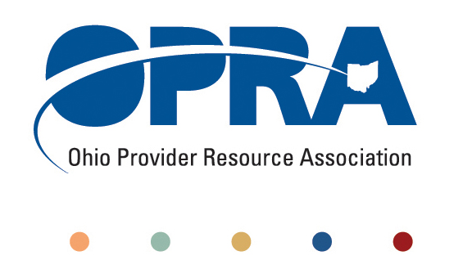
OPRA POLICY COMMITTEE AGENDA
Monday, July 11, 2011
10AM – 2PM
OPRA OFFICE
1152 Goodale Blvd, Columbus, OH 43212

You have several parking options: front of the building on the street, front parking lot adjacent to the right of the building, lot behind the building, lot across the alley behind the building, other legal street parking. Lunch options are a short drive from the office.

- Convene Meeting **Please turn off cell phones or place on vibrate. Thanks.
- State budget and Legislative Update
  - Revenue Report
  - **Special Presentation by Jeff Davis**
House Bill 153 (budget bill) - impact on DD and related services
- Simplification and Efficiencies Strategic Focus Area
  - Adult Day Services Training Requirements
  - SSA and Program Management Functions Grant Report
  - Deeming
- Reimbursement and Direct Support Professional Wages Strategic Focus Area
  - Direct Support Professional Wages, Benefits, Training And Supervision
    - 2011 Compensation, Benefits and Turnover Survey
  - Waiver Reimbursement Update
    - New waiver services
    - Waiver reimbursement pilot
    - Waiver reimbursement federal financing
  - IAF Modernization
- Waiting List and Unmet Needs
- Membership/Member Services
- Rules Summary
- Federal Issues
  - HCBS regulations comments
  - CMS Region 5 Summit
- Other Items
- Schedule:

Next Policy Committee Meeting – Monday, August 15th
- Program Directors Committee Meeting – Thursday, July 14th
- Coleman Institute and ANCOR Technology Summit – October 12 – 14th (www.colemaninstitute.org)

OPRA 2011 Fall Conference, Embassy Suites Hotel, October 25th - 26th
- Ethics Law Training, December 7th
- Positive Culture Trainings in August and September – see website for specific dates – www.opra.org
******Waiver Utilization Reduction Meeting will immediately follow the Policy Meeting from 2-3 PM. All are welcome to attend. ******

