

ADD’S BUCKEYE CONNECTIONS
ONGOING ACTIVITY SCHEDULE
WINTER QUARTER 2010

Program Start Date: 1/12/10

Monday Tuesday Wednesday Thursday Friday

DAY  OSU  RPAC  12:30-3:30  ___________  Golf  12:30-1:30 p.m.  Walleyball  1:30-2:30 p.m.  Swimming  2:30-3:30 p.m. | DAY  OSU  ARC  12:30-3:30  ___________  Soccer  12:30-1:30 p.m.  Flag Football  1:30-2:30 p.m.  Basketball  2:30-3:30 p.m. | DAY  OSU  RPAC  12:30-3:30  ___________  Volley Ball  12:30-1:30 p.m.  Racquetball  1:30-2:30 p.m.  Creative Dance  2:30-3:30p.m. | DAY  OSU  ARC  12:30-3:30  ___________  Soccer  12:30-1:30 p.m.  Flag Football  1:30-2:30 p.m.  Basketball  2:30-3:30 p.m. | DAY  OSU  RPAC  12:30-3:30  ___________  Swimming  12:30-1:30 p.m.  Creative Dance  1:30-2:30 p.m.  Walleyball  2:30-3:30 p.m.
EVENING  OSU  NCBC  4:30-5:30 p.m.  ______________  Next Chapter Book Club  4:30 p.m. –  5:30 p.m. | EVENING  OSU  Main Campus  4:00-6:00 p.m.  ______________  Campus Exploration  Activity  4:00-6:00 p.m. | EVENING  OSU  RPAC  4:30-6:30 p.m.  _______________  Sports/Fitness  Management  Internship  4:30 p.m.-  6:30 p.m. | EVENING  OSU  URBAN ARTS  4:00 -7:00 p.m.  ______________  Event Development Internship  4:00-7:00 p.m. | EVENING

Contact:
Amanda N. Johnson
Campus Activity Manager
ADD’s Buckeye Connections
810 W. Third Ave.
Columbus, OH 43212
614-439-7820
ajohnson@addohio.org
ACTIVITY DESCRIPTIONS:

Swimming:
Engage in monitored free swim and fun water activities while swimming with an Outreach Instructor and OSU Students at the Recreation and Physical Activity Center.

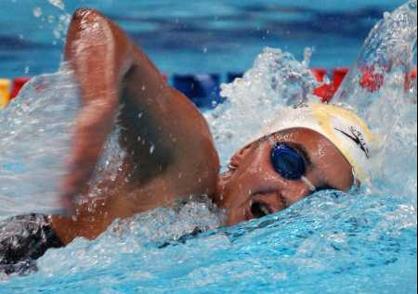

Walleyball:
Enjoy competing against peers and OSU Staff as an Outreach Instructor coordinates a structured game of Walleyball at the Recreation and Physical Activity Center.

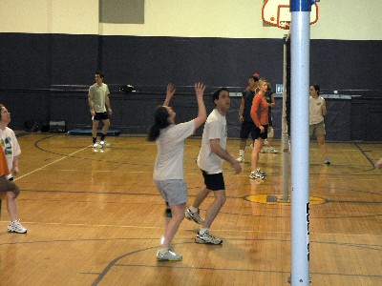

Golf:
Learn to golf, receive personalized attention, and practice your skills with Golf Lessons provided by an Outreach Instructor at the Recreation and Physical Activity Center.

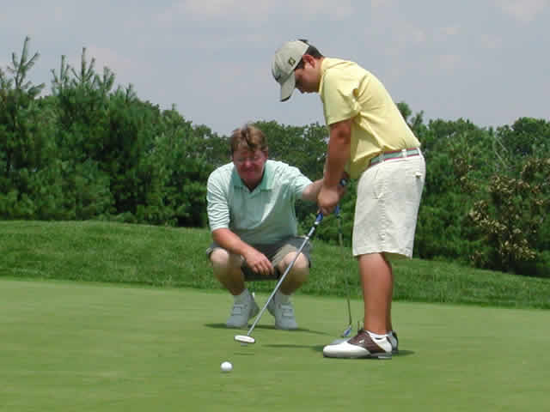

Flag Football:
Engage in football activity, without having to tackle, with peers and OSU Students, as games are monitored and coordinated by Outreach Staff at the OSU ARC on a turf field.

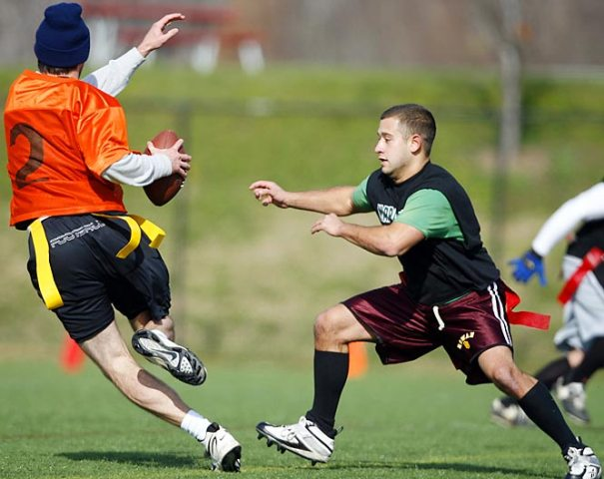

Basketball:
Feel like a professional as you engage in basketball on teams with peers and OSU Students, with games coordinated by Outreach Staff at the OSU ARC.

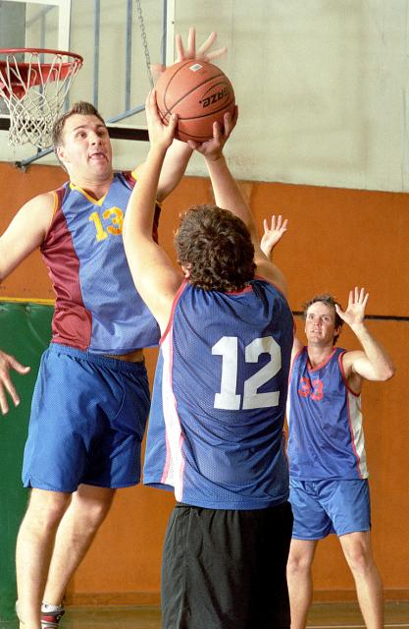
Soccer:
Kick it, and score! Engage in soccer on teams with peers and OSU Students, with games coordinated by Outreach Staff at the OSU ARC on a turf field.



Volley Ball:
Bump, set, and spike the ball with peers in competitive games of volley ball, monitored by Outreach Coordinators at the Recreation and Physical Activity Center.

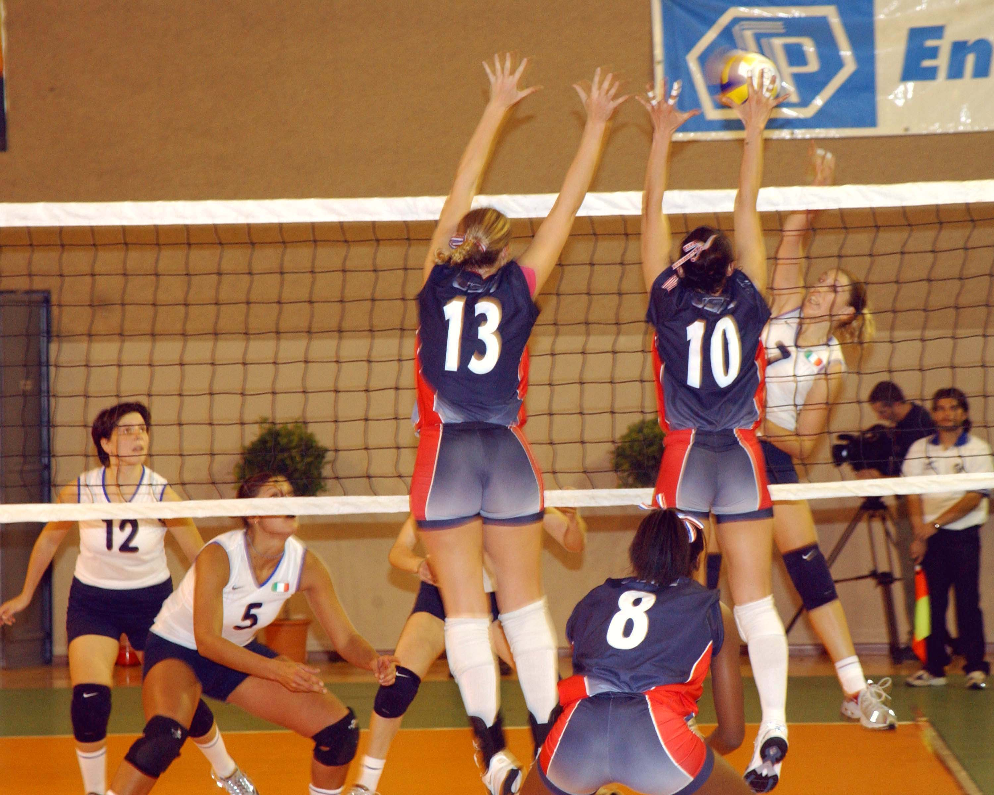

Racquetball:
Keep up and practice hand-eye coordination skills, with the help of an Outreach Coordinator, as you engage in Racquetball against OSU Students and peers at the Recreation and Physical Activity Center.

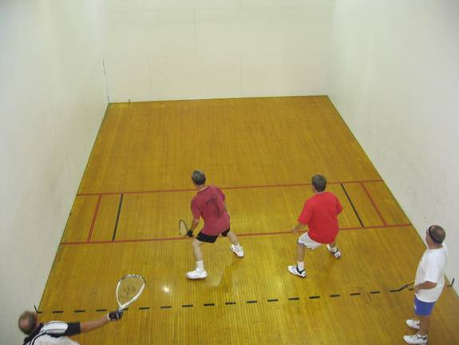

Creative Dance:
Perhaps the most fun way to exercise! Engage in creative dance of every kind, along side OSU Students and an Outreach Instructor at the Recreation and Physical Activity Center.

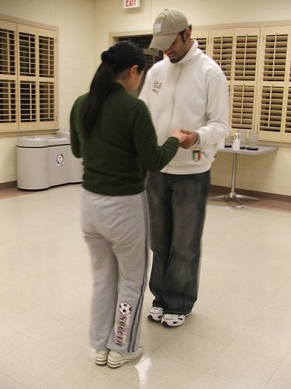

RPAC Sports/Fitness Management Internship:
Assist in Sports and Fitness Management alongside RPAC Staff; Interact with gym members, Learn to manage weight equipment, Check out fitness supplies, Conduct Head Counts throughout the facility, Change Towels along side staff, and more as an official OSU RPAC Fitness Intern!

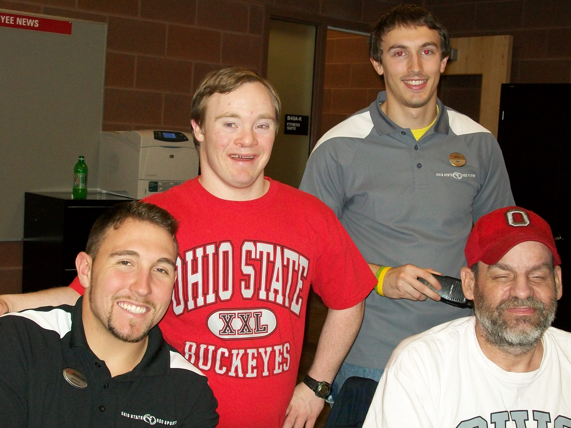

OSU Urban Arts Event Development Internship:
Assist in set up for all special events and engage with OSU Students, Staff, and visitors while participating in those events as an official OSU Urban Arts Intern, such as Special Arts Courses, Live Performances, and Gallery Exhibits!

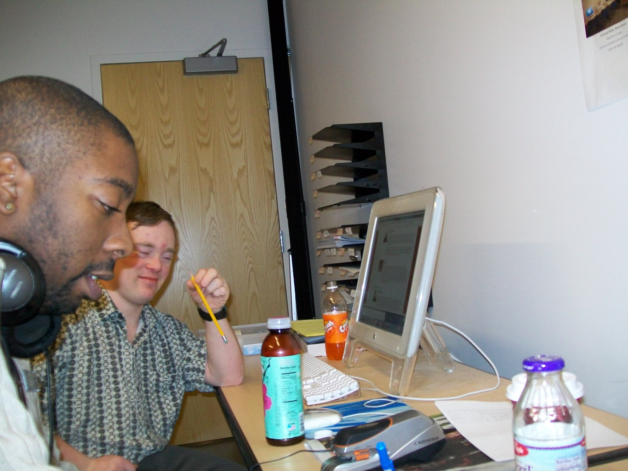

OSU Next Chapter Book Club:
Join us for group reading sessions on OSU campus. You pick the books, and enjoy reading your selections along with OSU Student Staff, hold discussions, and take advantage of socialization opportunities!

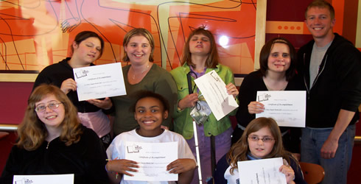

Campus Exploration Activity
Experience new sites and activities on main campus at The Ohio State University each week during our exploration sessions, accompanied by our Buckeye Connections Staff and OSU Students!

