

INTRODUCING OPRA’S SERVICE PROVIDER DIRECTORY

Linking You to Individuals Searching for Services in Ohio.

The Ohio Provider Resource Association’s (OPRA) Service Provider Directory (SPD) offers vital information for individuals with developmental disabilities, caregivers, and support professionals. This online guide features a comprehensive list of resources for individuals, families, and professionals searching for service providers in the DD system. The directory is easy to use and provides an extensive database that puts people in touch with providers that serve individuals with disabilities.

STEP 1 - Please visit our website at www.opra.org

You can drag/stretch all of the icons for clearer images
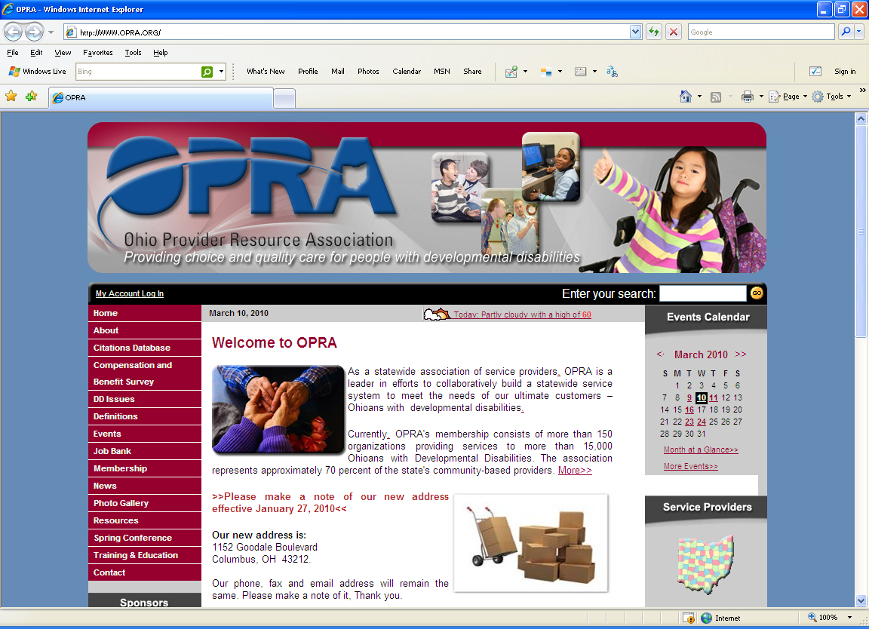

STEP 2 – VERY IMPORTANT: OPRA Members, you must have an online account to edit your Service Provider Directory. Click Here to create your online account using the Executive User link. You will need your membership dues information to complete your online registration form.
On this page, you will create a User ID & Password
(Please Note: Your User ID & Password is case sensitive)
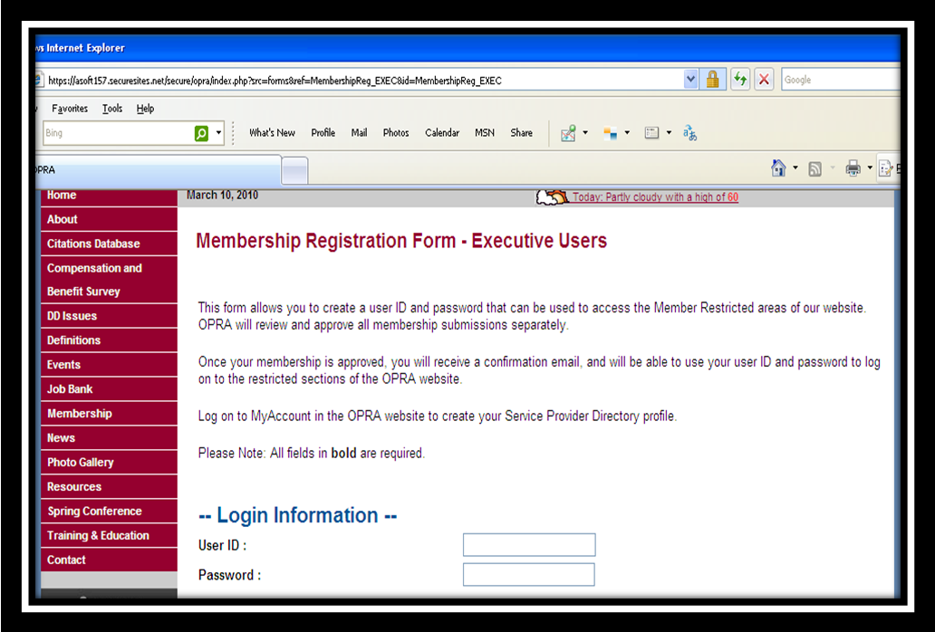

STEP 3 – Once you have successfully completed the Executive membership form, please log into your “My Account” page.

Having Trouble Logging In? If you are unable to log in, try the following: Check your spelling and Caps Lock key. Usernames and passwords are case sensitive. "JoeBrown" and "joebrown" are not the same. If you are still having problem, reset your password by clicking on the “Forgot My Password” link on the My Account page. OPRA will assign you a new temporary password and e-mail it to you.
On this page, type in your User ID and Password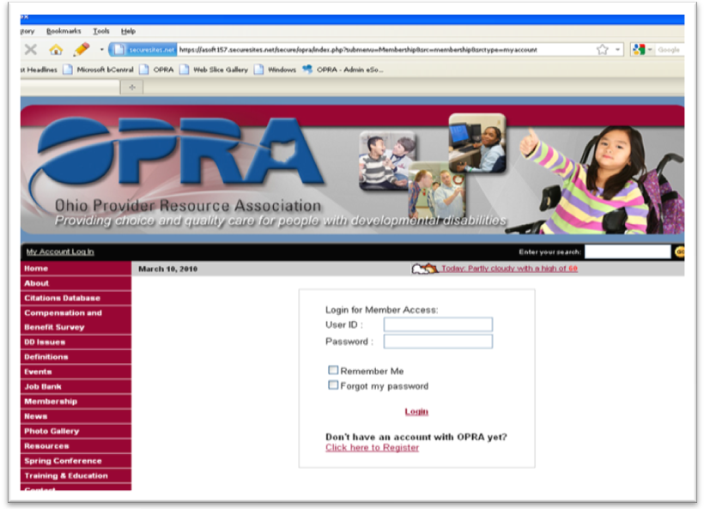

STEP 4 – Click on the Login button and it will take you to the “My Account Page” as shown below.
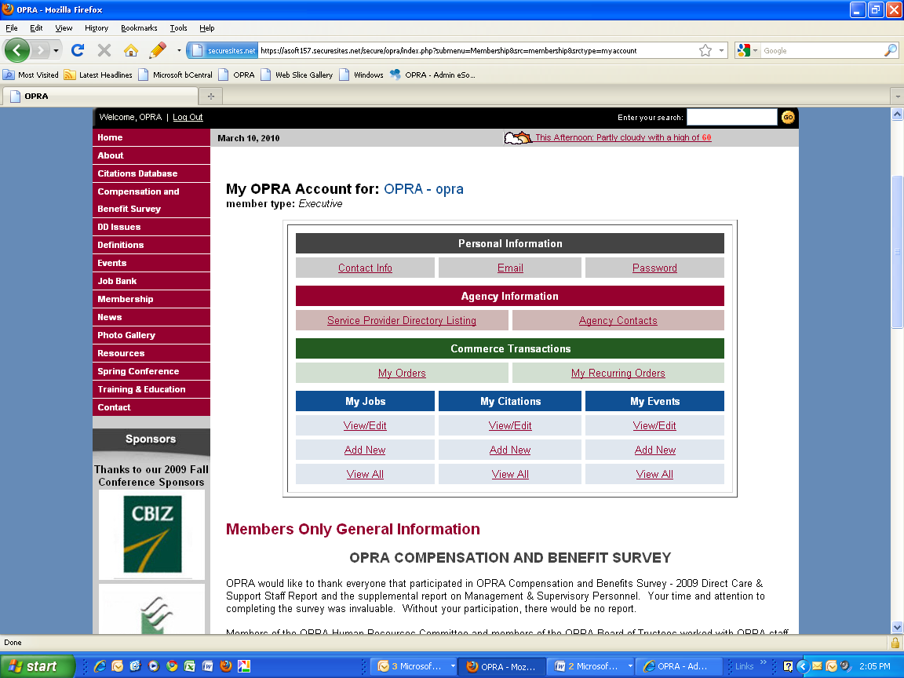

STEP 5 - Once you have logged in, you will have access to the Service Provider link. Please click on the link to enter the following information.
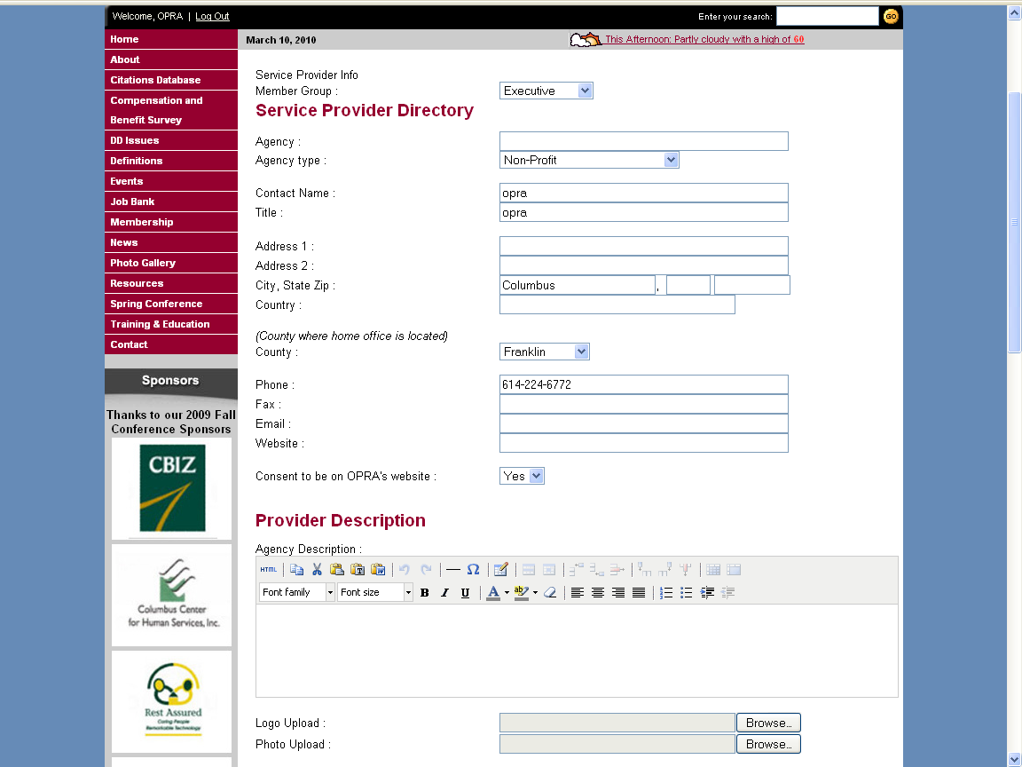
STEP 6 – Additional Information you should know about uploading your logo/picture. Please see below. Please allow 24 – 48 hrs for your images and page to display on our website.

*** Only jpg, jpeg, png, gif. Format images will be accepted.

- logos should not exceed 150 x 150
- Banners should be no larger than 550 pixels wide pixels.
- Agency pictures will be placed right at the top of the agency description. Images will be placed on this spot automatically when they are uploaded to the "agency picture" field in Blue. Keep in mind that the width of your content area (the central white area between the two side columns of your website) is 550 pixels. In case you want to place a banner at the top of an agency description, the banner should be no larger than 550 pixels wide. The height of photos and banners may vary without breaking the layout.
Please Note: Your County, Funding and Service Information were captured on your Executive Membership Form.
Click on the links below to see an example of a complete Service Provider Directory Page:
- REM Ohio
- Evant, Inc.
- Viaquest
If you have any questions about the Service Provider Directory, please contact Natalie Gayle at ngayle@opra.org or 614/224-6772 ext. 112.

