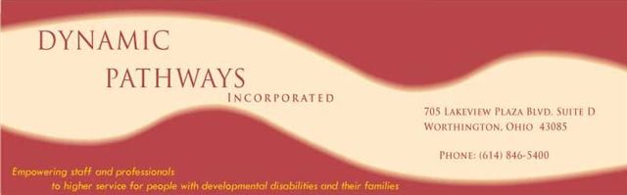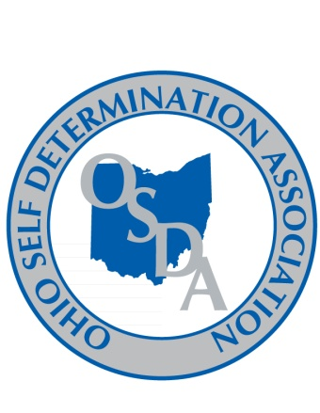

Looking for Training Modules & Best Practice!
(SSA and Program Management)

The Ohio Department of Developmental Disabilities [DODD] has established a goal of improving the processes and outcomes for the function of service and support administration [SSA] and Program Management in residential and day service settings. DODD awarded a grant to the OPRA/APSI/Superintendents Association Relationship Committee to provide the analysis and recommended tools to achieve the DODD’s goal.
The OPRA/APSI/Superintendents Association Relationship Committee has contracted with the Ohio Self Determination Association (OSDA) and Dynamic Pathways, Inc. (DPI) to carry out the work involved in the grant.
Deliverables in the grant include identifying existing training modules, best practice, and what may be needed in the future.
Although voluntary, OSDA and DPI encourage ALL providers and county boards participate in this part of the grant project. All who submit the information requested will be recognized as collaborative partners.
- We are asking that each County Board of DD and each Provider agency answer the following questions:
- What is your current caseload size for SSA and Program Management staff?
- Are they specialized caseloads? If, yes, please explain.
- What are the educational requirements/ experience backgrounds of the SSA’s/ Program Managers?
- What training modules do you currently use to train SSA’s/ Program Managers?
- Is there training that you consider best practice?
- What infrastructure do you have in place to support the SSA’s / Program Managers?
- How does communication occur across provider and county board systems?
- Is training needed that you have been unable to obtain?
- Additionally, please provide copies of all training modules, processes, and media tools your agency uses for delivery of SSA or Program Management.
- Please send the information by March 4, 2011 to Sharon Travis at 4405 Galloway Rd, Sandusky, Ohio 44870. Questions may be directed to Sharon at 419/ 626-0208 Ext. 4200
THANK YOU FOR YOUR ASSISTANCE!

