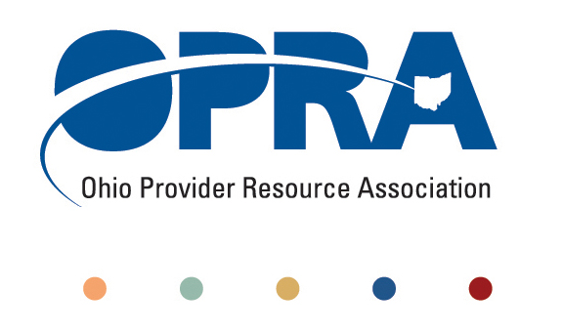
OPRA POLICY COMMITTEE AGENDA
Monday, April 25 2011
10AM – 2PM
OPRA OFFICE
1152 Goodale Blvd, Columbus, OH 43212

You have several parking options: front of the building on the street, front parking lot adjacent to the right of the building, lot behind the building, lot across the alley behind the building, other legal street parking. Lunch options are a short drive from the office.

- Convene Meeting **Please turn off cell phones or place on vibrate. Thanks.
- State budget and Legislative Update
  - ***Matt Mayer, President, Buckeye Institute – Special Guest Speaker on the Proposed Budget for the State of Ohio***
  - March Revenue Report
  - House Bill 153 (budget bill) - impact on DD and related services
- Simplification and Efficiencies Strategic Focus Area
  - Adult Day Services Training Requirements
  - SSA and Program Management Functions Grant
  - Med Admin/DN issues
  - Member Services
  - Deeming
  - Quality Assurance
  - Nursing Quality Assurance Reviews
- Reimbursement and Direct Support Professional Wages Strategic Focus Area
  - Direct Support Professional Wages, Benefits, Training And Supervision
    - 2011 Compensation, Benefits and Turnover Survey
  - Waiver Reimbursement Update
    - New waiver services
    - Remote Monitoring Assessment
  - IAF Modernization
- Rules Summary
- Federal Issues
- Other Items
- Schedule:

Next Policy Committee Meeting – Monday, May 16th
- Program Directors Committee Meeting – Thursday, May 12th

OPRA 2011 Fall Conference, Embassy Suites Hotel, October 25th - 26th
- Ethics Law Training, December 7th
- OPRA Committee Meetings (see OPRA Calendar under Events at www.opra.org)

