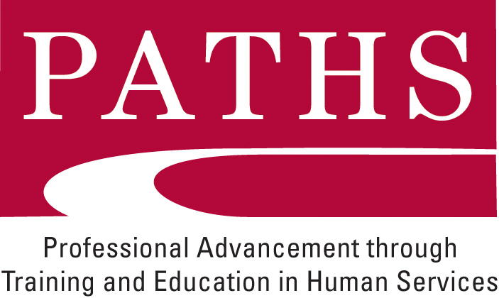
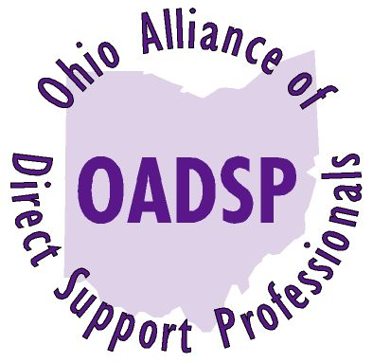 Autism Spectrum Disorder
and the Direct Support Professional

The Ohio Alliance of Direct Support Professionals (OADSP) is pleased to announce that a new Specialized Certificate Course is now available. The course entitled, “Autism Spectrum Disorder and the Direct Support Professional” will be offered in Columbus, Ohio for professionals who have completed the PATHS Certificate of Initial Proficiency (CIP). Jan Cline, an expert in the field of Autism, will be the instructor of the course and the course will consist of a variety of learning mediums including the following:
- Four on-site class sessions;
- Review of a variety of websites and written materials so that you can learn at your own pace, review materials, and sample an array of educational resources about Autism Spectrum Disorder;
- Completion of independent study questions and activities;
- Completion of a Portfolio, including three “Work Samples” that reflect your integration and application of learned information;
- Communication with a Mentor who has knowledge of Autism Spectrum Disorder with whom you will discuss questions and ideas as you progress through the material; and
- Observation and interaction with adults with Autism Spectrum Disorder in different settings to empower your confidence in advocating for, developing, and providing quality supports.

The tuition for this course is $250.00. Scholarships for all or part of the tuition may be available through your local PATHS Regional Council. Please make checks payable to OADSP.

The four class sessions will be held at the Columbus Center for Human Services which is located at 540 Industrial Mile Road, Columbus, Ohio 43228 from 9:30 AM to 1:30 PM. The dates of the classes are listed below. Students must attend all four sessions.

July 20, 2010 August 17, 2010 September 21, 2010, October 19, 2010

Registration Information:

Please submit payment and the following information to OADSP, P.O. Box 9853, Cincinnati, Ohio 45209. If you have any questions or need additional information, please contact Scott Osterfeld at sosterfeld@cinci.rr.com or 513-300-7038.

Name(s):
Date earned CIP:
Organization:
Address:
PATHS Region/Licensed Entity:
E-Mail:
Phone Number:
Total Payment =

