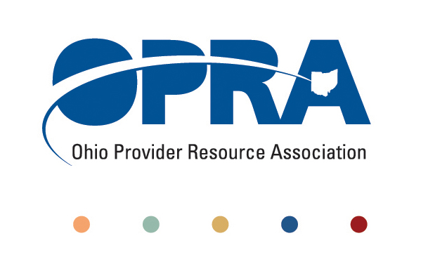
• • • • •

The Trusted Voice for Providers
Serving Ohioans with Disabilities

FOR IMMEDIATE RELEASE
March 3, 2011
1152 Goodale Boulevard, Columbus, Ohio 43212 614.224.6772 office 800.686.5523 toll free 614.224.3340 fax
www.opra.org

OHIO PROVIDER RESOURCE ASSOCIATION HIRES
(Columbus, OH) -- The Ohio Provider Resource Association (“OPRA”) announced the appointment of Jeff Davis to the position of Director of Government Relations at OPRA.

“We are pleased to have Jeff joining our leadership team here at OPRA,” said Mark Davis, President of the Ohio Provider Resource Association. “He brings a collaborative work ethic, a great deal of experience with the legislature and a history of working in the field of developmental disabilities.”

Jeff Davis most recently served as Director, Integrated Health Services, Buckeye Community Health Plan where he was responsible for emergency department diversion and the integration of physical and behavioral healthcare. Prior to Buckeye CHP, Jeff was Deputy Director at what is now the Ohio Department of Developmental Disabilities from 1991 to 2007.

“I’m looking forward to joining OPRA and making the vision of a more effective service system a reality,” Jeff Davis said.

The Ohio Provider Resource Association is the largest statewide advocacy organization representing community-based providers who serve individuals with developmental disabilities (DD). OPRA’s more than 150 members offer services to more than 15,000 individuals, families, guardians and community-based service providers working to meet the needs of Ohioans with developmental disabilities.

Founded in 1974, OPRA’s mission is to support and provide advocacy for community-based service providers to ensure availability of programs, services and funding to help Ohioans with developmental disabilities live productive and happy lives.

CONTACT:
Mark Davis
614-224-6772
mdavis@opra.org

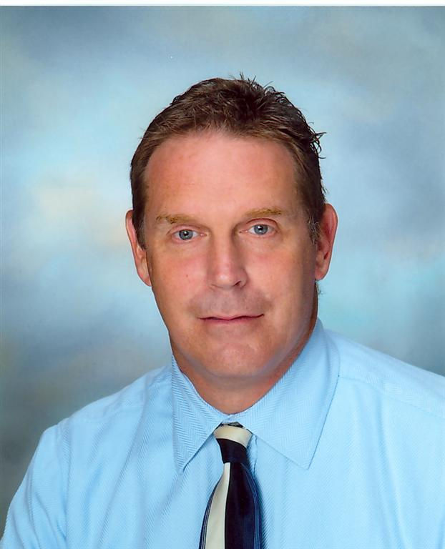
DIRECTOR OF GOVERNMENT RELATIONS
jeff davis
Director of
Government Relations

