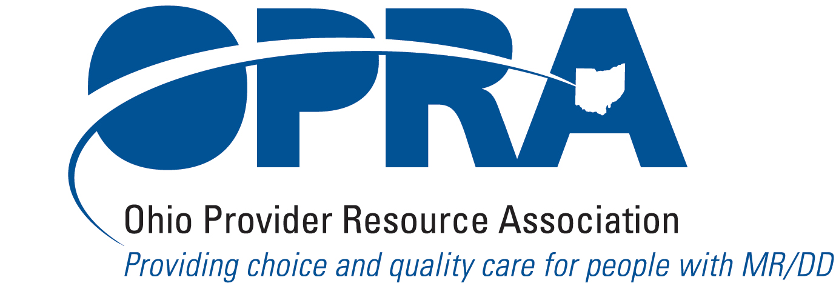
30 Spruce Street
Columbus, OH 43215
TELEPHONE: 614/224-6772
FAX: 614/224-3340
E-MAIL: opra@opra.org

To: OPRA Members

From: Mark Davis, President
Date: July 31, 2009

Re: OPRA Compensation and Benefit Survey

The 2007 OPRA Compensation and Benefits Survey was well received by our members. Issues of salaries, turnover and recruitment remain critical, especially in light of Ohio’s dire financial state. OPRA used the results of the 2007 survey in our lobbying and education efforts with legislators and state departments.

Our plan is to publish an updated survey every two years. Our hope is that the 2009 survey will be completed and available to members by October. Once again, we have contracted with Barry Associates to carry out this survey for OPRA. Barry Associates has conducted many similar surveys for other organizations in Ohio and across the country. The company’s principal, John Barry, MSW and MBS, brings significant background to this work.

The 2009 OPRA Compensation and Benefit Survey is available on the OPRA web site www.opra.org On the OPRA web site, go to the Members Only section.

Here are instructions for accessing the Members Only section of our web site:

FIRST TIME VISITOR TO THE MEMBERS ONLY SECTION OF THE WEBSITE

You will need to create a USERNAME and PASSWORD for the MEMBERS ONLY section of the OPRA website if this is your FIRST TIME visiting the members only section of the website. Click on the REGISTER HERE link to request your Username and Password. Once completed, we will receive a link for approval here in the OPRA’s office. A staff member will approve the request and you should receive an email in your inbox stating that you are now approved and can enter the Members Only section of the Website.

CURRENT MEMBER

If you have registered before on the Members Only section of the website, please click on the LOGIN link and enter your USERNAME and PASSWORD. If you forgot your username/password, then click on the "forget my password" link, enter your email address and you will be sent an email with your password. Please note that you have to know the email address that you used when you first registered. If you use a different email address that is not in our database, we will not be able to provide you with your password and you will need to follow the instructions for first time visitors.

Please contact the OPRA office at 614-224-6772 if you are having difficulty accessing the Member Only section of our web site.

Once at the Member Only section of the web site, click on Please read the entire “Introduction” tab before proceeding with the survey. Also note:

- OPRA members who complete and return the survey will receive one complimentary copy of the report. Each additional copy for OPRA members will cost $75.00.
- One copy of the report for nonmembers will cost $495.00 and each additional copy will cost $250.00.
- All results will be reported on an aggregate basis only. Individual organizations will not be identifiable when survey data are reported. To assure confidentiality, all surveys are to be returned to Barry Associates at john@barry-online.com, where the data will be tabulated, analyzed and incorporated into the final report.

- The survey contains a separate section on CEO Compensation and Benefits which will be available as a distinct report.

- Only YOUR participation can insure that this survey is an accurate and reliable source of salary and benefit data for Ohio providers. Our goal is to complete the final report by October 2009. In order to meet this timeline, we ask that the completed survey be returned by August 21, 2009.

Please do not return the completed survey to the OPRA office (excel document). Please email your survey as an attachment to john@barry-online.com. Be sure to save your data at all times before exiting the excel file.

The Survey Order Form is to be returned to OPRA.

If you have any questions about the survey itself, feel free to call John Barry Associates (919-490-8474). We look forward to seeing the results of this effort, and thank you in advance for your participation.

OHIO PROVIDER RESOURCE ASSOCIATION

2009 COMPENSATION AND BENEFIT SURVEY ORDER FORM

Please return the Survey Order Form to OPRA. Do not include payment with your order form.
You will be billed when the report is completed.

Name: _____________________________________________________________________

Title: _____________________________________________________________________

Organization: _______________________________________________________________

Address: ___________________________________________________________________

_______________________________________ Telephone: _________________

Fees for obtaining survey reports:

1. OPRA Active Member Returning Completed Survey

Free - First Copy _____ copy Free

Additional Copies _____copy(s) at $75 each = $ ______

2. OPRA Active Member Not Returning Completed Survey
1st copy at $75 each ______copy(s) at $75 each = $_______

Additional Copies _____ copy(s) at $75 each = $_______

3. OPRA Associate Member
1st copy at $150 ______copy(s) at $150 each = $_______

Additional copies _____copy(s) at $100 each = $_______

4. Non-OPRA Members
1st copy at $495 ______copy(s) at $495 each = $_______

Additional Copies ______copy(s) at $250 each = $_______

TOTAL $__________

