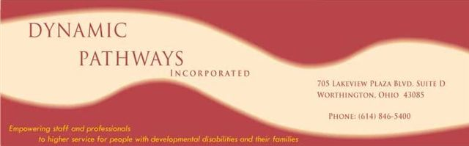 **We Need Your Help!**  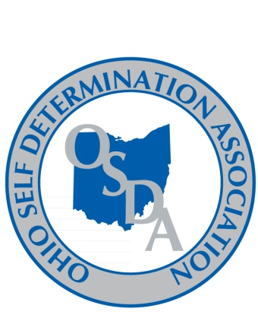

**Why?** There is an exciting project coming up to identify best practice across Ohio related to the working relationships and outcomes of Service and Support Administration [SSA] and Program Management in residential and day service settings.

The Ohio Department of Developmental Disabilities [DODD] has established a goal of improving the processes and outcomes of these two entities and have awarded a grant to the OPRA/APSI/Superintendents Association Relationship Committee to provide the analysis and recommended tools to achieve the DODD’s goal.  The OPRA/APSI/Superintendents Association Relationship Committee has contracted with the Ohio Self Determination Association (OSDA) and Dynamic Pathways, Inc. (DPI) to carry out the work involved in the grant. The grant will look at the function and roles of SSA's and Program Managers; existing training modules that support best practice; and may recommend changes to statute and rule to help make the practices of SSA and Program Management more effective. The goals of the project include greater consistency statewide, role clarification between SSA’s and program managers and enhanced involvement of individuals and families in the ISP process.

**Who?** We are looking to identify areas in the state where the functions of Service and Support Administration and Program Management in both residential and day service settings are working well. A joint application between a County Board or Council of Government and Providers is required in order to be considered for the project. Five applications will be selected to participate in the project. The selection process will involve a set of criteria outlining positive outcomes between the SSA's and Program Managers and will consider diversity of locations and size.

**How?**  The project will be carried out through a process of focus groups in each identified area. These focus groups will involve County Board SSA's; Program Managers of at least 2 providers (preferably 1 residential and 1 day service); family members; and people who receive support through the Developmental Disabilities system.

**What's Involved?** There will be a commitment of time and resources involved. Assistance will be requested to identify and contact the participants for the focus groups. Selected applicants will be requested to assist in providing a location, snacks for the focus group and, as needed, transportation and other support to ensure participation by all stakeholders. Grant funds will not be available for the focus group activities.

**When?**  Applications are due by February 23, 2011. Applications must include a paragraph outlining why the applicants believe they should be selected for the project, as well as, the attached Commitment of Support. Letters of support demonstrating diversity of opinion and outlining areas of excellence will be considered in the selection process. Requested documents may be scanned, faxed, mailed, or emailed to: SSA/Program Management Project, Attention: Mark Davis, OPRA, 1152 Goodale Blvd., Columbus, Ohio 43212 – [mdavis@opra.org](mailto:mdavis@opra.org) – Fax: 614/ 224-3340

**Questions?** Direct to [jstuntz@columbus.rr.com](mailto:jstuntz@columbus.rr.com) – [dcharlto@columbus.rr.com](mailto:dcharlto@columbus.rr.com) – [stravis@eriecbdd.org](mailto:stravis@eriecbdd.org)