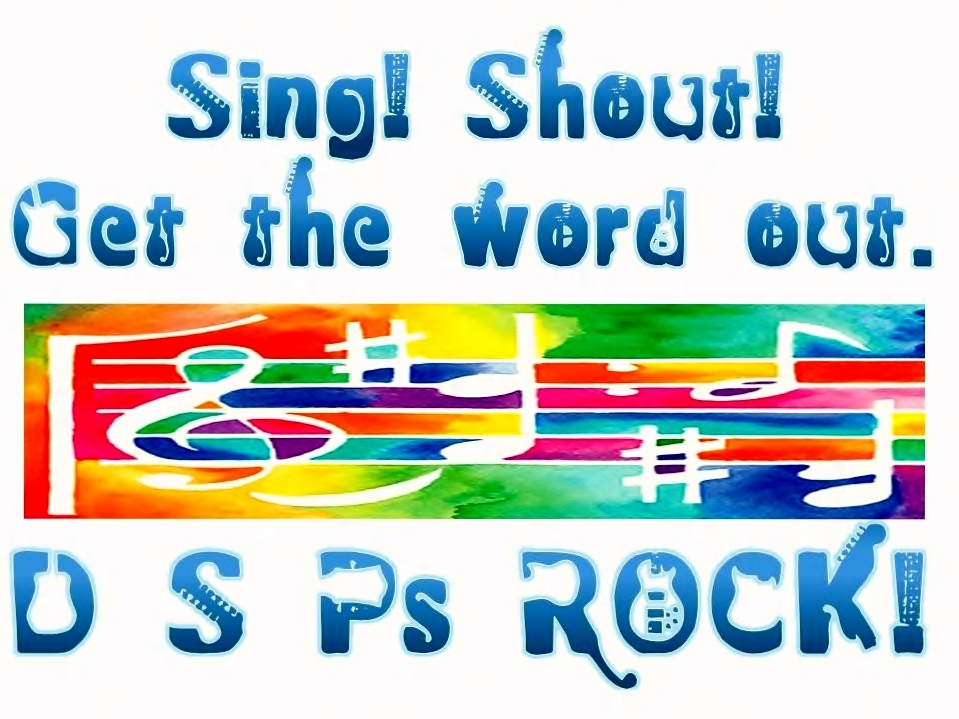
Opportunities for Sponsorship and Support

Second Annual DSP Recognition Event
September 15, 2011 – 10 – 3PM
Xenos – Columbus Ohio

A request to the community to help honor DSPs who work with people with Disabilities in Ohio

The 2010 DSP Recognition Event was an amazing success. 300 DSPs from around Ohio enjoyed a day that included lots of fun, lots of tears, and a stimulating and creative program. This event happened as a result of financial and volunteer support from over twenty agencies and dozens of people.

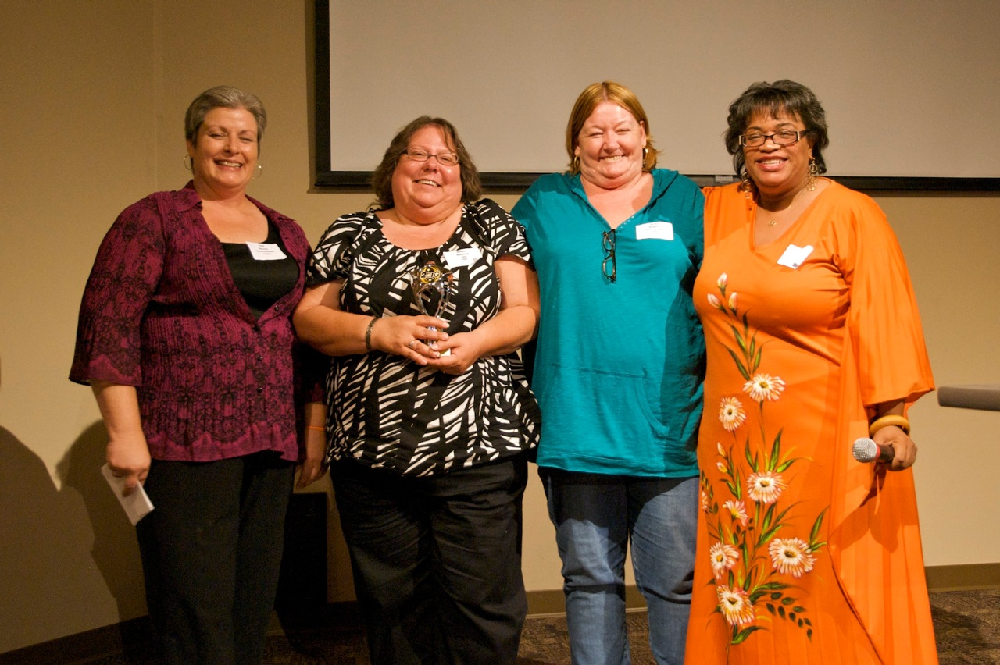
This event is free to all DSPs in Ohio so we need your help to make it happen again. OADSP is seeking co-sponsors for financial and program support. Peter Leidy will be the headliner. While he is a frequent visitor to Ohio, most DSPs never hear his message and his songs and creativity get to the heart of the work of DSPs. The program includes audio, video and an array of inspirational and fun activities. Of course lunch is provided.

In 2010 we raised over $10,000 and hope to surpass that amount this year so we can make it even better for DSPs. DSPs deserve this recognition for their important work.
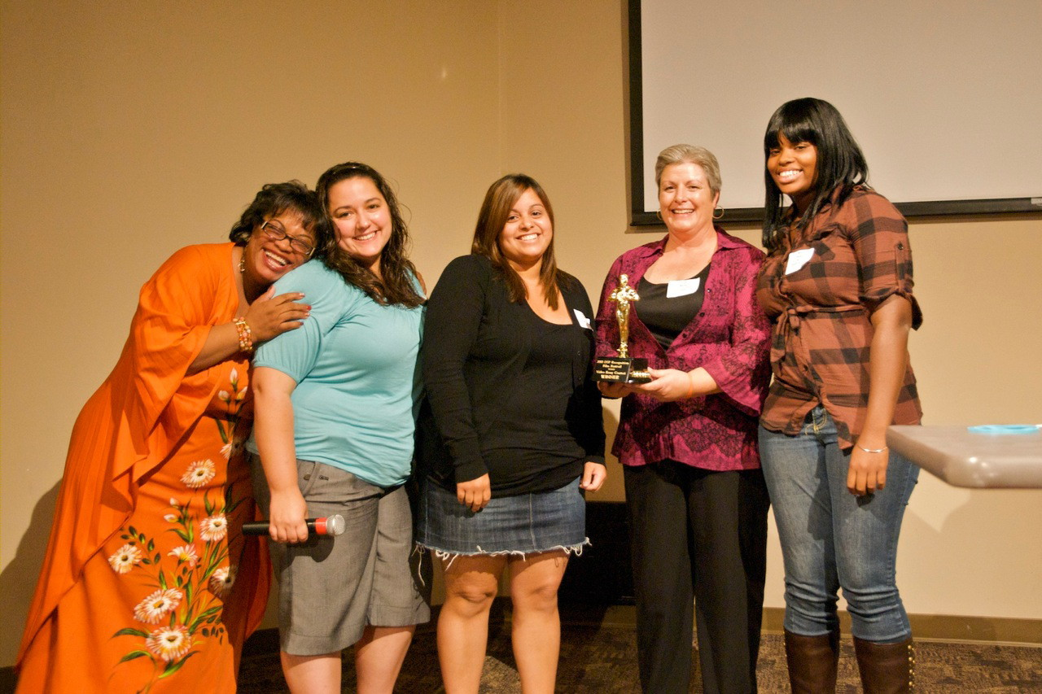
Please contribute to a special account that will be managed by OADSP. We are asking providers, county boards, and people who know and respect the work of DSPs to contribute. In 2010, donations ranged from $100 to $1000 and all donors were recognized. Those donations over $250 were especially recognized on the canvas bag filled with goodies that was given to all attendees.

Please send your contributions to OADSP, PO Box 9853, Cincinnati OH 45209 and indicate that the contribution is for the DSP Recognition Event. All funds received will be used exclusively for this event.

Thanks so much. If you have questions or suggestions, please contact Amy Gerowitz, at 513-484-2772, or agerowitz@me.com.

