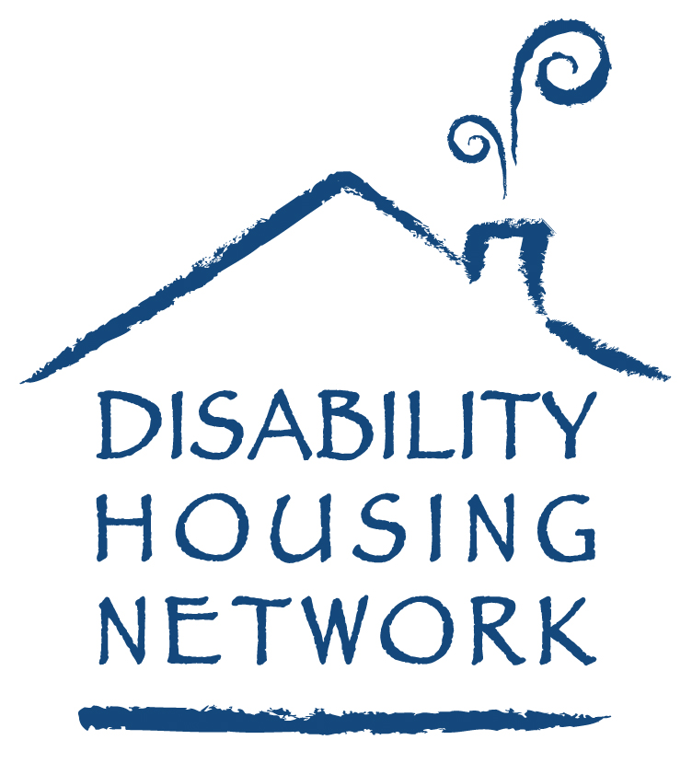

Jacalyn Slemmer Selected as
DHN Director

February 9, 2011

The Board of the Disability Housing Network announced today the Jacalyn Slemmer has been selected as the Executive Director. The DHN is non profit organization assisting housing corporations serving individuals with developmental disabilities throughout Ohio. Steve McPeake, Chairman of the DHN Board said “we are particularly pleased to have someone with Jacalyn’s broad skill set join DHN. Her experience as both a DD professional and her work with state wide low income housing developers will be invaluable now and in the years ahead”.

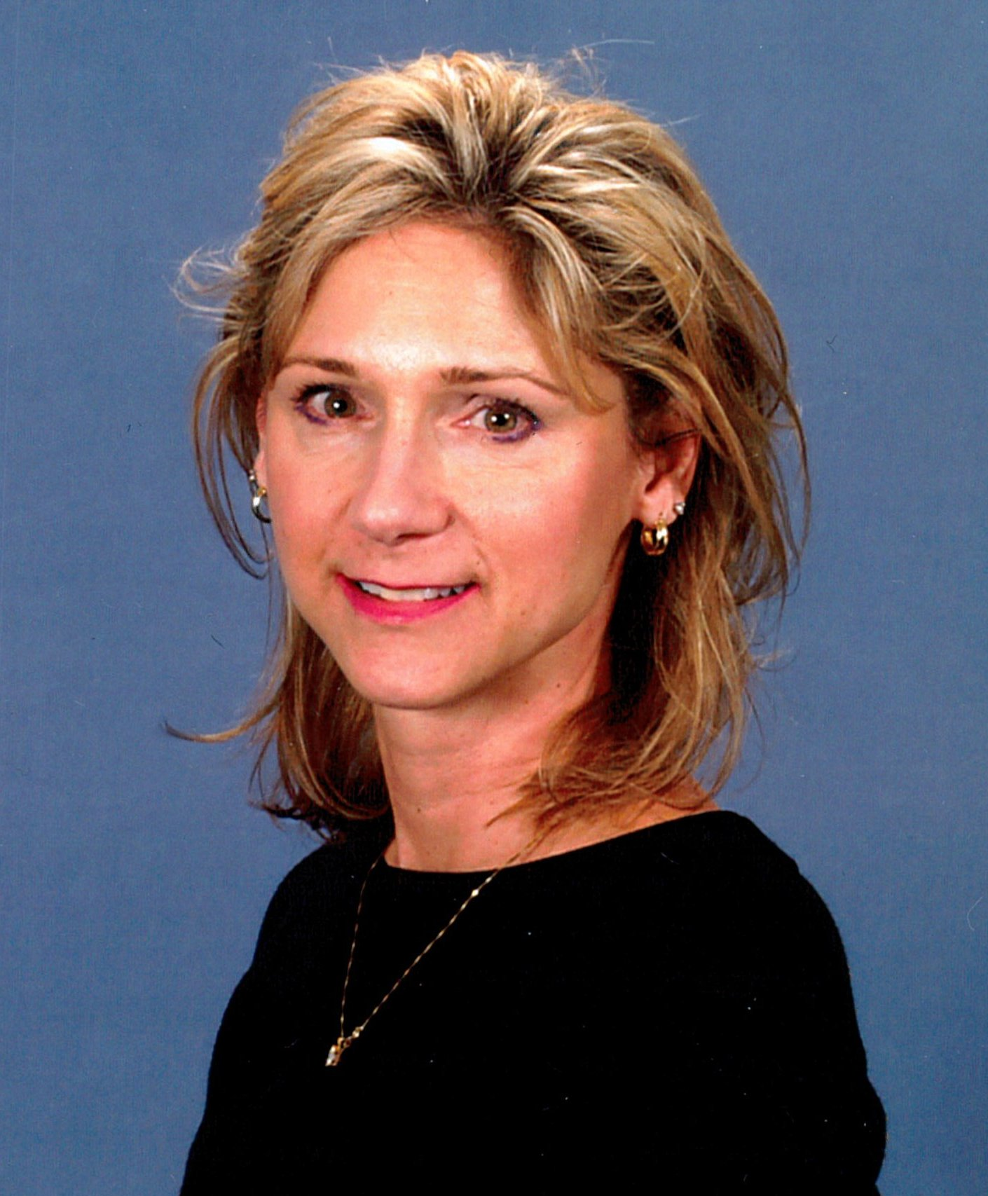
Ms. Slemmer worked in the service coordination area with the Franklin County Board of Developmental Disabilities before holding positions with the Ohio Housing Finance Agency and also the Ohio Capital Corporation for Housing. In addition she holds a Real Estate License, a bachelors degree from Ohio State University in Special Education and a MBA from Franklin University. Jacalyn also served for 20 years with the Ohio Air National Guard earning an honorable discharge as a non commissioned officer.

Ms. Slemmer will assume her duties on March 7 replacing Steve Farrell who recently resigned as Executive Director to take a position in his home town of Boston. Steve is continuing under contract with DHN to assist Ms. Slemmer in the transition period.

For additional information contact:
Steve McPeake
North Coast Community Homes
(216) 662-1880

