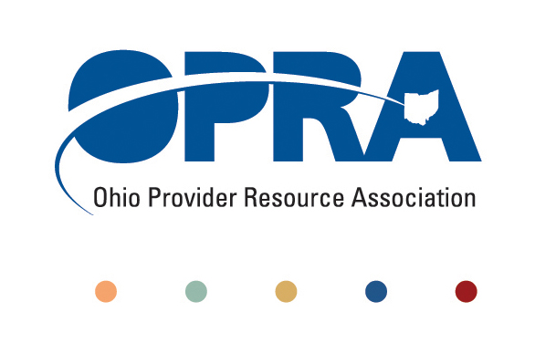

GROW 2010 MEMBERSHIP REFERRAL PROGRAM

OPRA is the respected leader for providers in Ohio. As the largest statewide advocacy group representing community-based providers serving individuals with developmental disabilities, OPRA is committed to advocating for its members and providing a strong, unified voice for the industry.

We are proud to introduce a new program that will increase the strength and power of our association, while also providing valuable benefits for current members who participate.

WHAT IS GROW 2010?
Grow 2010 is a new member referral program that offers valuable incentives when OPRA members refer new organizations to become members.

HOW IT WORKS:
We realize the power of a testimonial. Your words count. This program asks you to reach out to your colleagues in the industry who are not current OPRA members and encourage them to join forces with us to ensure quality services for all Ohioans with DD. OPRA is happy to provide you with membership materials and applications to pass along to colleagues so they can learn more about all the benefits of coming on board.

WHAT’S IN IT FOR YOU?
You choose your incentive. For each new member you refer, you will receive either $200 cash or one registration to OPRA’s spring or fall conference. If you refer three new members, you get three cash incentives or conference credits; five new members, five cash incentives or conference credits. There’s no limit to the savings you can enjoy just by talking about the importance of OPRA in the industry and how providers all over the state can reap the rewards of membership.

OPRA will also recognize your organization as a Grow Partner on the OPRA website, and in printed and e-news materials throughout the year.

Please Note: When completing the membership application, the new members must list your organization as a referral source in order to receive credit.

COMMUNICATING THE VALUE OF OPRA MEMBERSHIP:
Sharing your personal experiences about OPRA and the value of membership will play a key role in recruiting new members. Many providers are not familiar with the numerous benefits membership offers, or how our work is helping shape public policy and initiate positive changes for the entire industry.

Seeing firsthand what we do is a powerful incentive as well. Invite prospective members to district meetings, and reach out to them through other networking opportunities to ask for their support through membership. We’ve included a brief list of benefits you can refer to when describing OPRA and our mission and goals.

Member benefits include:
• Governmental, regulatory and legal representation on issues affecting providers
• Breaking news about policy developments at state and federal levels
• Networking opportunities
• Outstanding training and education resources
• Access to compensation, benefits and turnover survey results
• Valuable member discounts for services

Again, thank you for your support and helping OPRA Grow in 2010!

For more information or to request membership materials, please contact Anita Allen at 614-224-6772 or aallen@opra.org.

