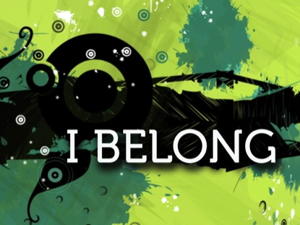

From Caregiving to Connecting:

A Provider’s New Role!

**Join us for a Day of Learning: November 29th 9- 4, Zanesville, Ohio**

**Registration Link:** [http://www.planetReg.com/E10710173105254](http://www.planetreg.com/E10710173105254)

**Our service structures and focus must change: Our leaders for the day have found a way to support people to belong.**

**Tim Vogt** – Starfire Council: Starfire has completely changed their service structure and focus; they connect people to relationships and uncover a person's talents and passions - so they can thrive in their communities alongside their neighbors.

**Joe Erpenbeck** – Asset Based Community Development Institute: Trains on connecting our gifts to create vibrant, safe and inclusive communities.

Brought to you by the imagiNetwork sponsors: 