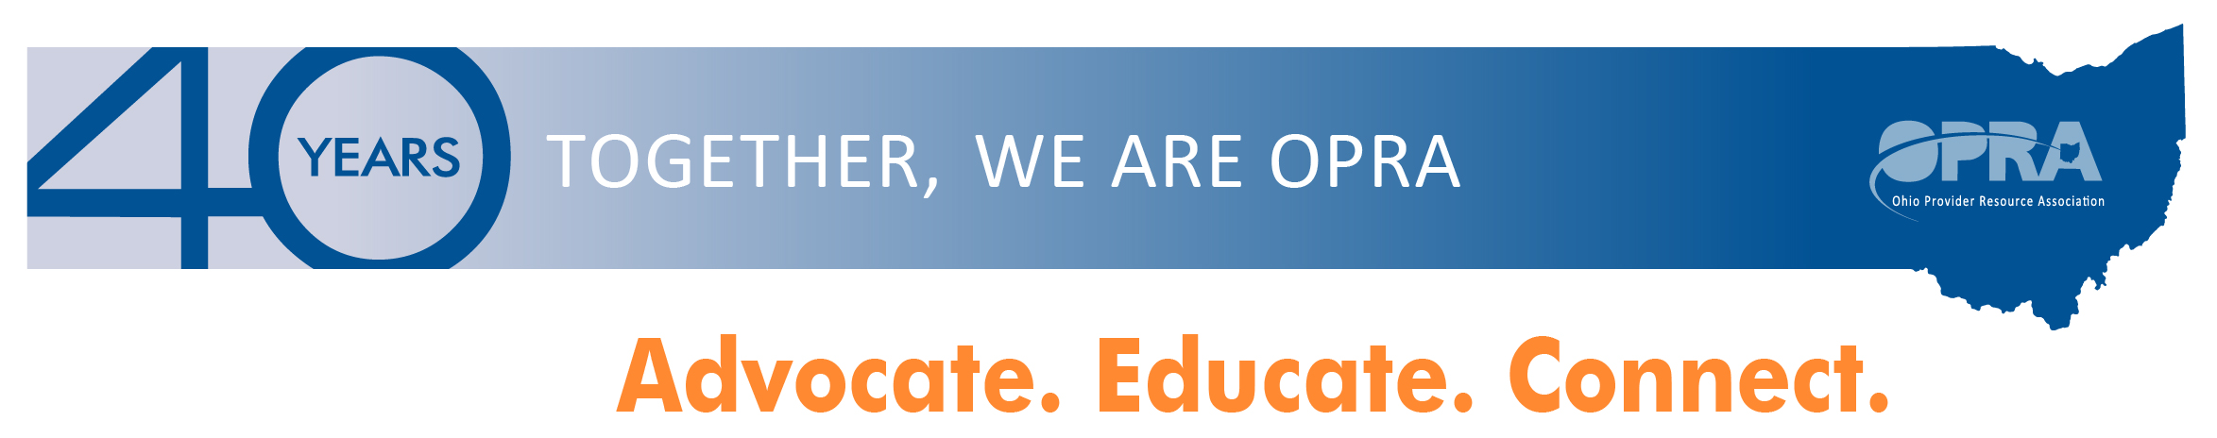***\*\*\*OPRA ALERT\*\*\****

Governor’s Office of Health Transformation

Releases Ohio’s Draft Plan to Comply with New Federal

Home and Community Based Services Requirements

As 2014 closes and we as a system enter into 2015, the Governor’s Office of Health Transformation (OHT) is leading the Administration’s efforts to modernize Medicaid and streamline health and human services programs. OHT continues to work with the Ohio Provider Resource Association (OPRA) and other stakeholders to improve services, enabling seniors and people with disabilities to live with dignity in the setting they prefer, especially their own home. A major part of this work has been around drafting the state’s plan to come into compliance with a new CMS rule.

On January 16, 2014, CMS published 42 CFR 441.301(c) (4)-6) in the Federal Register, which details new requirements that settings must meet in order to be eligible for reimbursement for Medicaid HCBS provided under sections 1915(c), 1915(i), and 1915(k) of the Social Security Act. The final rule compels the State to submit a transition plan describing the actions that will be taken to ensure initial and ongoing compliance with the regulations. The state must submit the final transition plan to CMS no later than March 17, 2015. OHT released the draft transition plan today. [Click here to review the PLAN](http://asoft8225.accrisoft.com/opra/index.php?src=documents&srctype=download&refno=372)

OPRA Board President, Janice Hall; OPRA Board Member, Jorji Milliken; and OPRA President, Mark Davis, worked with others to provide insight from the provider perspective to the transition plan input process. OPRA members participated in surveys, voiced their opinions via committees, conference calls and meetings to form OPRA’s perspectives as DODD’s transition plan committee developed the state’s plan to ensure compliance with the new CMS rule.

Governor Kasich’s administration, OPRA and the other stakeholder’s primary goals were to transition individuals from long-term care facilities into alternative settings, and move residents from institutions into home and community based settings keeping their best interests at the forefront of the discussions and the decision-making process.

In reviewing the draft transition plan, you will note it contains two groups of waivers, ICF/IID waivers (includes: IO, Level One, SELF and TDD) and the NF-LOC waivers. Pages 3 – 12 include the process used to assess Ohio’s DD waivers compliance with the new CMS rule and the remediation strategy. More detail on the plan for our system is included in the Appendices 1 and 2. For the most part, this is a “plan to plan” and lacks specific detail on the remediation tactics. This makes it even more important for OPRA to be involved in the process, for you to review the draft transition plan and for you to provide comments directly to OPRA.

There has been discussion around the state about the rule’s requirement for conflict-free case management, i.e.: the prohibition in the rule for TCM (federal term for SSA) providers to also provide waiver services - as many of our county boards do now. The state has said they will not deal with that issue in this transition plan. CMS does not require that it be included in the transition plan, because the regulation is in effect now (as of March 17, 2014), with no transition to compliance permitted by the new rule. The state has said they will deal with this issue of conflict-free case management, but later.

[Click here to review the POWERPOINT of the Transition Plan](http://asoft8225.accrisoft.com/opra/index.php?src=documents&srctype=download&refno=373)

DODD is holding community forums to solicit feedback on the draft transition plan. A new schedule for these forums has been set. The first forum is tomorrow, December 16th in Toledo. Join members of the DODD CMS Transition Plan Committee to learn more about the new rule from the federal Center for Medicare & Medicaid Services (CMS), and what the state is doing to ensure we are in compliance. Below is an updated schedule.

**Tuesday, December 16, 6:00-8:00 p.m.**

West Toledo Public Library

1320 Sylvania Avenue, Toledo, 43612

**Thursday, December 18, 6:00-8:00 p.m.**

Goodwill Columbus

1331 Edgehill Road, Columbus, 43212 

**Tuesday, January 6, 5:30-7:30 p.m.**

Athens County Board - Beacon School

801 West Union Street, Athens, 45701

**Thursday, January 8, 6:00-8:00 p.m.**

ESC Conference Center

6393 Oak Tree Blvd. South, Independence, 44131

**Saturday, January 10, 10:00 a.m.-noon**

Hamilton County Board - Beckman Adult Center

2600 Civic Center Drive, Cincinnati, 45231

On Friday, December 19, 2014 at 8:30am OPRA will host a members-only webinar on the state’s draft transition plan. Members will receive information regarding the webinar. For more information or questions, please email Mark Watson at [mwatson@opra.org](mailto:mwatson@opra.org)

OPRA will continue to advocate for providers and the individuals they serve throughout the transition process. Our hope is that all Ohioans with disabilities have the same opportunities as life as you and me. Stay tuned, stay involved.